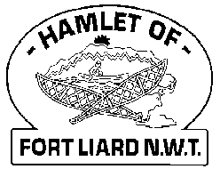

**Fire Chief Monthly Report for March 2021**

Every Wednesday evenings for the month of March, we invited the youth to come out to the Fire Hall to come out and participate for the “Help and Elder Program”. We started off a bit slow but as the word got out, we had 18 youth out the one evening. Their names would be added to one of the three ballot boxes we had in the community. We had 75 ballots that included participants from both Nahanni Butte and Fort Liard, as well participants outside the scheduled fire practice showing the involvement of independent efforts. Prizes for this event was a Nintendo Switch, Fort Liard Swags and Gift cards both from the Northern Store and General Store.

Seeing and hearing what great outcome this program was from community members along with elder’s made us all feel happy.

March 4th & 5th, 2021 Fire Fighters Nathan Wilson and Ivy-Lynn Marcellais renewed their First Aid at the Echo Dene School as theirs expire this year.

Kali Norn brought in her application to become a volunteer Fire Fighter March 5th, 2021 and will be coming out March 10th, 2021. As of right now, there will be more ladies on the Dept than men.

***Fire Practice:*** Every Wednesday evenings we meet at 6:30pm.

**March 3rd –** Six (6) members in attendance AFC Arthur Loe, Fire Fighters Nathan Wilson, Kayly Deneron, Ross Duntra, Ivy-Lynn Marcellais and me, Fire Chief Evelyn Wilson. We also had Constable McGuffin, Volunteers’ Kali Norn and Cooper Wilson come out to participant in “Help an Elder Program”. We were able to chop wood / shovel stairs/ ramp for Louie Betthale, Jim Seya, and Marie Hardisty. The three of them were so thankful.

**March 10th –** Six (6) members present Fire Fighters Nathan Wilson, Ivy-Lynn Marcellais, Collin Woehl, Bailey Weber, our newest recruit Kali Norn and I, Fire Chief Evelyn Wilson. Constable McGuffin and a long with Eight (8) youth, shoveled and chopped wood for the following elders Randy Dobbs, Theresa Bertrand, Jimmy Klondike, Freddie Mouye and Theresa Diamond’C.

**March 17th –** Seven (7) members, AFC Arthur Loe, Fire Fighters Ivy-Lynn Marcellais, Kayly Deneron, Collin Woehl, Ross Duntra, Kali Norn and me, Fire Chief Evelyn Wilson. Each of the elder’s home in the community received a goodie bag which contained muffins, tea, and a container of Clorox wipes. This evening we had a total of seventeen (17) youth participate in “Help and Elder” program. Cst McGuffin and I both baked close to 300 Chocolate Chip and Blueberry muffins as part of the goodie bags. We broke up in four teams and delivered all the goodie bags to 57 elder’s homes plus the 9-plex.

**March 24th –** Eight (8) members present, AFC Arthur Loe, Fire Fighters Collin Woehl, Nathan Wilson, Kayly Deneron, Ivy-Lynn Marcellais, Ross Duntra, Kali Norn and me, Fire Chief Evelyn Wilson. We broke up in three teams and chopped wood for George & Shirley Jooris, Laura Nande and Adele Klondike. We had eighteen (18) youth that came out to help us.

**March 31st –** Five (5) members in total, Fire Fighter Nathan Wilson, Kayly Deneron, Ivy-Lynn Deneron, Kali Norn and me, Fire Chief Evelyn Wilson. We held an Appreciation gathering with the youth that came out for the month of March. We supplied hot Dogs (all individually wrapped), juice boxes, Tim Horton doughnuts, apples, and oranges. Afterwards, we handed out the prizes. Our main winner for the Nintendo Switch was Linkyn Lauck. Once that was done, we took the youth out for one last drive through town with them. This was such a great turn out with the youth and as well for the elders.

***Fires or Other Emergency calls:***

**1) March 20, 2021 at 10:18pm** we received a call from the 911 operator stating that a bystander called in worried that the bonfire at the Arbor would get out of control. I called Arthur on the radio, he got to the Hall and started both Pumper and Support truck. Once on scene, all the youth took off on foot. I texted the group at 10:21pm ***FIRE, FIRE, FIRE*** and first two on scene were AFC Loe and Fire Fighter Wilson, they had it extinguished by **10:36pm**. Fire Fighters Deneron and Woehl did arrive on scene as well. I did call the R.C.M.P at 10:21pm to let them know about the call and the youth that took off on foot. Once the fire was put out, we tidied up and left back to the Fire Hall.

**2) March 31, 2021 at 9:49pm**, I received a call from Corporal Meeko with the RCMP Detachment called March 31st requesting Ambulance assistance to a call they were at; I did advise him that we do not have an ambulance or provide an ambulance service. Constable McGuffin said they brought them to the Health Centre in their RCMP truck. I think an ambulance is needed for this community, even just to be able to provide triage and to bring them to the Health Centre.

***Issues:*** Requesting for Ambulance Service

***Fire Works Permit:*** NIL

***Phone calls:***

***Fire Emergency*** – Two (2) call - Bonfire at the Arbor & RCMP requesting Ambulance Service.

**Unknown Calls (No response)** – Three (3) calls, one no answer and the other wrong number, one a scam

***Active Members to Date:***

Evelyn Wilson Collin Woehl Arthur Loe Ross Duntra

Nathan Wilson Kayly Deneron Ivy-Lynn Marcellais Bailey Weber

Kali Norn

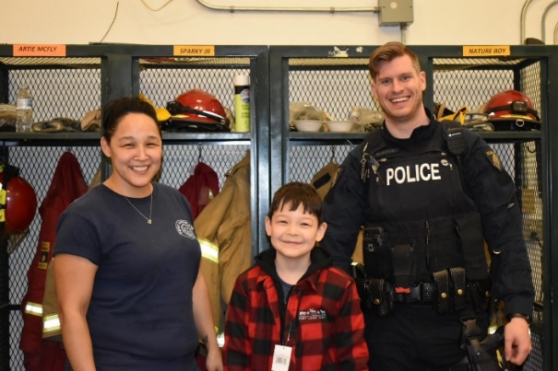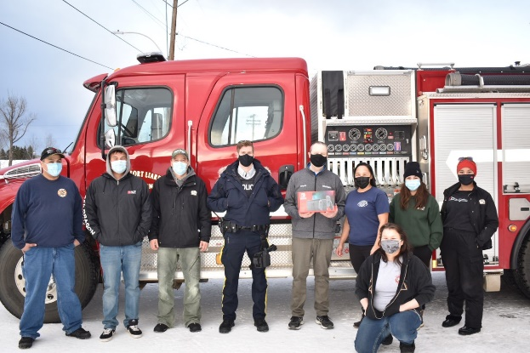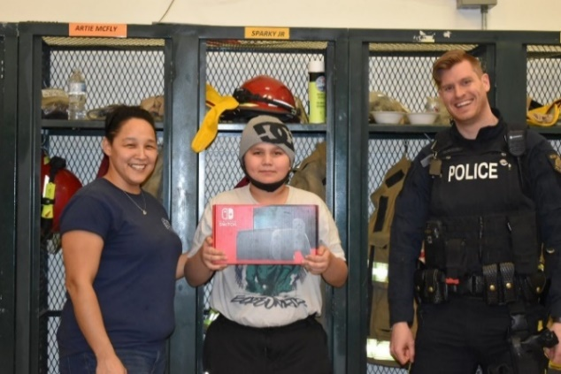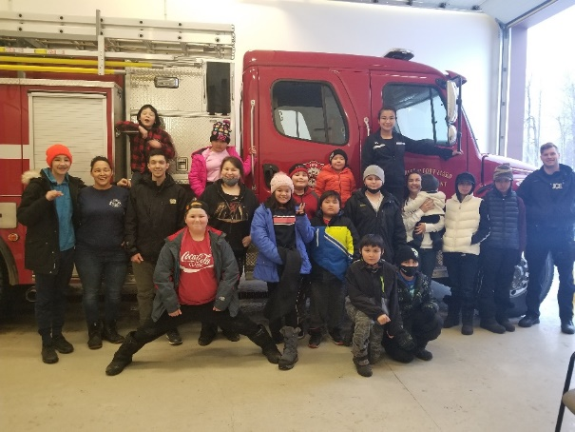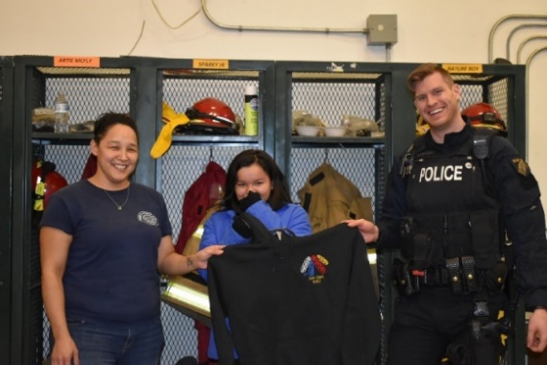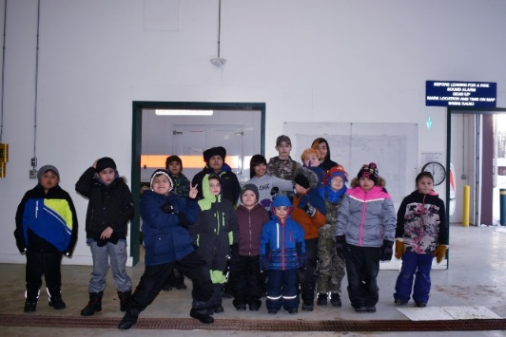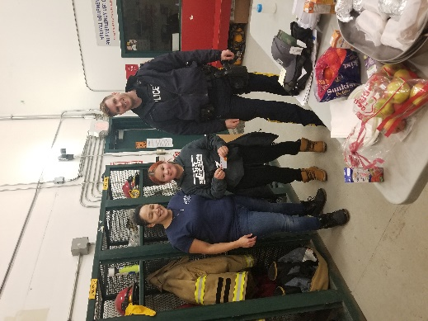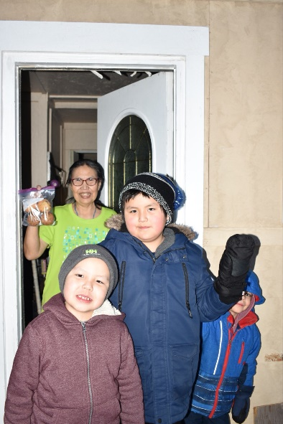

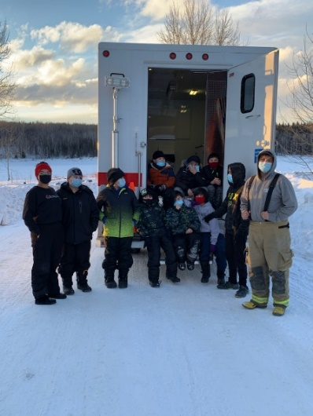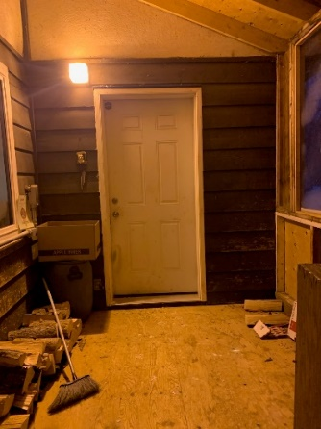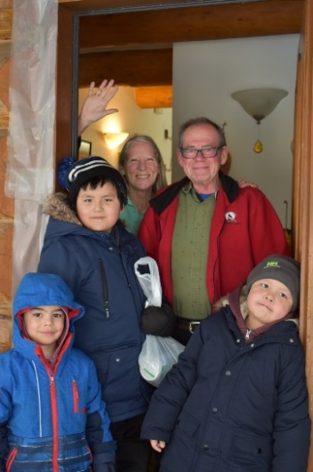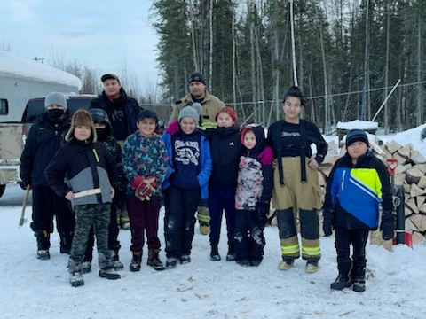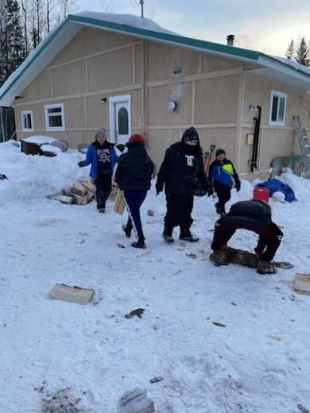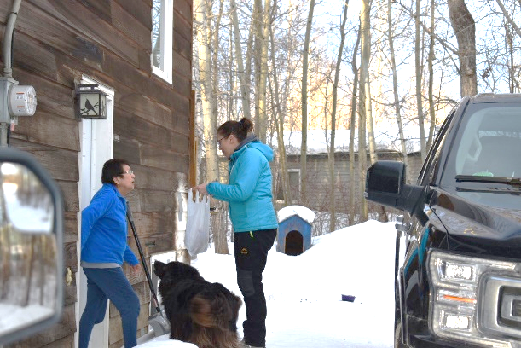

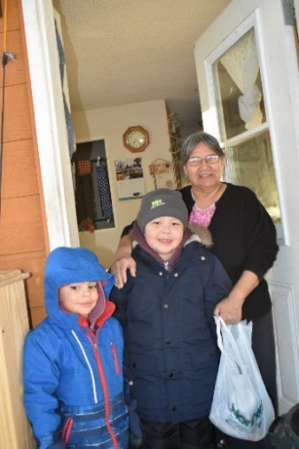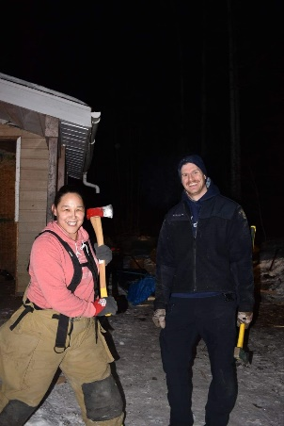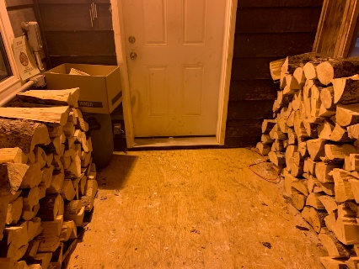

AFTER

BEFORE

