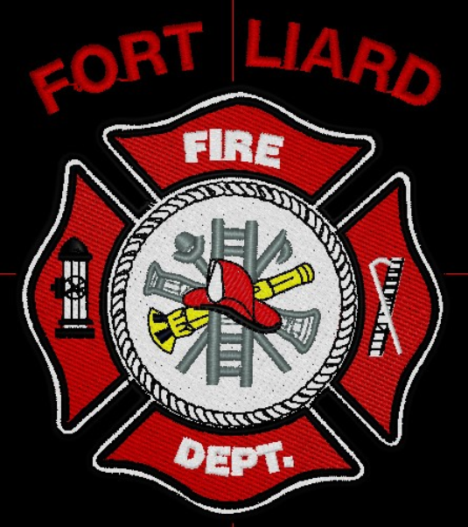
Current me mbers

Fire Chief – C. Evelyn Wilson
Start date: June 11, 2018

Assistant Fire Chief – Arthur Loe
Start date: April 1, 2012

Fire Fighters

Ivy-Lynn Marcellais
Start date: October 18, 2018

Kayly Deneron
Start date: November 1, 2018

Nathan Wilson
Start date: November 18, 2018

Ross Duntra (Gahcho Kué Mine) *will attend when in town
Start date: August 19, 2020

Kali Norn
Start date: March 5, 2021

Travis Goodburn (Rookie)
Start date: May 11, 2022

Lyle Bertrand (Rookie)
Start date: July 13, 2022

Cedar Wechlin (Rookie)
Start date: July 13, 2022
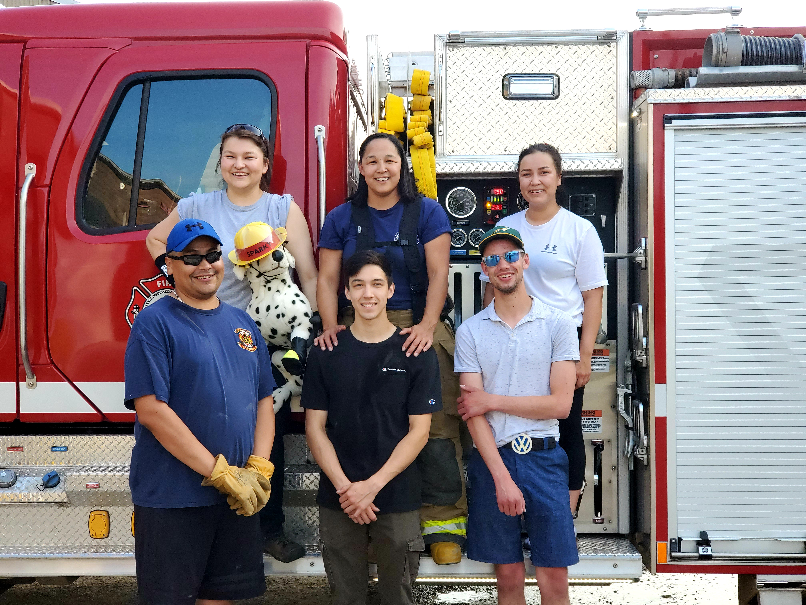
  - JULY 2022

fire chief’s report
Fire Fighters Wilson, Goodburn and me Fire Chief Wilson along with our Mayor Genevieve McLeod helped with the Canada Pancake Breakfast and AFC came out to help with the parade.

We received a fire call at one of the RCMP units about smoke coming from the attic. We got the call at 6:17pm, arrived on scene 6:23pm and left the scene at 8:36pm. Five of us on scene along with Water truck driver and Community Safety Officer. Shane Seaman, Assistant Fire Marshal came back into the community July 6, 2022, after lunch to inspect the RCMP unit. A report has been filed with the Fire Marshals office.

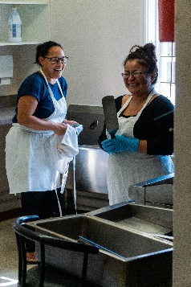
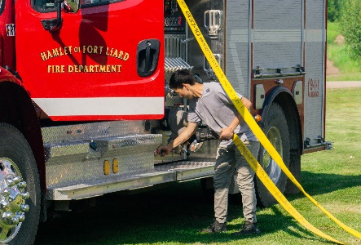

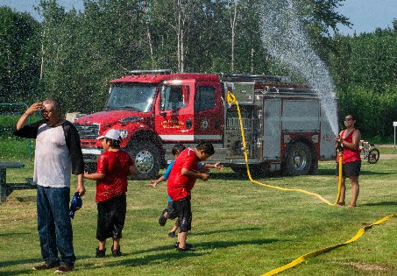
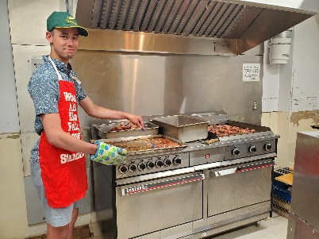

ISSUES / CONCERNS:
Five (5) Fire Fighters need to replace their Bunker Gear jackets due to tears or oil residue on them. They are to be destroyed. Our PPE gear will need to be replaced soon.

Fire Practice – every Wednesday’s at 6:30pm

July 6th, 2022
Cancelled practice
With the fire call we had the day before on July 5, 2022; I cancelled practice.

July 13th, 2022
Six (6) of us in total, Fire Fighters Marcellais, Deneron, Goodburn and me, Fire Chief Wilson along with our newest recruits Lyle Bertrand and Cedar Wechlin. This evening we took the Water Truck to the plant to fill up then we went back to the Fire Hall to do some pumper truck training with Travis, Lyle, and Cedar.

July 20th, 2022
Four (4) of us in total Fire Fighter Norn, Rookie Fire Fighters Goodburn and Wechlin and me Fire Chief Wilson. We brought both Pumper and Water Truck outside the Bay and gave the water truck a wash. Afterward Norn and I taught Goodburn and Wechlin how to properly load and deploy hose from the Pumper.

Assistant Fire Marshal Shane Seaman emailed over a Community Fire Service Training request from School Community Government for Exterior Fire Fighting Basic training. I have confirmed 8 out of the 10 for this upcoming two weekend course.

July 27th, 2022
Two in attendance, Assistant Fire Chief Loe and Fire Fighter Deneron.

PERMITS: | CALLS RECEIVED:
Burn Permits: NIL  Fire Works Permit: NIL | Fire Emergency: One (1) attic fire in one of the RCMP units, filed a report and sent off to AFM Shane Seaman.  Non-Emergency: One (1)

