**FOUR FORTS IN FORT PROVIDENCE**

On the Inside:

Pg. 2 Movember

Health Centre Schedule

Pg. 3 Coloring Contest Winners

Smoke Signals

Pg. 4 The Path to a Healthy Life

Pg. 5 Coming Up…

Pg. 6 Health Promotion

Pg. 7 Northern Store Schedule

Pg. 9

**‘FOUR FORTS’ SPORTS EVENT IN PROVIDENCE**

Twelve Fort Liard youth travelled to Fort Providence for the 2nd Four Forts sporting event Nov. 16th to 18th and enjoyed the badminton instruction and tournament. They were busy as they also attended a sports nutrition seminar and worked up a sweat on the Providence fitness equipment. In their spare time youth from Simpson, Liard and Providence played soccer and visited with their new friends. As always, our youth were good athletes and good sports, joining in all activities with enthusiasm and energy. Mahsi Cho to **Michael Sassie** for driving safely on those snowy roads and to **Beaver Volunteer, Ollie Williams,** for chaperoning and playing ‘net’ so very well at soccer games! Thanks also to **Echo Dene School** for supporting us.

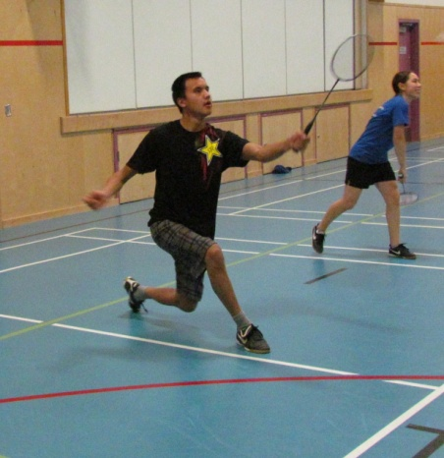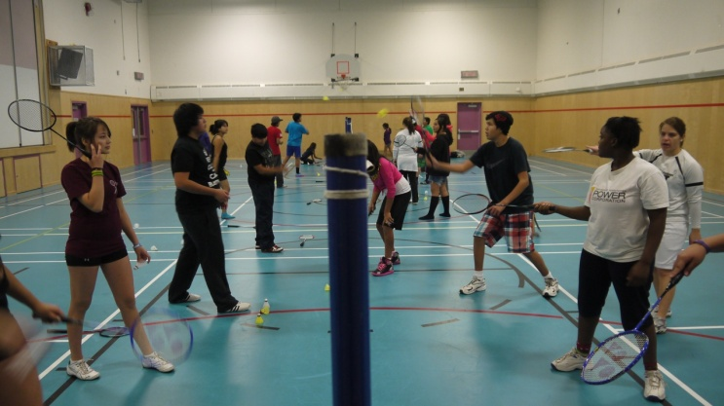

Quick Notes:

- The Community Calendar for December will be coming out next Friday, November 30th. If there is anything you would like included in the newsletter please call Christine at the Hamlet Office 770-4104 or e-mail christineboyde@hotmail.ca

- Parent and Child Craft Night at the Library has been cancelled for the remainder of the year

- Check out the Hamlet’s website at www.fortliard.com. E-mail web@fortliard.com with any suggestions

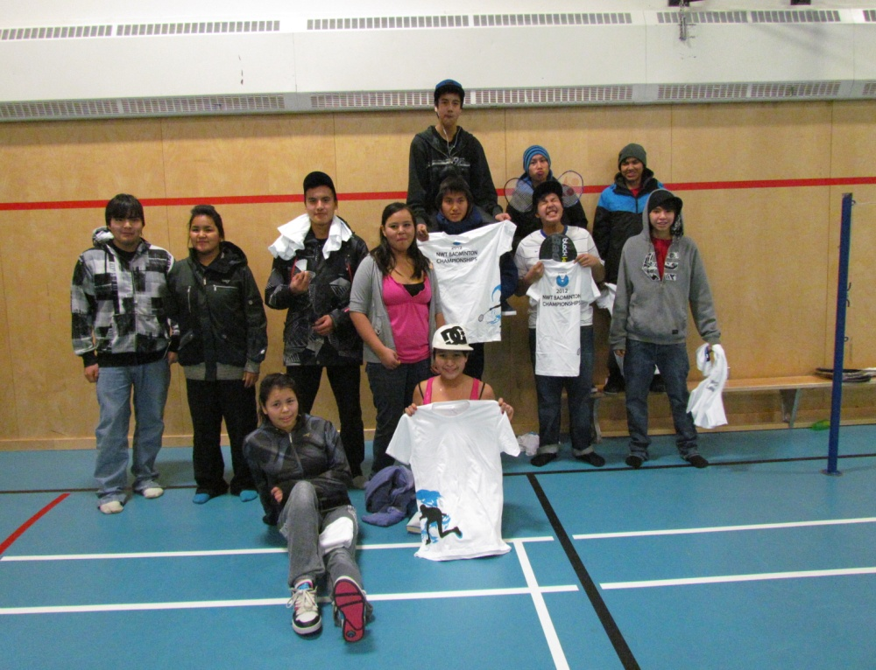

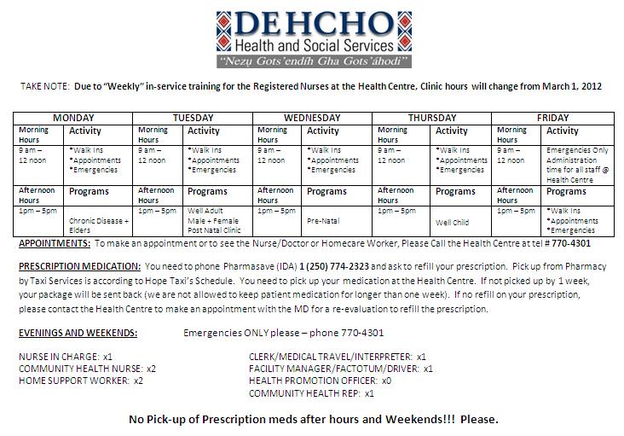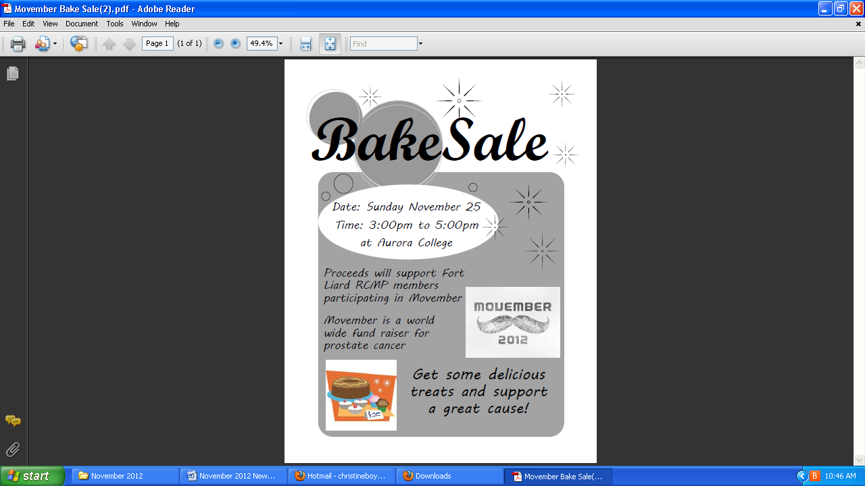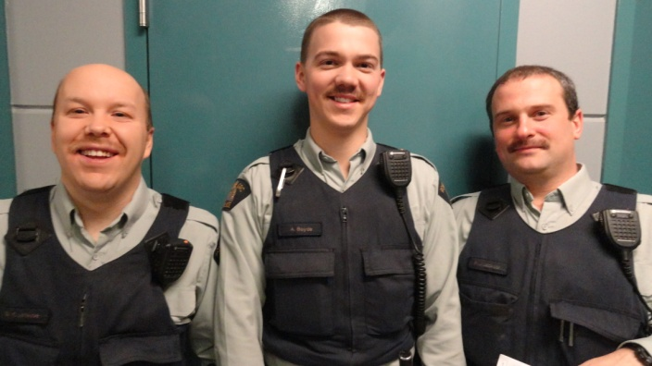

**FROM THE HEALTH CENTRE**

Movember is an annual, month-long event involving the growing of moustaches during the month of November to raise awareness of prostate cancer and other male cancer and associated charities.

By encouraging men ("*Mo Bros*") to get involved, Movember aims to increase early cancer detection,

diagnosis and effective treatments, and ultimately reduce the number of preventable deaths.

This year, the Fort Liard RCMP Detachment is participating in Movember. Show your support by donating or purchasing some goodies at our Bake Sale on Sunday, November 25th.

**MOVEMBER IS HERE!**

**COLORING CONTEST WINNERS!**

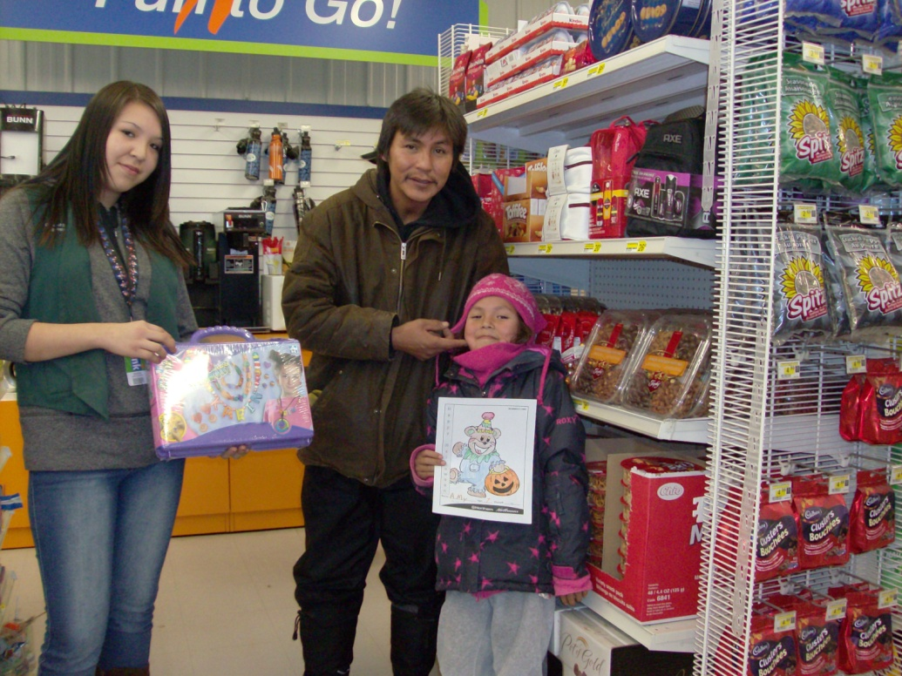

Congratulations to the Northern Store Halloween Coloring Contest Winners.

Category 2-4 years – Kei Isaiah

5-7 years – Amy Duntra

8-12 years – Brandon Hardisty

Thanks to all who participated in the contest.

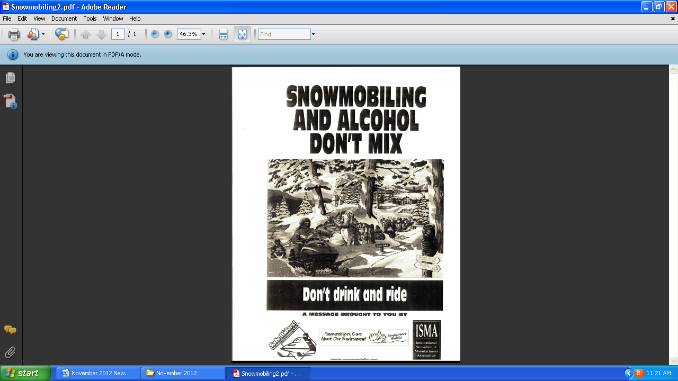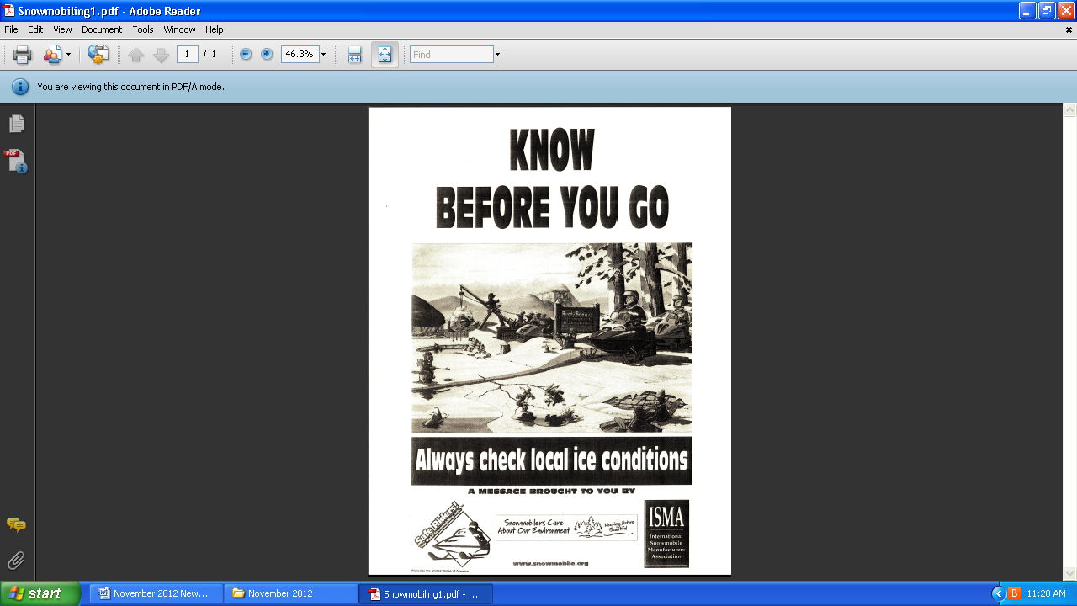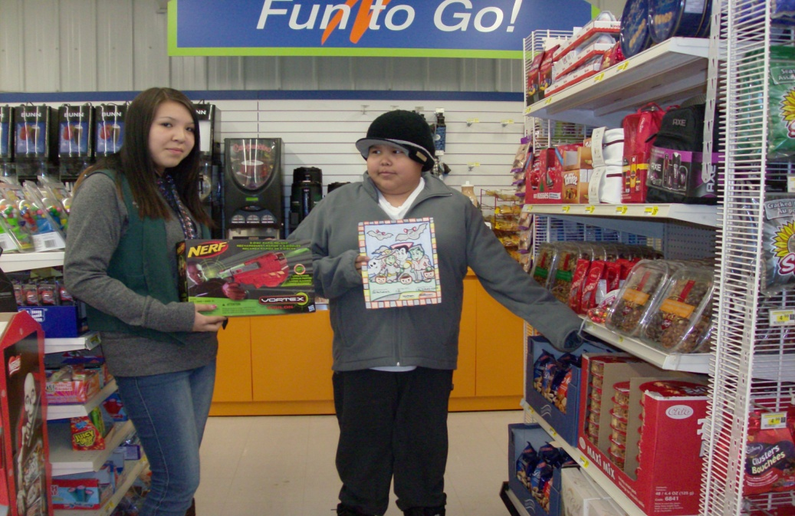

**SMOKE SIGNALS**

C:\Documents and Settings\mwr\Local Settings\Temporary Internet Files\Content.IE5\F0DNX41Z\MC900432173[1].wmf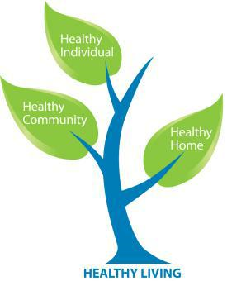C:\Documents and Settings\mwr\Local Settings\Temporary Internet Files\Content.IE5\04KHN3GJ\MC900333118[1].wmf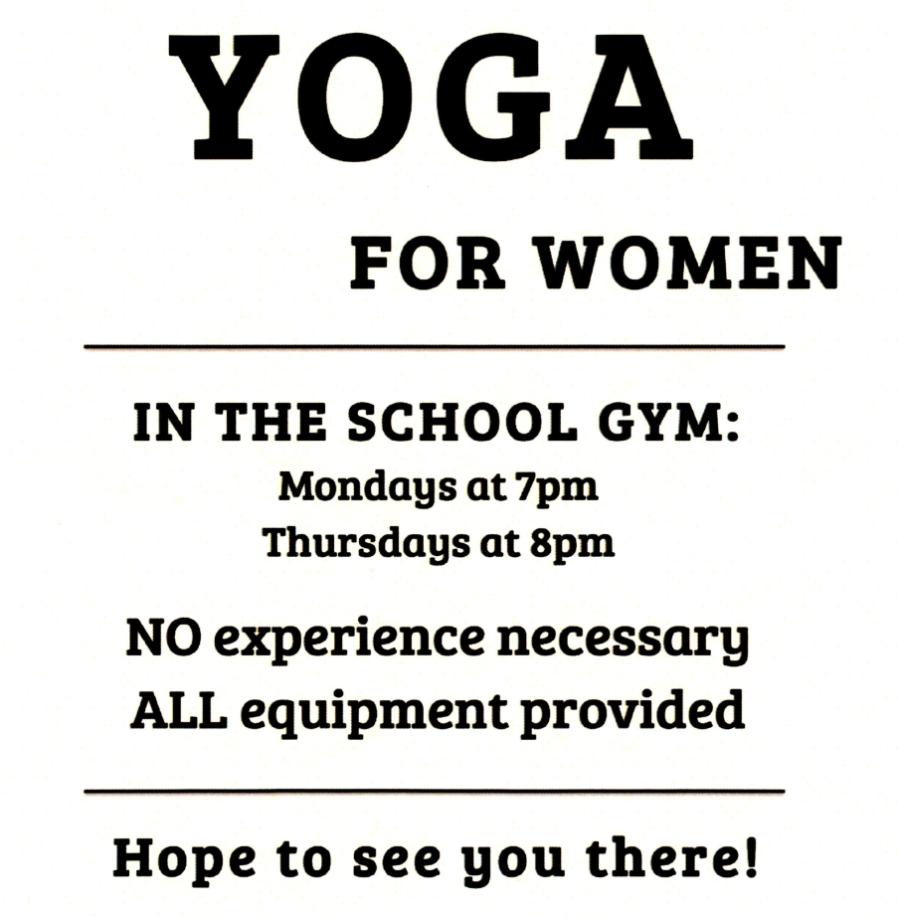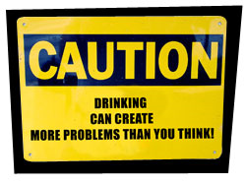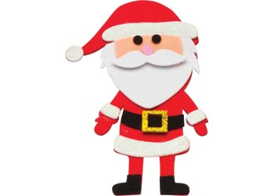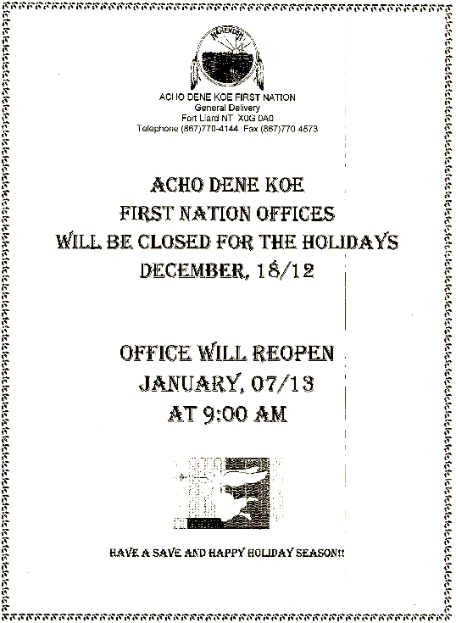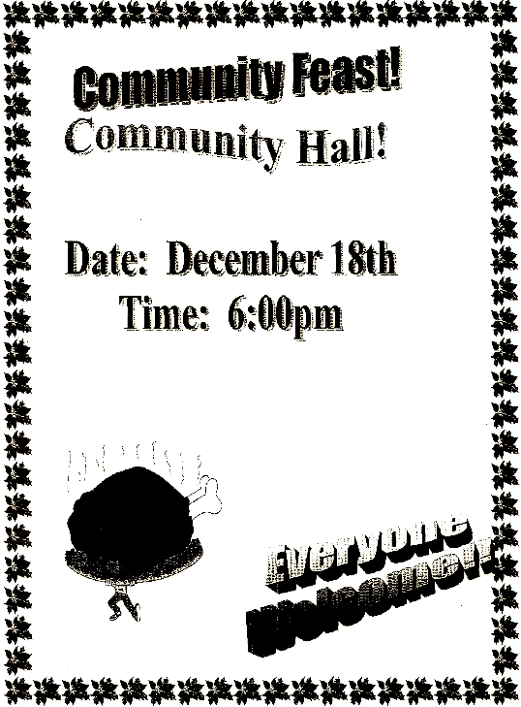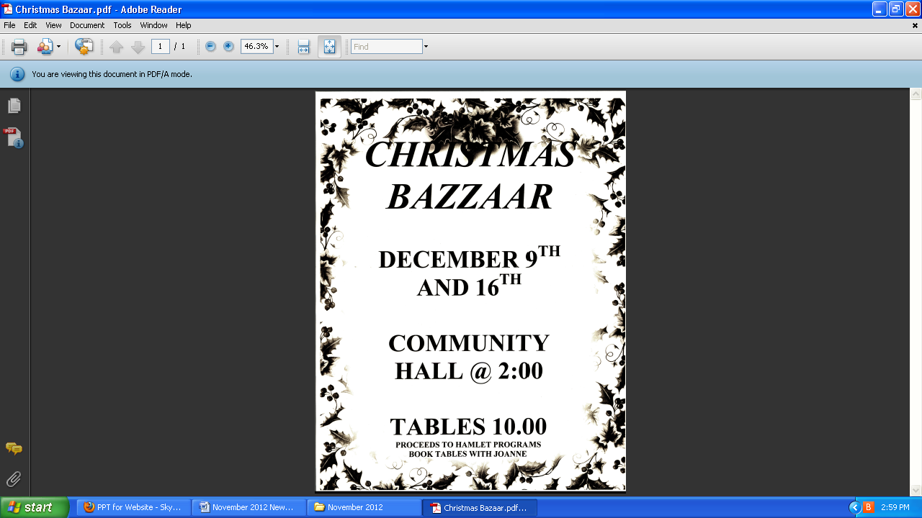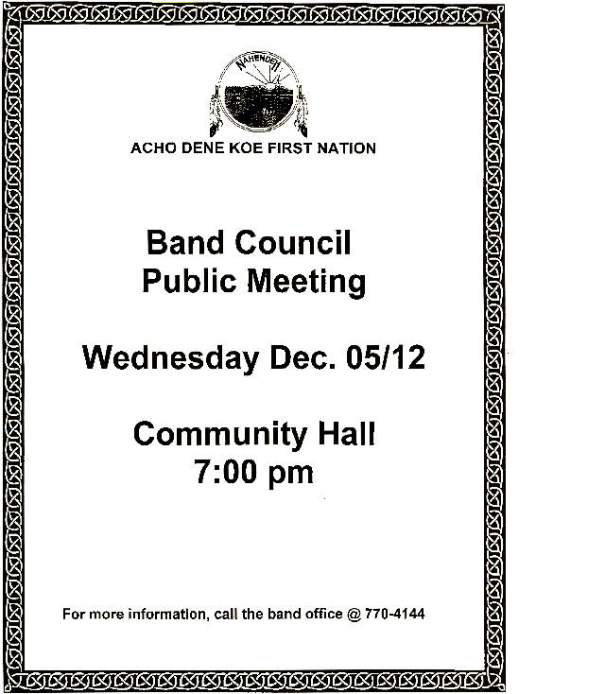

**MEN’S RECREATIONAL HOCKEY PLAYERS**

THE ICE IS READY! IN ORDER TO PLAY HOCKEY YOU **MUST** REGISTER AT THE HAMLET OFFICE AND PAY $40.00.

YOU WILL NEED TO REGISTER YOUR HEALTH CARE CARD NUMBER SO PLEASE REMEMBER TO BRING IT WITH YOU. HOCKEY TIMES ARE:

TUESDAY 7 P.M.

THURSDAY 7 P.M.

SATURDAY 7 P.M.

Regular physical activity:

* helps the circulatory system deliver oxygen and nutrients around the body
* helps the removal of toxins and waste products from your body
* improves the condition of your skin
* reduces the rate of bone loss, the risk of heart disease, hypertension (high blood pressure) and diabetes
* alleviates feelings of depression and anxiety
* controls weight
* builds and maintains strong and healthy bones, muscles and joints

Exercise also stimulates the production of endorphins – chemical substances produced by the body that make you feel happy and exhilarated. So exercise is not only good for you, but it makes you feel happy.

Mixed Volleyball….IS on!

We didn’t get off to a great start but volleyball for men and women over 16 **DOES** take place every Thursday night at 6:30 in the school gym.

See you there!

**Next Newsletter: Part 4 - 1am 15 Units: Let me tell you about my ex...**

**WHAT ALCOHOL *REALLY* DOES TO YOUR BODY… PART 3**

**11pm 10 Units: Sorry, what was your name again?**

LUNGS: A small amount of alcohol speeds up the breathing rate. But at this level of intoxication, the stimulating effects of alcohol are replaced by an anaesthetic effect that acts as a depressant on the central nervous system. The heart rate lowers, as does blood pressure and respiration rates, possibly to risky levels - in extreme cases the effect could be fatal. During exhalation, the lungs excrete about 5 per cent of the alcohol you have consumed - it is this effect that forms the basis for the breathalyser test.

**THE PATH TO A HEALTHY LIFE…**

Stay tuned for information on more upcoming Christmas events in our next newsletter, to be released on Friday, December 7th.

The next Dental Clinic for Fort Liard is scheduled for January 14th – 18th. Contact the Health Centre to make an appointment.

**COMING UP…**

**HEALTH PROMOTION**

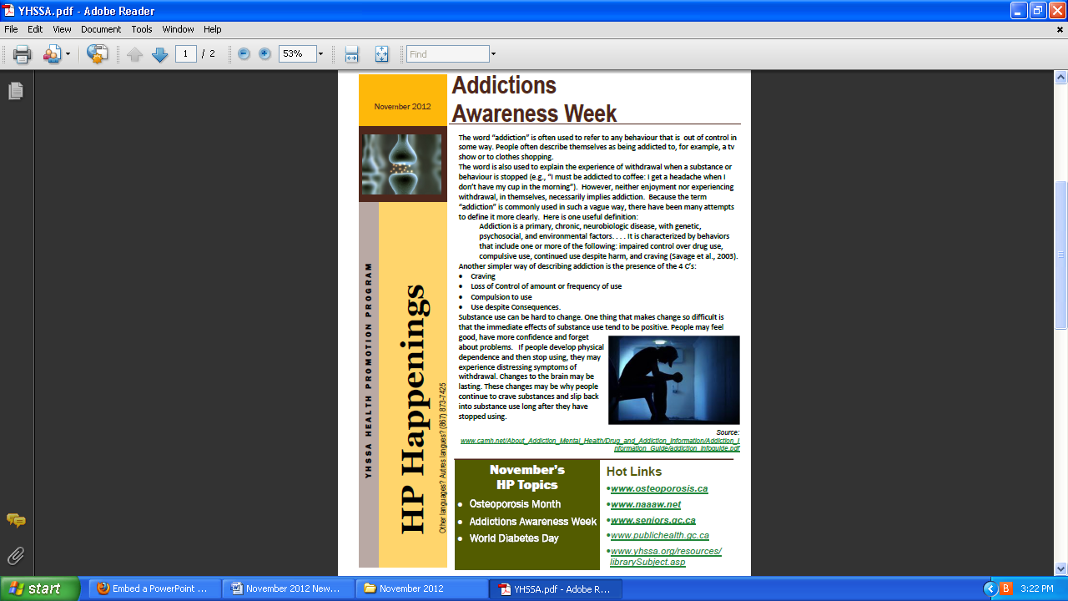MC900059854[1]MC900059854[1]

**NORTHERN STORE SCHEDULE**

