**IMPORTANT SCHOOL NEWS**

September, 2012. For each student who does not register before the end of September, Echo Dene School will lose over $16,000 in funding. That means if we end up with 10 fewer students at the end of September, the school will lose over $160,000. This loss can only be made up in reduction of staff which means larger classes and fewer programs for students.

**With the help of the members of the DEA, parents, grandparents, staff and especially members of the community we hope to get families who have still not**

**brought their children to school to get their school aged children registered as soon as possible. *Let’s get these children into school and learning.***

It’s hard to believe we are nearing the end of our first month of classes at Echo Dene School. So far we have had a very successful opening and we hosted the community at on Thursday, September 6, 2012. Even with a great start to the New Year, we are faced with a serious dilemma our Open House– **our student registrations are much lower than we had expected.**

Members of the Fort Liard community need to know that funding for the school and for student programs is based on our registration numbers at the end of



Youth ‘Frozen Eyes’ Photography Project

18 youth participated in this 5 day workshop that was held here from September 10th to 15th. They quickly learned some of the more technical aspects of digital photography and applied their new skills very effectively. Their creativity is impressive!

Photos will be displayed in the library after October 1st. Be sure to stop in and admire their impressive and imaginative images.

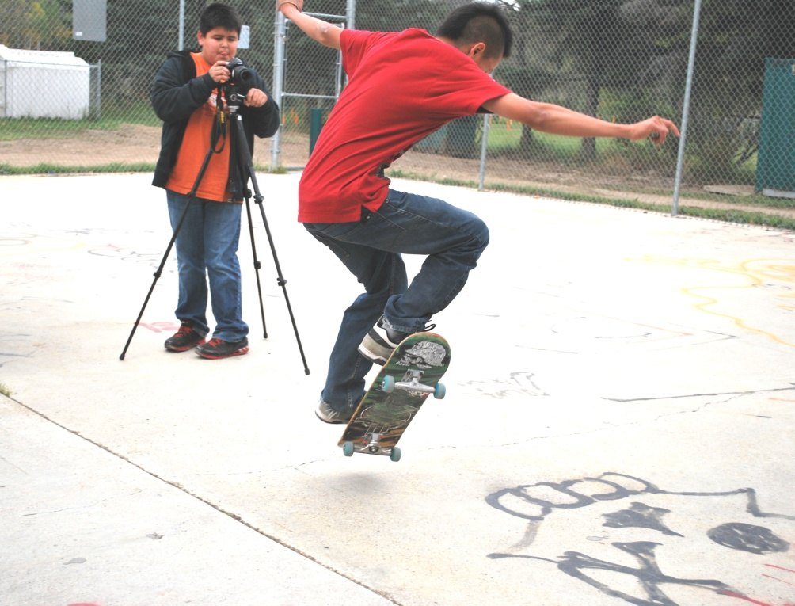

**Dylan concentrates on capturing Stan’s technique at the skateboard park.**

**SMOKE SIGNALS**

The Fire Ban on open fires in the community is finally over until further notice. Thanks to everyone who helped keep the community safe this summer.

Ross Duntra, Terrance Kotchea, Brent Kotchea, and Tina Bertrand have joined the Fire Department as Junior Fire Fighters. We still need 2 more to join us. It would be nice if 2 girls were to join Tina on the Fire Department. Way to go kids!

Echo Dene Koe School allows each Junior Fire fighter to earn High School Credits by attending the Junior Fire Fighter program. The Fire

Department will work with the school so you can earn credits for your contribution to the community and for training time.

Fire Prevention Week takes place October 7-13th. What is Fire Prevention Week? This is an opportunity to make your families and homes safe from fires. Check your smoke alarms, batteries, and chimneys. Cut any long grass and brush near or touching your house. Put a plan together with your family as to what would happen if there was a fire in your home. Do your kids know what to do, 2 places to get out? Smoke alarms won’t save lives if the battery is dead, covered with a plastic bag or disconnected.

Furnace rooms need space around the furnace for air and shouldn’t be used for storage. The Fire Department will come and check your smoke detectors, and install a new one and do a quick safety inspection. Call 770 4104.

Fall is here and people are on the river. **Please wear your life jacket when you are on the river.** If you don’t wear a life jacket you put your life and the lives of others at risk. You are teaching your kids it’s ok not to wear a lifejacket. See the new art work by Neil Kotchea in front of the Hamlet.

**Mahsi…**



**PLAYGROUP RETURNING TO THE COMMUNITYHALL!!**

Bring your kids ages 0 – 4 for an hour of fun! Snacks will be provided

Starting September 25th, every

**Tuesday 10:30 – 11:30am**

**and**

**Thursday 2:30 – 3:30pm**

**COMING UP**

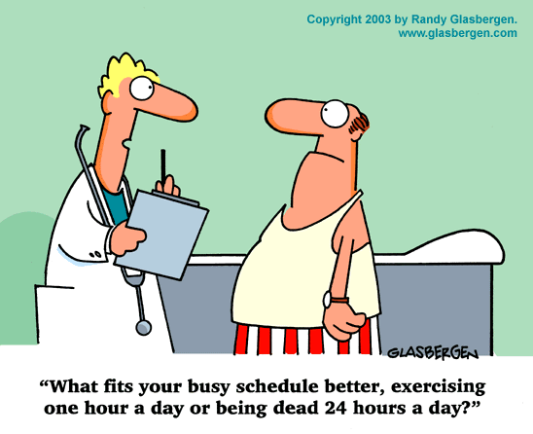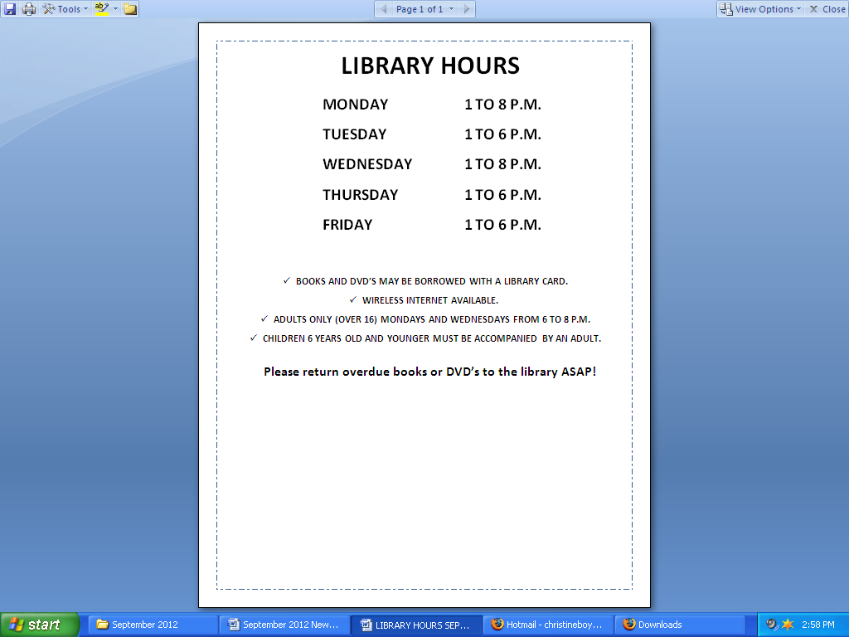

Tips for Healthy Eating

* Eat smaller meals 3 – 5 times per day.
* Eat nutrient-rich, dense foods such as whole grains, lean meat, fruit and vegetables.
* Eat slowly and wait 10 – 15 minutes before taking a second helping.
* Don’t eliminate everything you like from your diet. Eat those things in small amounts (pizza, candy, cookies etc.)
* Prepare healthy snacks that are easily available (cut carrots, apples, etc
* Drink plenty of water.

Simple Tips for Healthy Living

Exercise and a healthy diet are the mainstays for a healthy lifestyle. Here’s some tips for developing healthy eating habits and increasing daily physical activity☺

* Try to do 30 minutes of moderate intensity cardiovascular activity each day, walking, for instance. You can do all 30 minutes together or do short bouts of 10 minutes at a time.
* Make leisure time active, garden, walk, ride a bike with family and friends, participate in an exercise class, join a sports activity.
* Select activities you enjoy and find satisfying, and that give you a sense of accomplishment.
* Be sure your activities are compatible with your age and physical condition.
* Make it convenient to be active. Choose activities that are readily accessible (right outside your door) like gardening, walking or jogging.
* Walk to work and school.
* Make your activity enjoyable – listen to music, include family and friends.

HEART: Your pulse quickens after just one unit. Alcohol is a vasodilator - it makes the peripheral blood vessels relax to allow more blood to flow through the skin and tissues, which results in a drop in blood pressure. In order to maintain sufficient blood flow to the organs, the heart rate increases. Your breathing rate may also speed up.

**Next Newsletter: Part 2 - 8pm Five Units: Whose round is it then?**

**WHAT ALCOHOL *REALLY* DOES TO YOUR BODY… PART 1**

**6pm One Unit: It's been a long day...**

BRAIN: From the first sip, alcohol is absorbed into the bloodstream and reaches the brain. Although you won't be aware of it, there is an impairment of brain function, which deteriorates further the more you drink. Cognitive abilities that are acquired later in life, such as conduct and behaviour, are the first to go. Early on you will experience mild euphoria and loss of inhibition, as alcohol impairs regions of the brain controlling behaviour and emotion. Most vulnerable are the brain cells associated with memory, attention, sleep and coordination. Sheer lack of mass means that people who weigh less become intoxicated more quickly, and women will feel the effects faster than men. This is also because their bodies have lower levels of water.

**THE PATH TO A HEALTHY LIFE…**

Men’s floor hockey starts Tuesday September 25th, 7:30 at the school gym. Everyone 16 and over welcome.

Contact Roberto Loe for more information

**AURORA COLLEGE KICKS OFF THE 2012-13 SCHOOL YEAR**

**IN OTHER NEWS**

The Adult Basic Education program at Aurora College Community Learning Center is underway with participation at capacity. I would like to extend a warm welcome to the new and returning students and look forward to another great year.

Let’s take a moment to look back at the achievements during the 2011-12 school year. In addition to the Adult Basic Education program, Aurora College Community Learning Center offered a Heavy Equipment Operator program, a Class 5 Driver Training program and a Family Literacy program. A group of students had the privilege of travelling to Aurora College in Fort Smith to explore college life. Thank you so much to all the community members who supported this trip by participating in our fundraisers last year.

Keep in mind, Aurora College has computers for the community to use week days from 3:30pm to 4:50pm. If you need to use a computer, please come by.

Fort Liard Community Learning Center

General Delivery

Fort Liard, NT X0G 0A0

867. 770. 3064 (phone & fax)

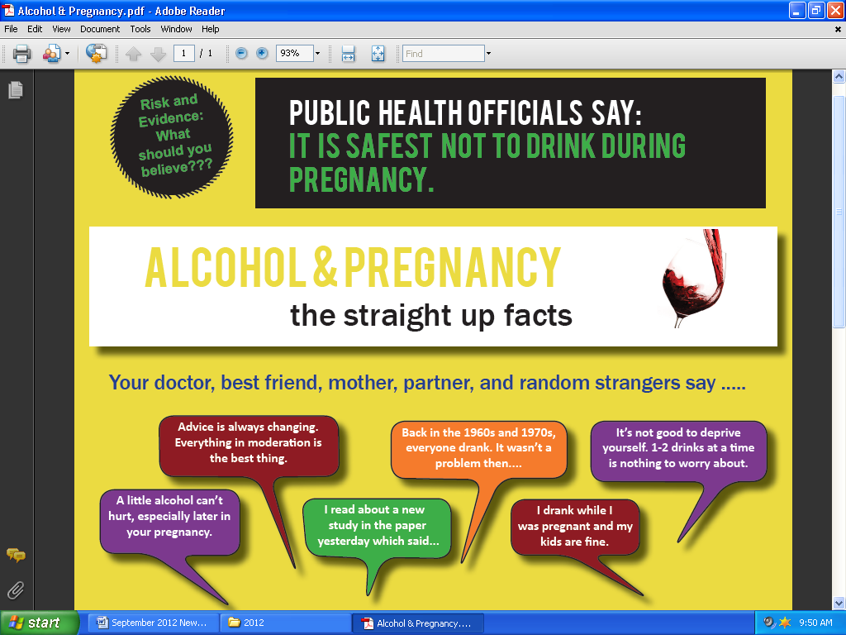

MC900059854[1]MC900059854[1]



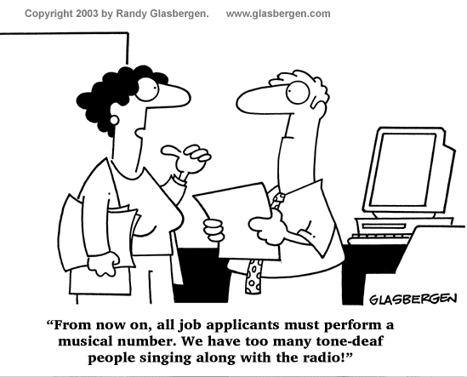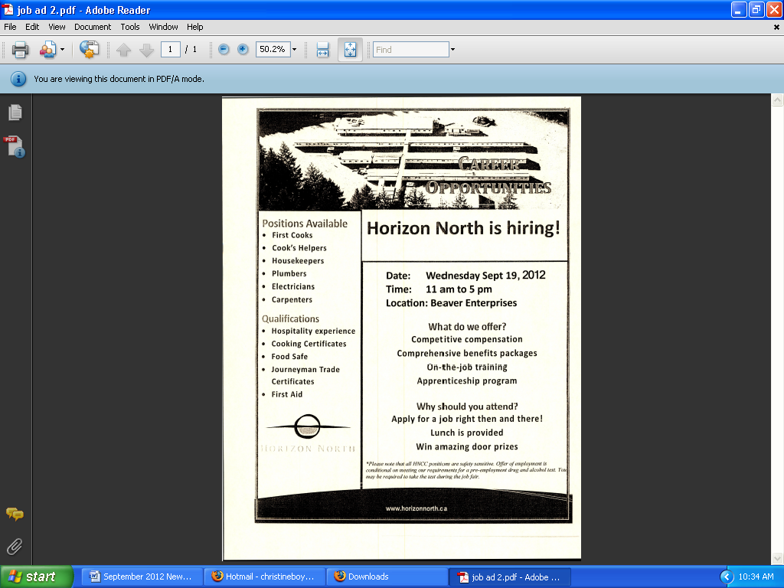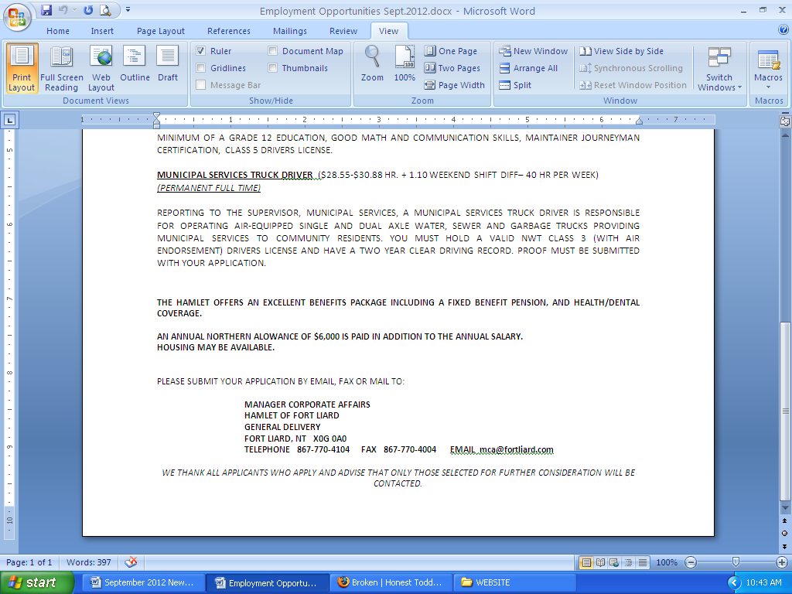

**EMPLOYMENT OPPORTUNITIES**