**FISHING DERBY RESULTS**

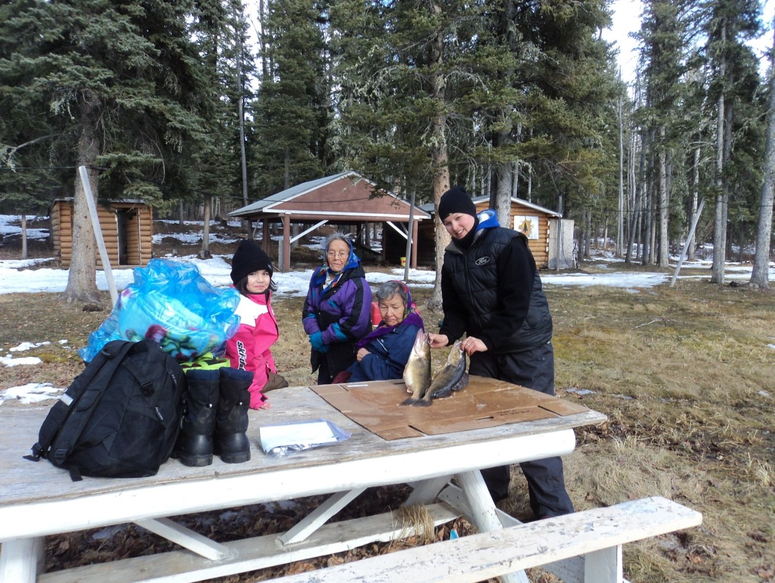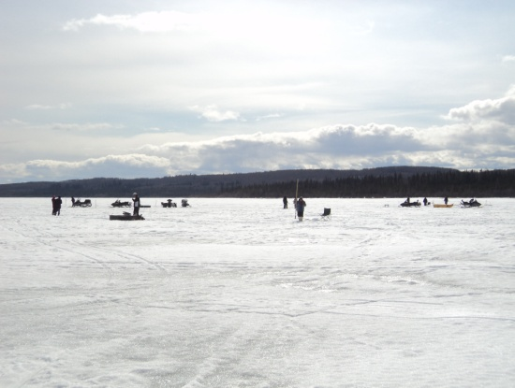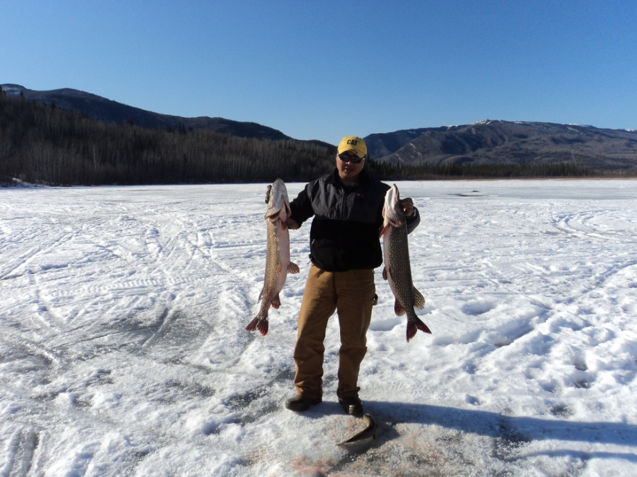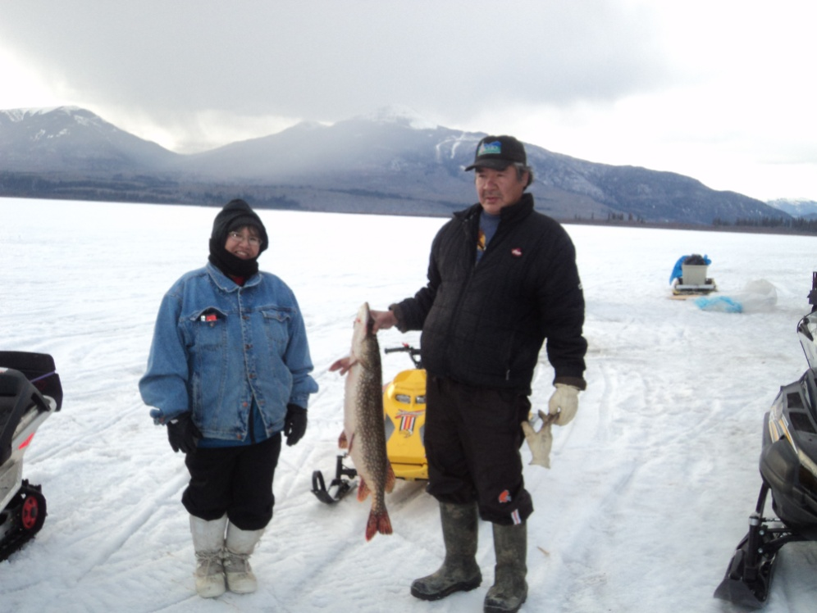

(Kids)

**Pickerel Prize**

1st – Julianne Klondike 1.5 lbs Mini DVD Player

**Jack Prize**

1st – Abby Duntra & Madison MP4 Player

Capot-Blanc – **Tie** 8 lbs

2nd – Adam Yeadon 5.5 lbs 40 Game System

3rd – Burton Duntra 2.5 lbs Sleeping Bag

4th – Trayson Duntra 2 lbs Sleeping Bag

Above From Left: Kianna McLeod, Theresa Bertrand, Germaine Betthale and Hillary Deneron with her winning 6 lb pickerel

Above & Below: People fishing on Fisherman Lake

Far Right: Helena Timbre with her husband Ernest Timbre holding her 16lb jack fish

Below: Manny Vital holding his 16lb jack & Jochim Klondike's 2nd place 12lb jack

**Congratulations to the Fishing Derby Prize Winners!**

(Adults)

**Pickerel Prize**

1st – Hillary Deneron 6 lbs 45 gal. gas

2nd – Rosie Reid 4 lbs BBQ

3rd – Arthur Nande 3.9 lbs Johnny’s Place Dinner for 4

4th – Linda Duntra 3.6 lbs Acho Bag/Sweater/Mug

5th – Ernie Timbre 3.5 lbs Picnic Bag/Mug/Thermos

6th – Louie Betthale 3 lbs Lantern/Tackle Box/Mug

7th – Jane Vital 2.5 lbs Jumbo Fish Crib Board

**Jack Prize**

1st – Helena Timbre & Manny 45 gal. gas (Split)

Vital – **Tie** 16 lbs

2nd – Jochim Klondike 12 lbs Tent

3rd – Roy Bertrand 11 lbs Johnny’s Place Dinner for 4

4th – Janna Deneron 10 lbs Sleeping Bag/Beaver

Cutlery/Mug

5th – Julie Capot-Blanc 9 lbs Beaver Cutlery/Life

Jacket/Thermos

6th – Harry Deneron 7 lbs Lantern/Tackle Box/Thermos

7th – Jim Duntra 6 lbs Jumbo Fish Crib Board

**Whitefish Prize**

1st – Roy Bertrand 4.5 lbs Camping Accessory Bag

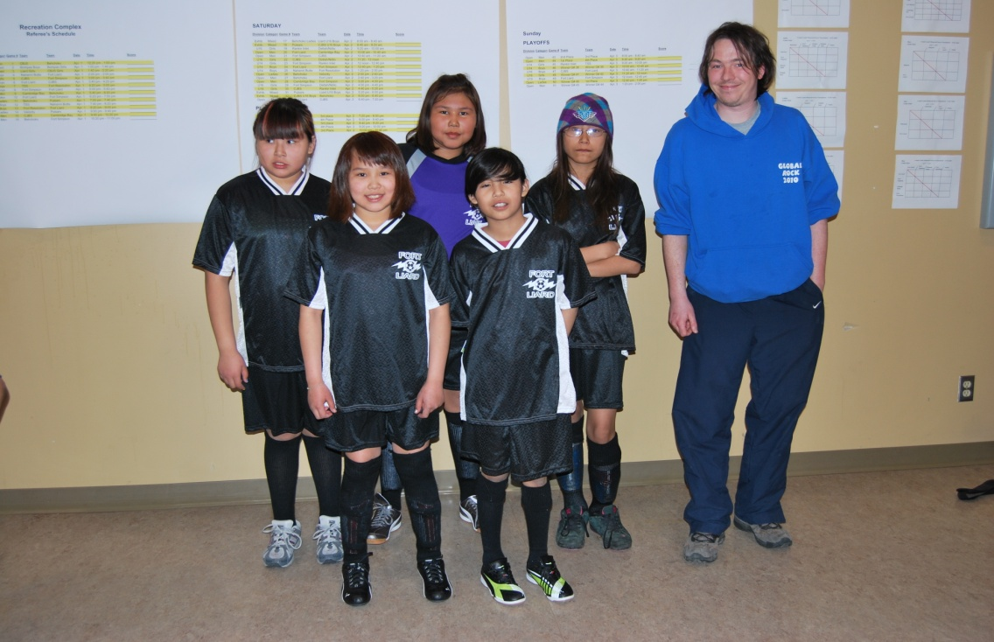

**Soccer teams travel to the Connie Loutit Tournament in Fort Simpson**

26 young Fort Liard soccer players participated in this year’s Connie Loutit tournament, making up U12 boys and girls teams, U14 and U16 boys teams and an Open Men’s team. Everyone played extremely well and all teams came home with medals. Way to go, athletes, we are very proud of you!

Special thanks to soccer coaches Mr. Amprako and Jamie Walls who have dedicated so much of their time to the soccer teams and a big thanks to Catherine Walls for chaperoning on the trip.

All the soccer players are looking forward to participating in the “Rock Around the Clock” soccer tournament in Grande Prairie at the end of April.

**SOCCER TEAMS TRAVEL TO FORT SIMPSON**

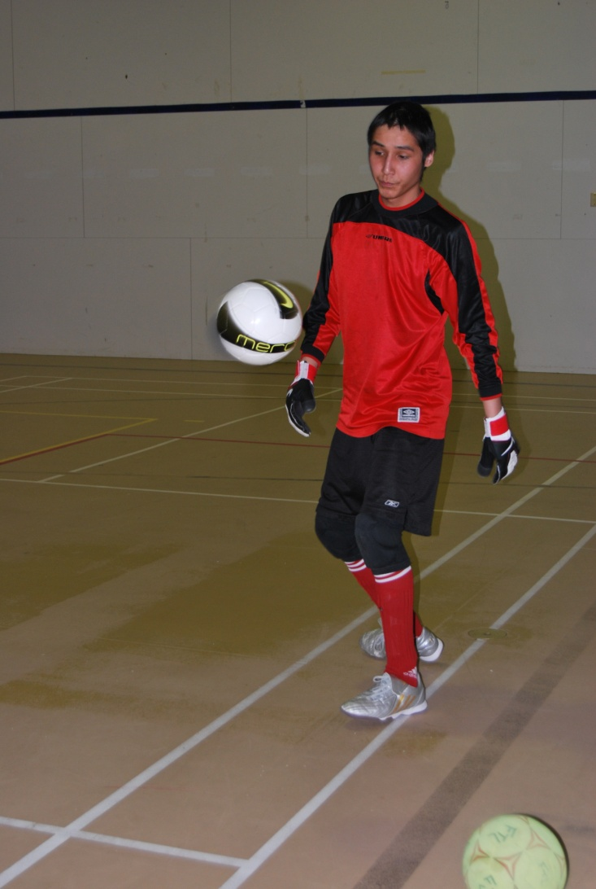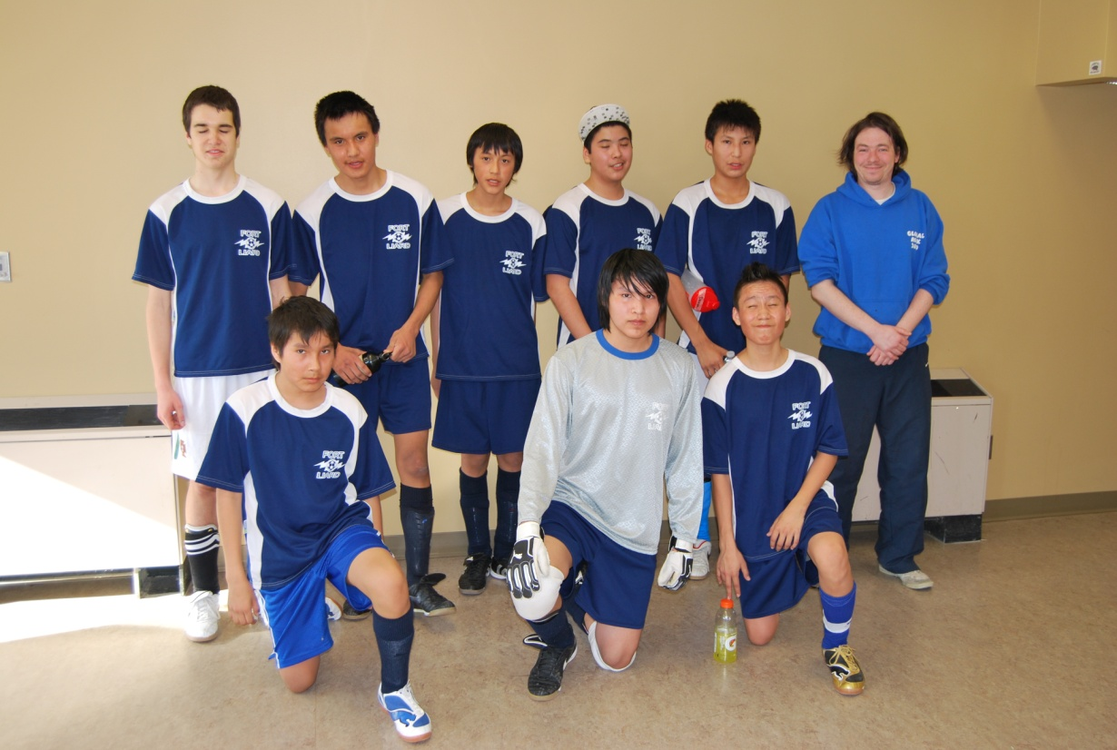

Collin Needlay Tending Goal

Boys’ U16 Soccer Team with coach Jamie Walls

Silver Medalists!

Girls’ U12 Soccer Team with coach Jamie Walls



Happy Belated Birthday!

To Stanley Bertrand and Ricky Edda

Who celebrated their birthdays on April 10th

C:\Documents and Settings\mwr\Local Settings\Temporary Internet Files\Content.IE5\TMAM7XVF\MC900436019[1].wmf

Mammograms for Women over Age 40

The Fort Liard Health Center is setting up two Mammogram trips to Hay River on May 31, 2011 and June 01, 2011.

If it’s time to have your mammogram, call the Health Center @ 4301 to book your appointment.

Spaces for these trips are limited.

Deadline for bookings is May 06, 2011.

RECREATIONAL MIXED VOLLEYBALL

FOR AGES 17 AND OVER

**STARTS THURSDAY APRIL 28TH**

TUESDAYS AND THURSDAYS

8:30 TO 10:00 PM AT THE SCHOOL GYM. NEED INFO?

TALK TO CHERYL BERTRAND.

Community Hall Playgroup

Tuesday and Thursday afternoons at the Community Hall from 2:30 – 3:30, Pre-school aged children are invited to join in the fun!!

Contact the pre-school for more information at 770-4880

**TAKE NOTE...**

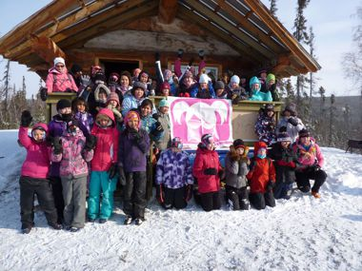

**Angel Kotchea and Mikala McLeod travel to youth empowerment week-end “Fast and Female”**

Along with 44 other girls from nine NT communities, Angel, Mikala, and chaperone Kristen Kotchea attended this exciting week-end in Norman Wells April 8th, 9th and 10th. This unique week-end aimed to inspire and motivate aboriginal girls in cross country skiing. Throughout the weekend, participants had the opportunity to get first hand instruction both on and off snow from former National Ski Team member and NWT athlete, Sarah Daitch and 4-time Olympian, Sharon Firth. Biathalon expert Lindsey Bolivar was also on site with other elite instructors to share their wisdom with the girls.

**YOUTH EMPOWERMENT WEEKEND**

**Be willing to help in an emergency and be willing to work and train to be ready to give that help safely.**

The **#1 goal of any firefighter and all fire departments is fire prevention.** Our fire department can provide many services to our community. Sometimes these services, such as emergency response, investigation, inspection and education are done right alongside other agencies in providing services that are essential to public safety. Fire department support is based on all the agencies working together (RCMP, Nursing Station, Airports, Public Works, Highways, Forestry, Emergency Measure, Social Services, etc.

**The first mission of the fire service is prevention of fire.**

When that fails, the mission of **fire prevention,** the system of **fire operations** begins. There is an emergency! Although it’s called fire

operations it does not mean that the emergency has to be a fire. It could be a vehicle accident, the threat of flood or a medical emergency needing help. **Fire operations could be any emergency situation.**

The **order of goals and tasks** that must be followed and ***followed* SAFELY:**

* **Rescue**
* **Exposure protection**
* **Fire confinement**
* **Fire extinguishment**
* **Salvage and overhaul**
* **Fire cause determination**

**The personal conduct of a fire fighter must that must be followed at all times:**

Common sense should prevail; you must remember to be aware of your conduct at all times. No activity should ever be undertaken that would lower the public’s or elected officials’ respect for the fire service.

These things listed here are not ever acceptable within this department:

* **Reporting for duty under the influence of alcohol or drugs**
* **Horseplay with or around the fire department’s gear and equipment**
* **Profanity – our jobs are not to insult or upset anyone**

Being a member of the fire service can bring a lot of personal reward. To be able to be one of those couple of people that can always be depended on to help in an emergency. But it also means being willing to sacrifice some of your free time on a pretty regular basis. A group of people must learn to work together as a team to be successful in helping in an emergency. This means donating about 3 hours a week to training on the different skills needed and more importantly training together as the team that could be using them.

**FIREFIGHTERS BASICS**

The group of participants in Norman Wells at the “Fast and Female” youth empowerment weekend.

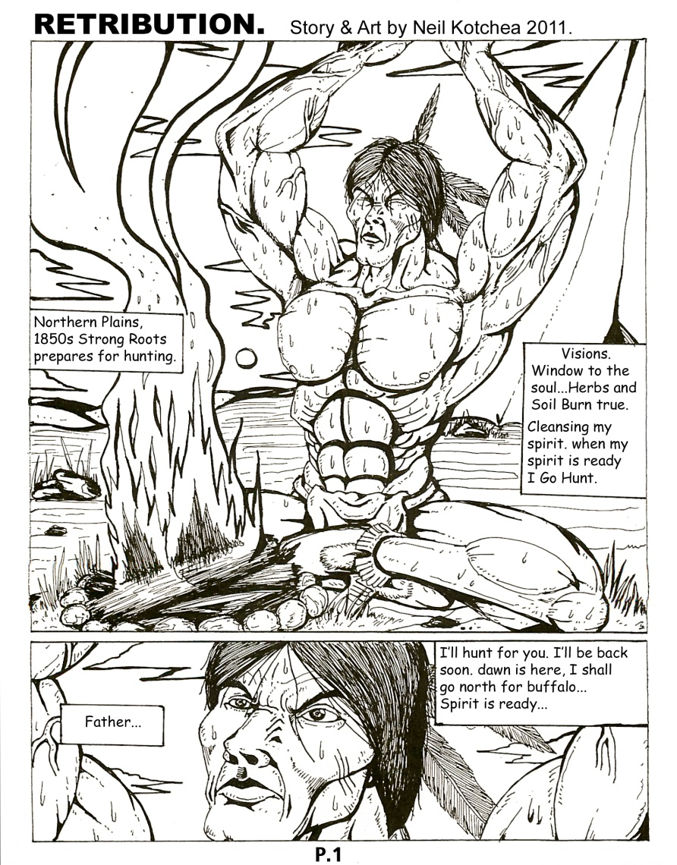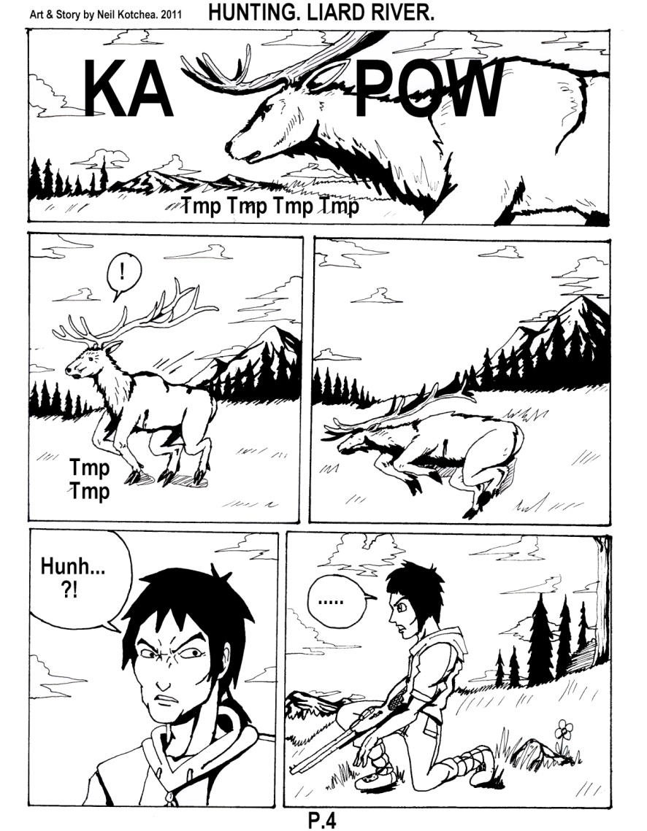

**LOCAL TALENT *Support your Local Artist!!***

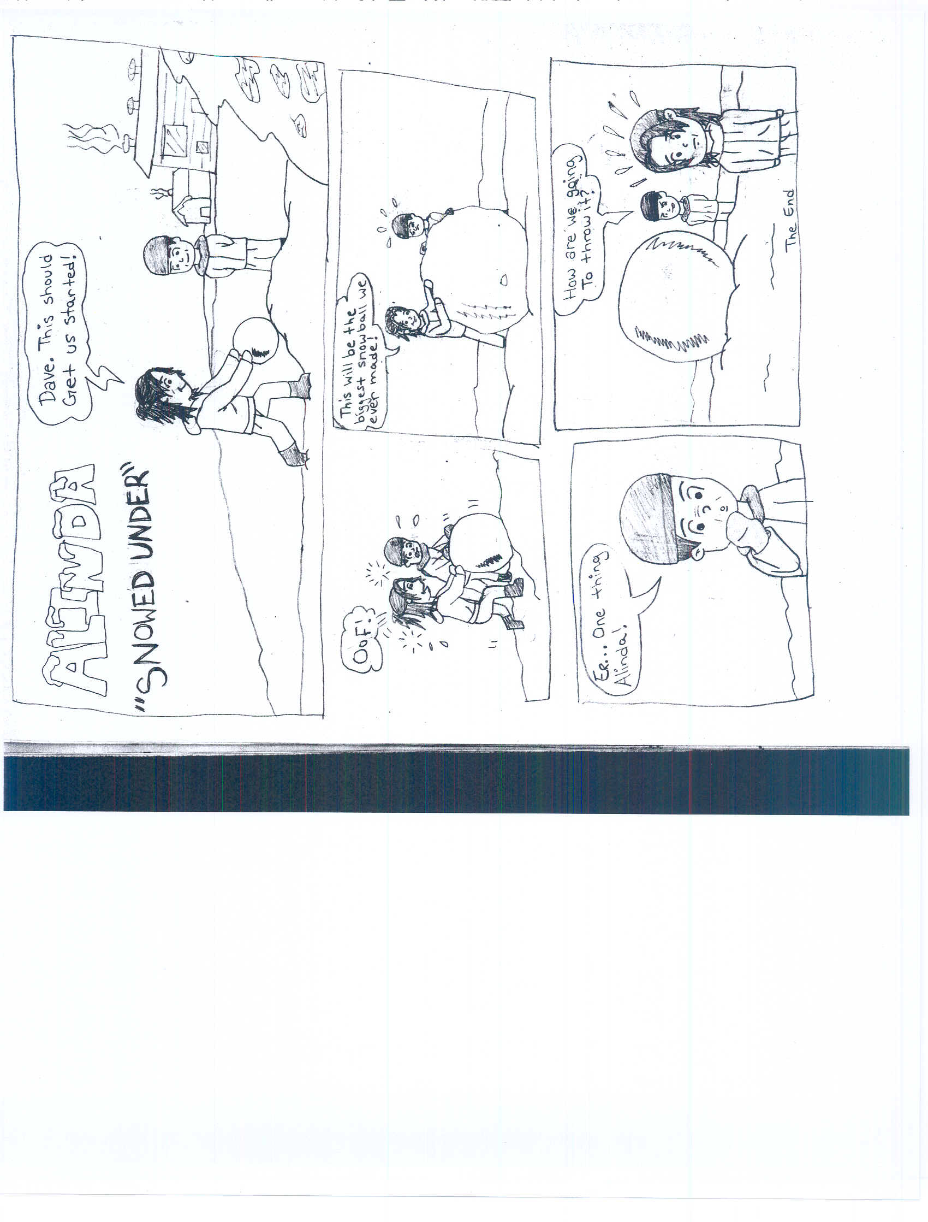

July 1st - 3rd 2011

For more information visit:

www.openskyfestival.ca

**Application Deadline: May 15th, 2011**

Below: Comic by Alinda Edda

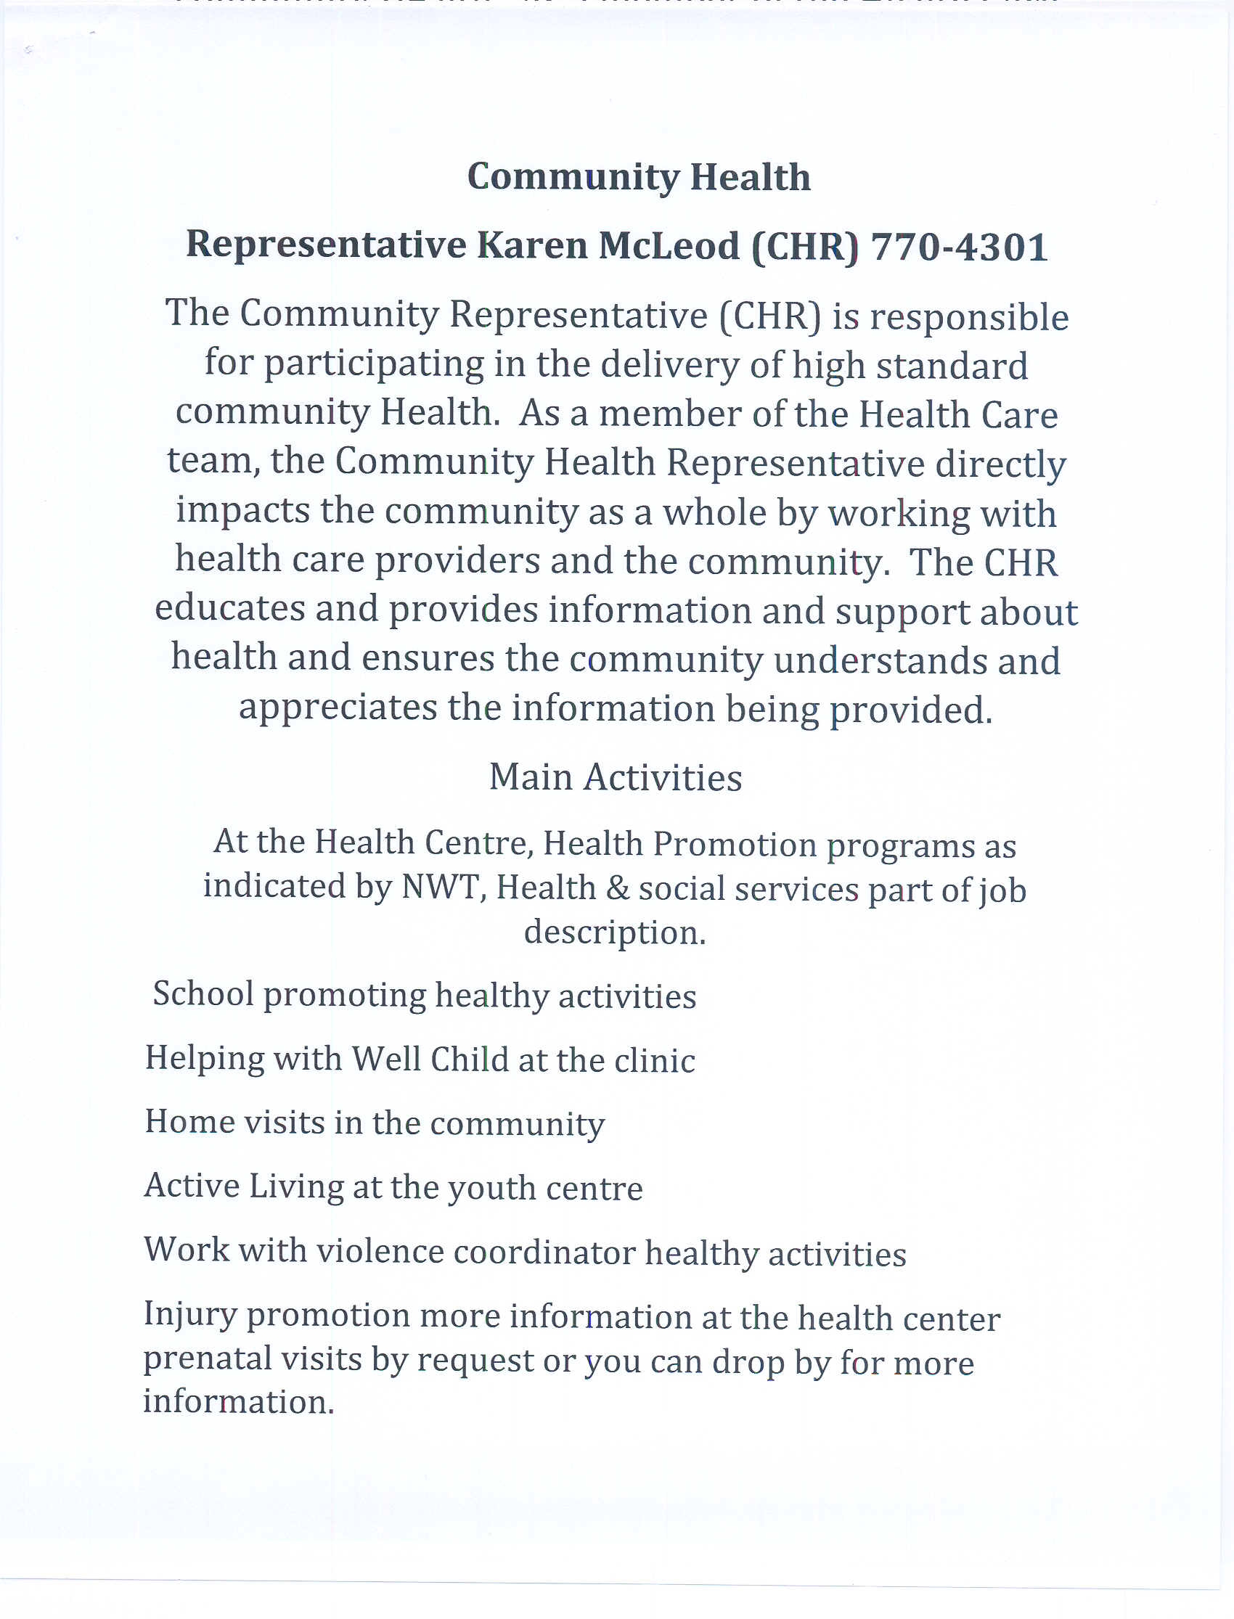

**COMMUNITY HEALTH**





**Break up**

What will your Fire Department be doing during breakup?

We will be doing river watch 24 hours a day. This is to provide warning if something should happen in the day or night. If high water looks certain, please untie your dogs so they don’t drown tied to their house or the trees.

If the river is broken up and there is high water in town, we will be barricading the flooded area and expect the community to respect the barricades. They are there for the safety of the public, and to minimize the damage to the road.

We will be visiting all the homes especially the homes of Elders to ensure they are safe and have a plan to leave if they need to. We would like to know who will be in town during the breakup, so if something should happen we

All COMMUNITY MEMBERS

Tuesday April 26 2:30 pm

SIREN WARNINGS TEST

ONE SHORT SIREN – WATER IS TO THE TOP OF THE RIVER BANK

TWO SHORT SIRENS – MOVE ITEMS FROM BASEMENT OR TO HIGHER GROUND

THREE SHORT SIRENS– THE COMMUNITY WILL BE EVACUATED

CONTINOUS BLAST - FIRE

**THE WORD FROM THE FIRE HALL**

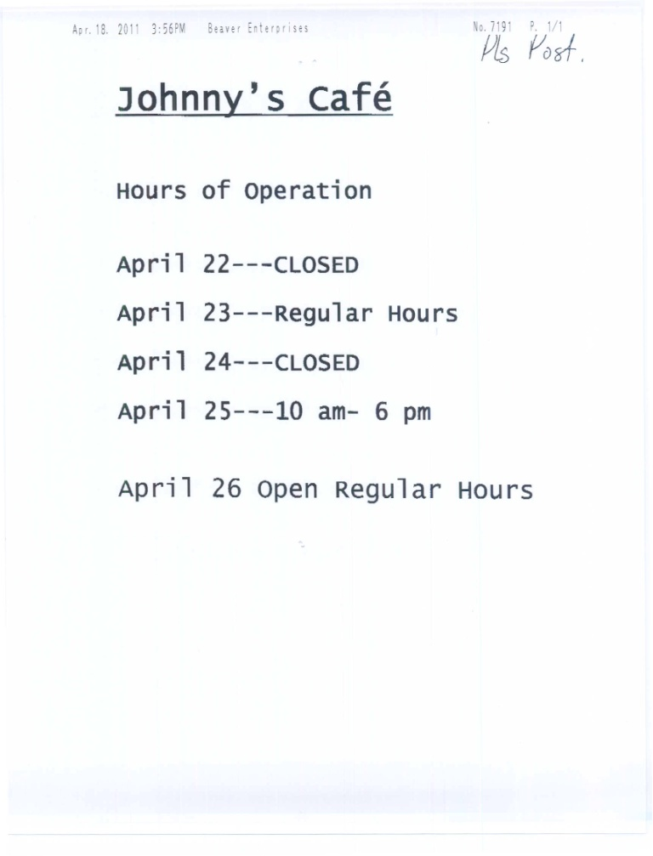

Have a Safe and Happy Easter Everyone!!

**FINAL NOTE...**

**S.A.F.E Smoke Alarms for Everyone**

The Fire Department will be working hard to make sure you have a new working Smoke Detector in your house. If we missed you please call the Fire Department 770 4104 and let us know. You can also pick up a Smoke Detector at the Fire Hall.

**Remember Smoke Alarms are a sound you can live with!**

**If you have ever thought of joining the Fort Liard Fire Department Call Robert 770 4104 come down to the Fire Hall and have a coffee. All we ask is you to be minimum of 18 male or female and willing. We will take care of the rest.**

**Mahsi**

aren’t looking for someone who was never there.

We will be testing the warning siren April 26th at 2;30 pm, one short, 2 short and 3 short sirens. This is to ensure it works and so everyone who has recently moved here knows what they sound like and what they mean.

Please don’t be drinking and paddling or poling around any flooded areas in town because if you fall in we will have to come and get you, we don’t want anyone risking your life or the firefighters because of silly behavior.

The water will kill you in less than 3 minutes if you aren’t wearing a lifejacket. If you need to boat somewhere please wear a lifejacket.

We will be practicing this Saturday April 23rd at 1130 am .

Stay safe everyone.

Our children need a new play, and we adults can become active participants in the total rewrite. However, before we can begin this change, we need to analyze and understand the original tragedy of why is bullying being done in our community.

The bullied does whatever it takes to get rid of the pain. The pent-up rage may explode into violent aggression – against the bully – those who appeared to help the bullying – those who stood by and did nothing – or the adults who failed to protect them. These tragedies have run far too long within this community.

Lewis P. Lipsitt put it this way: CAN WE NOT TEACH CHILDREN, even as we protect them from victimization, that for them to become victimizers constitutes the GREATEST PERIL OF ALL, SPECIFICALLY THE SACRIFICE – PHYSICAL AND PSYCHOLOGICAL – of the well-being of other people? And that destroying the life and safety of other people, through teasing, bullying, hitting, or otherwise “putting them down” is as destructive to themselves as to their victims.

To be continued in the next newsletter...

afraid to tell; bystanders who either watch, participate in the bullying, or look away; and adults who discount bullying as just teasing – not the tormenting that it really is.

Bullying is a learned behaviour. If it can be learned, it can be examined, and it can be changed. Herman Melville once said, “We cannot live only for ourselves. A thousand fibres connect us with our fellow men; and among these fibres, as sympathetic threads, our actions run as causes, and they come back to us as effects. When the dignity and safety of an individual is assaulted, the dignity and fabric of the community as a whole is diminished.”

The idea that being excluded, shunned ridiculed, ostracized, and physically assaulted by the bullying faction merits vengeance and violence is but one of those self-degrading ideas that we embrace, creating a cure that is worse than the disease itself.

Once we understand the roles of – the person bullying – the person bullied – and the person observing – the goal is to gain understanding of these roles and how interactions involved in such roles are NOT HEALTHY, NOT NORMAL, and certainly NOT NECESSARY. Once these roles are understood we can re-channel the governing – or controlling behaviour of the bully positively into leadership activities. The role of the bystander can be transformed into that of a witness: someone willing to stand up, speak out, and act against injustice.

Another note from a concerned parent, one Jack Yeadon

My dear friends;

Once again I have decided to speak out. Recently my children have brought it to my attention there are problems within our school and therefore our community that cannot be ignored. As a parent blessed with the responsibility of raising youngsters to be honest, helpful and kind towards others, I choose to believe the goodness we accomplish ought to be measured by what we embrace, what we create, and who we include.

Bullying is about CONTEMPT... meaning the feeling one has towards another considered low, worthless... the condition of being despised... HATRED in fact. Bullying is a life-and-death issue that we ignore at GREAT DANGER... to our children... to ourselves... to the FUTURE of our community.

Children who are bullied spend a lot of time dreaming of ways to avoid the trauma... thus having less energy left for learning. Others who are bullied often resort to rage and/or violence to get the bully off their back. Breaking the cycle of violence involves more than merely identifying and stopping the bully (or bullies). It requires that we examine the why and the how a child becomes a bully or a target of a bully as well as the role bystanders play in perpetuating this cycle of violence. A DEADLY combination is a bully who gets what he or she wants from the target – a bullied child who is

**LETTER FROM A CONCERNED PARENT (Part 1 of 2)**