FDFSDF

**A SAD DAY FOR THE 30 CHILDREN WHO ARE IN THE CROSS COUNTRY SKI CLUB**

**A NOTE OF RECOGNITION**

This is the 4th year Ft. Liard youth have been involved in cross country skiing. They spend many happy hours on skis all through winter, a fun and healthy activity for them. Two years ago the club built a warming hut just off the trail to 9 Mile and the children really enjoyed ski excursions out there. The Northern Store generously donated a wood stove for our hut and we had a stock of wood, fire starter etc to help everyone stay warm. We are sorry to say that when we went out to the hut last week this is what we found…

Yes, a totally empty hut.

Someone has stolen our stove, wood and fire starter. **We hope this person is ashamed of** **themselves** and if you see this notice and will return our property to the hut.

Al Harris, Manager of Municipal Operations for the Hamlet recently attended the annual meeting of the Northern Territorial Water and Waste Association in Iqualuit, Nunavut. Communities from NWT and Nunavut were in attendance and Al gave a presentation on the recent upgrades to Fort Liard’s water plant and on our new solid waste site. Water from all communities that attended this conference was tested and Ft. Liard won 3rd place for water quality. An excellent standing considering the number of communities in the North!

Al has been elected to the position of Vice-President of the Association Board.

**We appreciate the hard work of all Hamlet municipal services workers!**

Merry Christmas, guys!

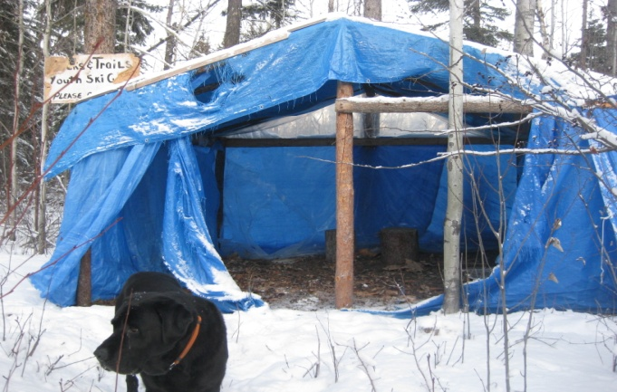

A big thank you to Deb Wotherspoon for donating Wii games to the Youth Centre!

C:\Documents and Settings\mwr\Local Settings\Temporary Internet Files\Content.IE5\W59S7BN7\MC900437581[1].wmf

To Lucienne D. on December

5th and to Laura D. on

December 18th.

“A Happy Birthday from the Staff

at the Health Center”



**Notice:** Home Care Workers Barbara McLeod & Shirley J. will be off work for the holidays starting on December 22nd. Please make sure you have enough meds until after the New Year!

**COMING UP…**

There will be an Elders Christmas Potluck Dinner on

**Saturday, December 17th at the Community Hall from 3 – 6 p.m.**

Any donations are welcome

Organized by: Home Care Workers Barb & Shirley

(Rides will be available if needed)

Drummers needed for youth hand games

A number of young people are learning hand games at the community hall on Tuesdays from 7 to 8 p.m.

We really need drummers for these games and to teach drumming to the youth. If you are available please come out and help to pass on these traditions.

Mahsi cho

Acho Dene Koe First Nation offices will be closed for the holidays from Dec. 16th to

January 3rd.

HAVE A SAFE, MERRY CHRISTMAS AND A HAPPY NEW YEAR!

C:\Documents and Settings\mwr\Local Settings\Temporary Internet Files\Content.IE5\W59S7BN7\MC900413714[1].wmf

**SMOKE SIGNALS**

Please call me at the Fire Hall or leave your name at the Hamlet Office. I need to know who you are and what years you served. We don’t want to miss anyone. If you know someone call me, if it’s you, call me.

If you have ever thought of joining the Fort Liard Fire Department Call Robert 770 4104 come down to the Fire Hall and have a coffee. All we ask is you to be minimum of 18 male or female and willing. We will take care of the rest.

Mahsi

Have a safe and fun Christmas…

In the New Year the Fire Department will be hosting a celebration to recognize our present and past firefighters.

There will be a Community Dinner, awards, and a dance with Eric Ashdown and his new 5 piece old time fiddle band. Posters will be around town in the next 2 months.

We need to know everyone who has been on the Fire Department in Fort Liard since Fort Liard has had a Fire Department . I know you are out there , its time you were recognized for your service.

Christmas is almost here… that means fun, visiting, parties, and drinking too much. The last thing you want to happen is for someone to burn their house or someone else’s house, or your house down by passing out with a cigarette. In fact, the house doesn’t have to burn down to kill you; smoke will kill your family long before the house burns.

It would be a lot better to have Santa Claus visit your house than the Fire Department… we don’t say Ho! Ho ! Ho !

There has been far too much tragedy in Fort Liard this past year. Let’s not create more.



**SCHOOL ATTENDANCE AWARDS**

|  |  |  |  |  |  |  |
| --- | --- | --- | --- | --- | --- | --- |
| **Grade K / 1 Class** |  |  |  | **Grade 7 / 8 Class** |  |  |
| Conrad Sassie |  | 97% |  | Ian Berreault |  | 100% |
|  |  |  |  | Keith Nelson |  | 100% |
| **Grade 1 / 2 Class** |  |  |  | Michael Bertrand-Sassie |  | 100% |
| Lorissa Berreault |  | 100% |  | Nathaniel Lomen |  | 97% |
| Lynden Deneron |  | 95% |  |  |  |  |
|  |  |  |  |  |  |  |
|  |  |  |  | **Grade 9 / 10 Class** |  |  |
| **Grade 2 / 3 Class** |  |  |  | Alinda Edda |  | 100% |
| Chantel McLeod |  | 100% |  | Emily Amprako |  | 100% |
| Keanna McLeod |  | 97% |  | Kaitlin Nelson |  | 100% |
| Chase Berreault |  | 97% |  |  |  |  |
| Ariana Timbre |  | 97% |  |  |  |  |
|  |  |  |  |  |  |  |
|  |  |  |  |  |  |  |
| **Grade 4 / 5 Class** |  |  |  |  |  |  |
| Leona Berreault |  | 100% |  |  |  |  |
| Jordan Hikomak-Nelson |  | 100% |  |  |  |  |
| Charlene Bertrand |  | 95% |  |  |  |  |
| Angus Capot-Blanc |  | 95% |  |  |  |  |
| Dallas Sassie |  | 95% |  |  |  |  |
| Hailey Sassie |  | 95% |  |  |  |  |
| Wyatt McLeod |  | 95% |  |  |  |  |
|  |  |  |  |  |  |  |
| **Grade 6 Class** |  |  |  |  |  |  |
| Laura Nelson |  | 100% |  |  |  |  |
| Katrina Emmons |  | 100% |  |  |  |  |
| Tyler Bertrand |  | 100% |  |  |  |  |

*ATTENDANCE RECOGNITION for NOVEMBER*

*Students who maintain a high level of attendance at school are recognized every month at an assembly. Next month’s assembly will be on the afternoon of Wednesday, January 4th to recognize those students who had a high attendance for the month of November. Parents are encouraged to attend!!*



The Echo Dene School will be hosting its annual Christmas Concert on

**Thursday, December 15th at 7:00 p.m. in the School Gym**

**PARENT AND TOTS PLAYGROUP HAS STARTED UP!**

Yes, there is play time in the community hall with lots of toys and fun activities available for babies and toddlers (up to 3 years of age).

Moms, Dads, Grandparents and Caregivers are all welcome to bring children in for some healthy activity and social time.

**Every Tuesday and Thursday from 11 a.m. to 1 p.m. at the Community Hall**

**Lunch/Snacks are provided!!!**

**Library Hours of Operation**

Monday 4 P.M. to 5:45 P.M.

Tuesday 4 P.M. to 5:45 P.M. and ***6:30 to 8 P.M. ADULTS ONLY***

Wednesday 4 P.M. to 5:45 P.M.

Thursday 4 P.M. to 5:45 P.M. and ***6:30 to 8 P.M. ADULTS ONLY***

Friday 4 P.M. to 5:45 P.M.

C:\Documents and Settings\mwr\Local Settings\Temporary Internet Files\Content.IE5\D79RWD15\MC900322449[1].wmfIf you are interested in learning traditional sewing, classes are being held on Mondays, Tuesdays and Wednesdays from 6 to 9 P.M. at the preschool. Lucy Bertrand is teaching the classes. If you have any questions please contact the band office at 770-4104 ext .119

**COMING UP…**

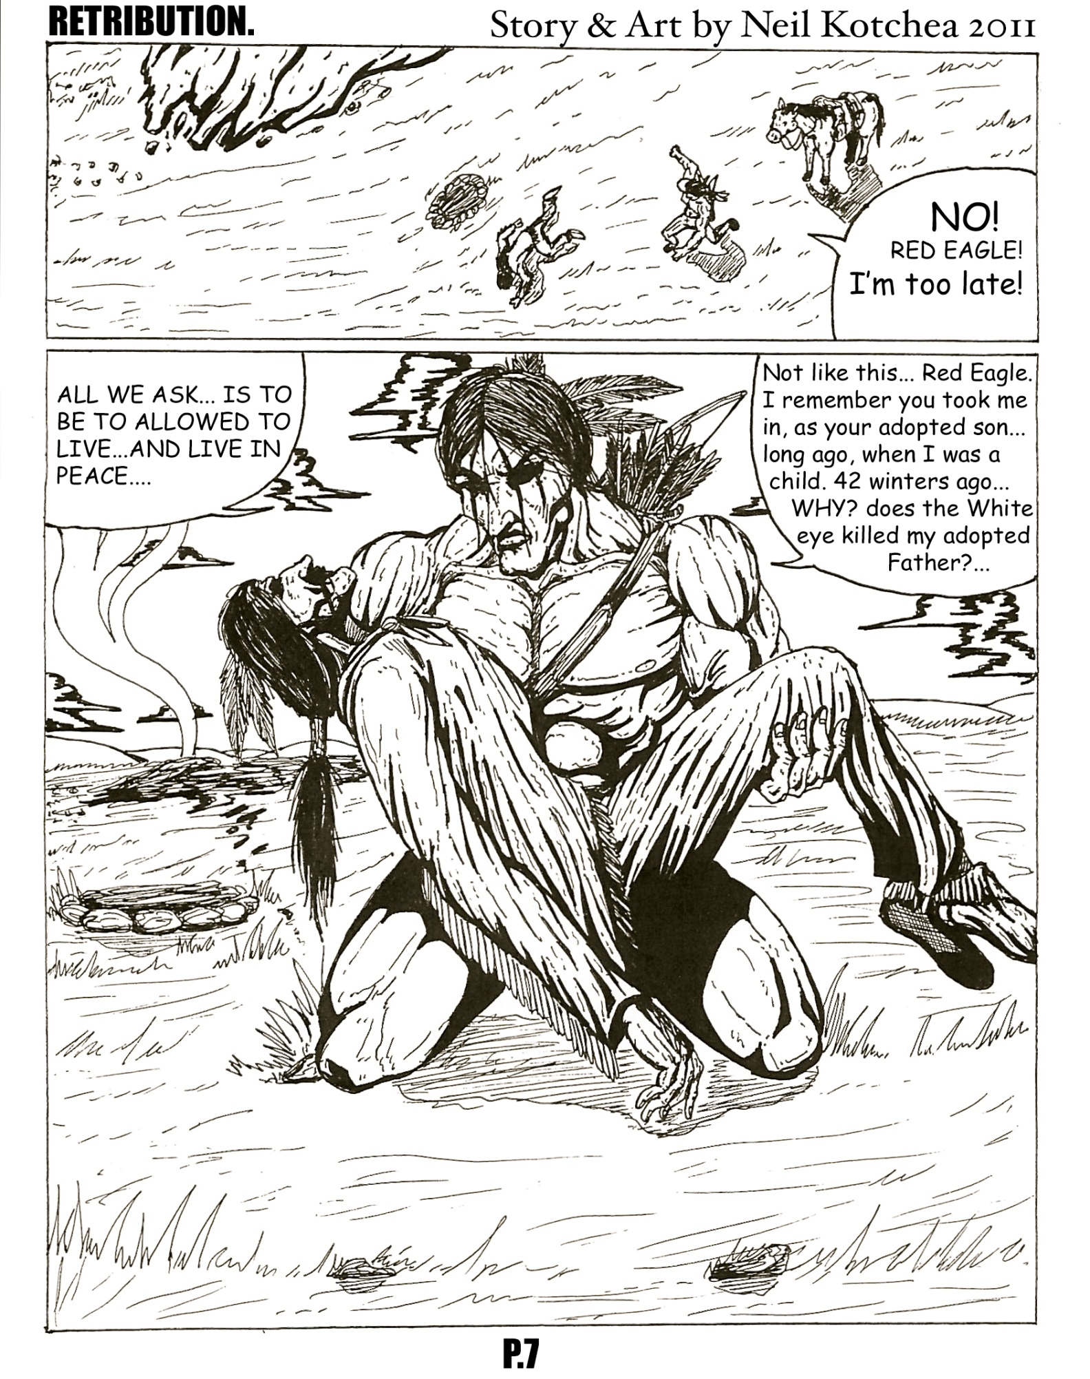

**COMIC BY NEIL KOTCHEA, P.6**

**THE CORONER’S CHRISTMAS WISH**



**My wish is for everyone to be safe this Christmas. I wish for no one to lose their life needlessly because they drove drunk, passed out outside and froze to death, were assaulted, assaulted someone else, committed suicide, alcohol poisoned themselves or for any other reason.**

**Just because they were trying to have a good time at Christmas... My wish is for people to look after themselves and each other so I don’t have to…**

**Mahsi**

**The Coroner…**

C:\Documents and Settings\mwr\Local Settings\Temporary Internet Files\Content.IE5\W59S7BN7\MC900116470[1].wmf

**DECEMBER 21ST WILL BE A VERY SPECIAL DAY FOR THE WHOLE COMMUNITY**

**1:30 P.M.**  Santa arrives by helicopter at the Community Hall with presents for every boy and girl aged 10 and under.

**6:30 P.M.** Community Feast and drum dance

with drummers from meander river

**COMING UP FOR CHRISTMAS…**

**TAKE NOTE…**



**Rosemary Gill, Career Development Officer will be in Fort Liard, Tuesday January 10th to Thursday, January 12th, 2012. Please call (867) 770-4104 – Ext. 106 for appointment.**

**Rosemary could assist with the following:**

**Career Planning, Resume Writing, Job Search, Educational Planning, Student Financial Assistance and Program Planning/Funding.**

**HOLIDAY HOURS - HOUSING/INCOME ASSISTANCE**

**j0424084DEC. 23th - 09:00 A.M. TO 12:00 NOON**

**DEC. 26th, 27th - CLOSED**

**DEC. 28th, 29th, 30th - REGULAR HOURS**

**JAN. 02nd - CLOSED**

**JAN. 03rd - REGULAR HOURS**

PLEASE KEEP ACCESS TO POWER METER AND FUEL TANK CLEARED TO ALLOW FOR FUEL DELIVERY AND FOR PROPER METER READING.

MC900030226[1]

**HOLIDAY FIRE SAFETY TIPS**

MC900059854[1]MC900059854[1]

* **When using a live tree, be sure the tree is fresh. The tree should not lose needles when tapped on ground. Keep stand filled with water at all times.**
* **Please be sure to place your tree away from radiators and doorways.**
* **Check each strand of lights for broken or cracked sockets, frayed or bare wires, or loose connections. Discard any damaged sets.**
* **Use no more than 3 standard size sets of lights per single extension cord.**
* **Do not use lights designated as “indoor” when decorating the exterior of your home.**
* **Turn off all lights before going to bed or leaving the house.**
* **Be extremely cautious when burning candles. Never leave them burning unattended.**
* **Take special care to avoid using decorations that could be swallowed by small children.**

"*Christmas is most truly Christmas when we celebrate it by giving the light of love to those who need it most."*

HAPPY HOLIDAYS!



