**WHAT’S NEW AT THE HAMLET?**

**Parent & Child Craft Night:** Every Thursday Evening from 6 – 7 pm there will be a craft night at the Library, featuring a different seasonal craft each week.

**Playgroup:** Every Tuesday morning from 10:30 – 11:30 and every Thursday afternoon from 2:30 – 3:30, join in the fun with your child at the Community Hall. There are lots of toys and children can interact with each other and their parents/guardians. A snack is provided.

**Community Calendar:** At the end of each month, a calendar highlighting activities and events available for community members will be posted. If there are any events you would like advertised in the Community Calendar please contact Christine Boyde at christineboyde@hotmail.ca. The calendar will also be posted on the front page of the community website, www.fortliard.com.

**Community Newsletter:** Once a month, this newsletter is released to share news and events with the community. Watch for signs around town that the newsletter is to be released and contact Roslyn at the Hamlet Office (mwr@fortliard.com or 770-4104 ext. 106). The newsletter is also available on the community website at www.fortliard.com/newsandevents.htm.

**Community Library:** In case you didn’t already know, the Community Library has moved to the Hamlet Office! Along with the move the Library acquired a lot of new books and DVDs, all you have to do to borrow them is to come in and get a library card! Public computers are also available for use at 15 minute intervals and there is Wireless Internet in the Library. Library Hours are posted on page 5. Along with library upgrades was the addition of a couple of programs:

**Adult Writing Workshop:** Every Wednesday evening from 6 – 7 pm Jennifer and Ollie will be available in the library to give assistance with any writing you are trying to do. This includes resumes, letters, e-mails, stories, etc.

**Family Literacy Night:** A Family Literacy Night will take place at the Library every Wednesday evening from 7 – 8 pm. Jennifer and Ollie will have a new theme each week.

**Hamlet Office Sign:** At the front of the Hamlet Office there is a digital sign that displays public notices and community event information. Check out the sign as you’re going by to see what’s going on in the community. Also, look out for a bigger sign to be coming soon!

**IMPORTANT! If you know anyone in the Community who needs translation please share with them what’s going on in Fort Liard!**

There are many things going on at the Hamlet Office these days, and we want you to take full advantage of new opportunities!

**Website:** The community website has recently been reorganized for easier access to community news and event information. Some areas of the website are still under development. If you have anything to add to the website, or any suggestions to make please don’t hesitate to contact Christine Boyde at christineboyde@hotmail.ca. The website address is www.fortliard.com.

**Facebook Page:** The Hamlet’s Beaver Volunteers, Jennifer and Ollie, have put together a Facebook Page to advertise Fort Liard’s news and events. Check it out at facebook.com/fortliard.

On the Inside:

Pg. 2 Community Events

School Crest Competition

Pg. 3 Smoke Signals

Pg. 4 The Path to a Healthy Life

Pg. 5 Classifieds

Take Note…

Pg. 6 & 7 Information about the Flu Shot

Pg. 8 Hallowe’en Safety Tips

Pg. 9 Employment Opportunities

Pg. 10 Community Calendar



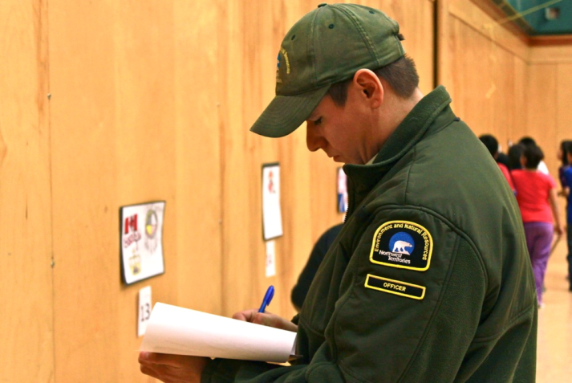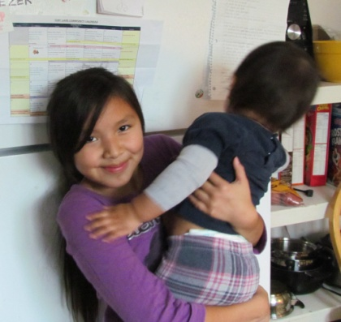

The young artists eagerly await the judges’ final decision, particularly since the grand-prize winner will receive an iPad.

**YOUNG ARTISTS COMPETE TO DESIGN NEW SCHOOL CREST**

Artwork lined the Echo Dene School walls in late October as students competed to have their drawings chosen as the new official school crest.

All 29 entries included images representing the Crown, Canada and First Nations culture, and the judges - all local Fort Liard residents - deliberated for over an hour before narrowing the field to a handful of finalists.

**SCHOOL CREST COMPETITION**

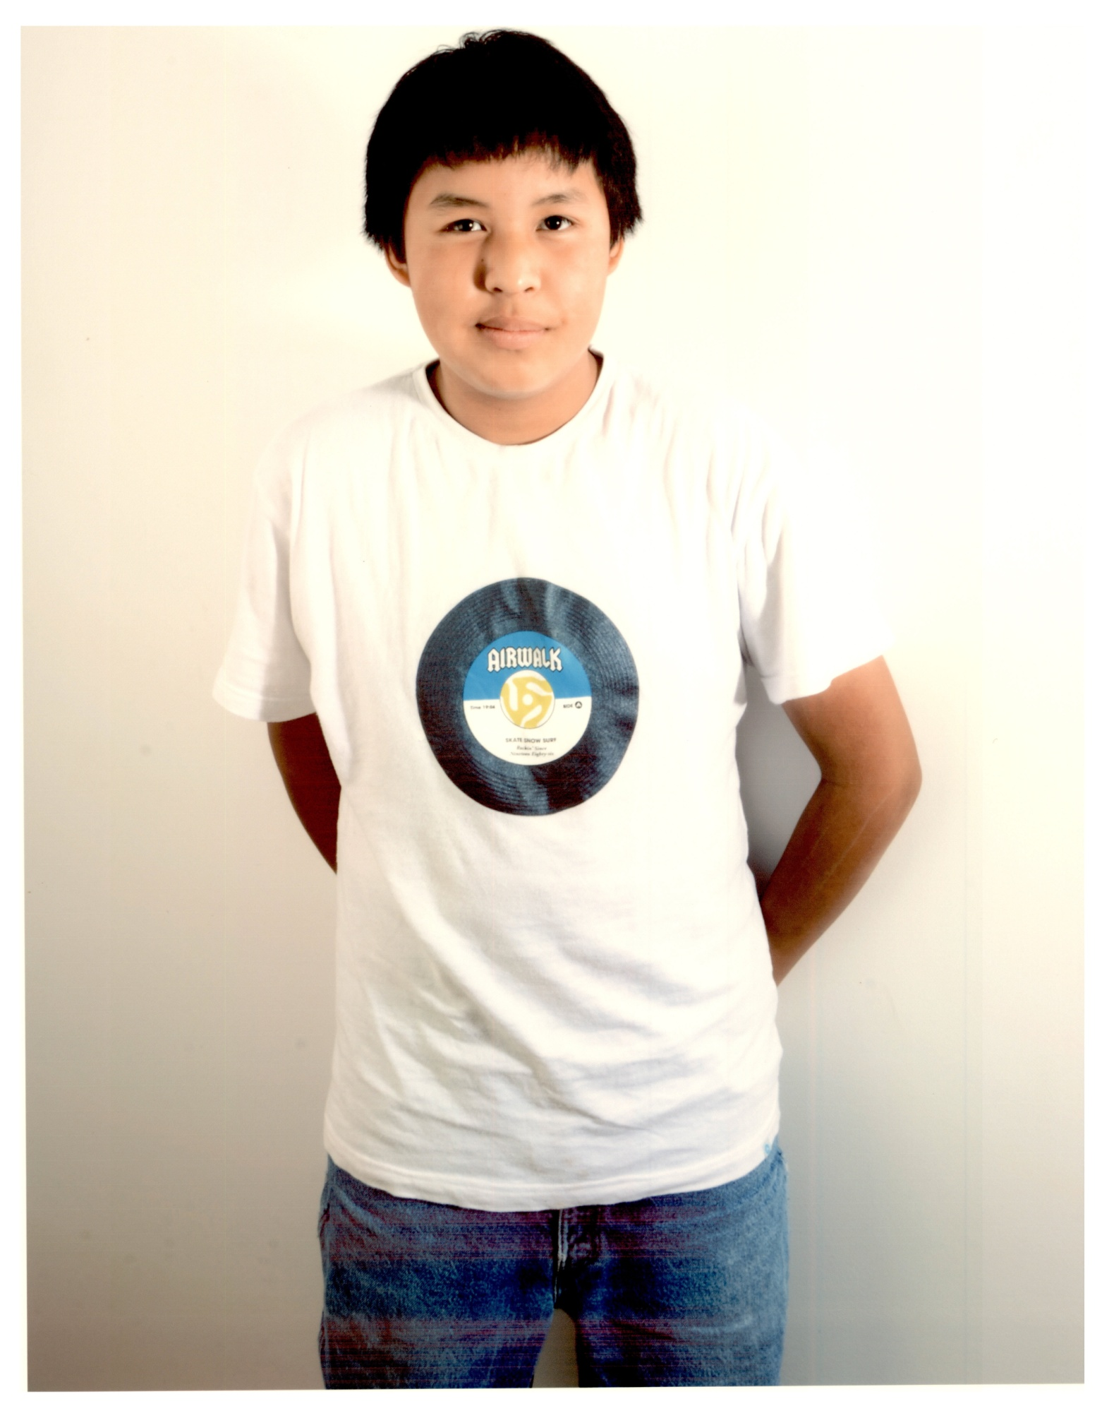



Happy birthday to Haley

October 22nd!

**CHECK IT OUT! (Community News and Upcoming Events)**

**SMOKE SIGNALS**

Put a plan together with your family to get out if there ever was a fire in your home .Do your kids know 2 places to get out?

Smoke alarms won’t save lives if the battery is dead, covered with a plastic bag or disconnected. Furnace rooms need space around the furnace for air and shouldn’t be used for storage. The Fire Department will come and check your smoke detectors, and install a new one and do a quick safety inspection. Call 770 4104.

**Mahsi…**

Echo Dene Koe School allows each Junior Fire fighter to earn High School Credits by attending the Junior Fire Fighter program. The Fire Department will work with the school so you can earn credits for your contribution to the community and training time.

Fire Prevention is a year round job. This is an opportunity to make your family and homes safe from fires, check your smoke alarms, batteries, chimneys. When was the last time your chimney was cleaned?

Clean out any old stuff stored in your basement or furnace room.

Congratulations, four households recently installed 2 or more Smoke Detectors in their homes. If you have kids in the house you NEED to have working smoke alarms in the house. We have new Smoke Alarms and will install them in your house for **Free**.

Ross Duntra, Terrance Kotchea, Brent Kotchea, Tina Bertrand have joined the Fire Department as Junior Fire Fighters. We still need 2 more to join us. It would be nice if 2 girls were to join Tina on the Fire Department. Way to go kids!

** SMOKE SIGNALS**

**PUT IN A FREE SMOKE ALARM**

**SMOKE ALARMS SAVE LIVES- most fatal fires happen at night when people are asleep, Often they never wake up. A working smoke alarm will smell smoke and sound an alarm to wake you up, giving you and your family time to escape.**

**GET THE BEST ALARM – an alarm like we give out at the Fire Hall has a button to turn off alarms due to cooking or cigarette smoke.**

**ONE ALARM IS NOT ENOUGH- install a smoke alarm in each bedroom in every level of your house.**

**WHERE TO PUT THEM? – smoke rises; put your alarm on your ceiling. Don’t put them near bathrooms, heating appliances, windows or ceiling fans.**

**TEST YOUR ALARM THIS WEEK AND EVERY MONTH - Push the test button, -- if it doesn’t beep it needs a new battery.**

**CLEAN THE DUST FROM YOUR ALARM –with a soft brush or vacuum cleaner.**

**SMOKE ALARMS DON’T LAST FOREVER – Every 10 years get a new one.**

**PLAN YOUR ESCAPE –make sure your family knows what to do if a fire occurs- get out and stay out!**

**The Fire Department has Smoke Alarms to give away; we will install them and check your existing alarm.**

**Mahsi**

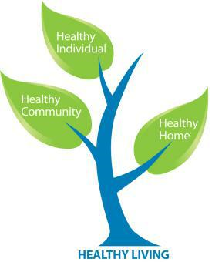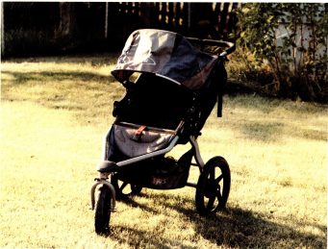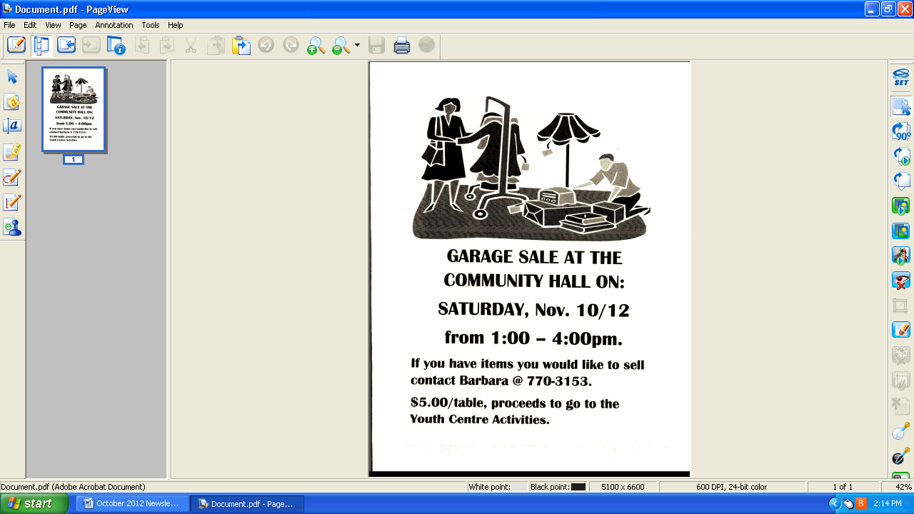

***Children***

*If children live with* ***Criticism,*** *they learn to* ***Condemn.***

*If children live with* ***Hostility,*** *they learn to* ***Fight.***

*If children live with* ***Fear,*** *they learn to be* ***Apprehensive.***

*If children live with* ***Pity,*** *they learn to feel sorry for* ***Themselves.***

*If children live with* ***Ridicule,*** *they learn to feel* ***Shy.***

*If children live with* ***Jealousy,*** *they learn to feel* ***Envy.***

*If children live with* ***Shame,*** *they learn to feel* ***Guilty.***

*If children live with* ***Encouragement,*** *they learn* ***Confidence.***

*If children live with* ***Tolerance,*** *they learn* ***Patience.***

*If children live with* ***Praise,*** *they learn* ***Appreciation.***

*If children live with* ***Acceptance,*** *they learn to* ***Love.***

*If children live with* ***Approval,*** *they learn to help* ***Themselves.***

*If children live with* ***Recognition,*** *they learn it is* ***Good*** *to have a* ***Goal.***

*If children live with* ***Sharing,*** *they learn* ***Generosity.***

*If children live with* ***Honesty,*** *they learn* ***Truthfulness.***

*If children live with* ***Fairness,*** *they learn* ***Justice.***

*If children live with* ***Kindness*** *and* ***Consideration,*** *they learn* ***Respect.***

*If children live with* ***Security,*** *they learn to have* ***Faith*** *in* ***Themselves*** *and* ***Family.***

*If children live with* ***Friendliness,***

*they learn the world is a nice*

*place in which to* ***Live.***

* *Author Unknown*

**Impacts of**

**...Family Violence**

A violent parent cannot simultaneously be a good parent. Just by virtue of abusing their mother, an abusive father is not a responsible parent. Whether he intends to or not, his abuse/disrespect of their mother negatively affects the children. It is impossible for children to be unaware of their fathers' core attitude toward their mother: he is role-modeling how to treat their mother and others.

The welfare of children is strongly linked to the physical and emotional safety of the non-offending parent.

**Impact on Children and Teens**

Not all children who witness abuse grow up to be abused or become abusive, especially if they have a positive role model to follow. This could be a grandparent, a teacher, family of friends. However, exposure to family violence does have a dramatic effect on children.

Children exposed to family violence can be affected as much as the individual experiencing the abuse. Some parents hope that if their children do not see the violence, it will not harm them. Others think they can protect their kids from the impact of abuse. But abuse harms children even if they are not consciously aware of the violence or if they are in a different room when it happens.

Exposure to anger and abuse can affect a child's brain development, emotional well-being and their ability to connect with others and make friends. Children exposed to family violence are more likely to be bullies or be bullied. They are also at greater risk of growing up to be abusive to others, to be abused or both. If a parent stays in an abusive situation, children learn there are few or no consequences for violent behavior. Children may grow up to abuse their partners or others and may accept violence in relationship because they consider violence to be a normal part of a relationship.

SKIN: Alcohol increases blood flow to the skin, making you feel warm and look flushed. It also dehydrates, increasing the appearance of fine lines. According to Dr Nicholas Perricone, a dermatologist, even five units will lead to an unhealthy appearance for days.

**Next Newsletter: Part 3 - 11pm 10 Units: Sorry, what was your name again?**

**WHAT ALCOHOL *REALLY* DOES TO YOUR BODY… PART 2**

**8pm Five Units: Whose round is it then?**

DIGESTIVE SYSTEM: The Government advises men to drink no more than three to four units a day and women no more than two to three, so after two pints of normal-strength beer (four units) or a large glass of red wine (3.5 units) we have already exceeded our healthy guidelines. The alcohol is absorbed through the stomach and small intestine and if you are not used to it, even small amounts of alcohol can irritate the stomach lining. This volume of alcohol also begins to block absorption of essential vitamins and minerals.

**THE PATH TO A HEALTHY LIFE…**

**For Sale:**

Round Convertible Wooden Table and 3 Chairs. Light Birch Colour.

Asking $300. Call Kathie at 770-4689 or drop by anytime to check it out.

**For Sale:**

4 – 16” Winter Tires on Rims. Only used 2 winters. In excellent condition, paid over $1,300.

Asking $450. Call Andrew at 770-4567

**FOR SALE**

B.O.B Stroller

In excellent condition. Only used for one summer. Comes with bug screen. Stroller has off road tires and suspension. Paid over $600 new.

Asking $350 o.b.o.

Call Andrew 770-4567

**REMEMBRANCE DAY**

**NOVEMBER 11TH**

**THERE WILL BE A CEREMONY IN THE SCHOOL GYM FRIDAY, NOVEMBER 9TH AT 10:30 AM**

**LIBRARY HOURS**

Monday 1 TO 8 P.M.

Tuesday 1 TO 6 P.M.

Wednesday 1 TO 8 P.M.

Thursday 1 TO 6 P.M.

Friday 1 TO 6 P.M.

Saturday 1 TO 5 P.M.

* BOOKS AND DVD’S MAY BE BORROWED WITH A LIBRARY CARD
* WIRELESS INTERNET AVAILABLE
* ADULTS ONLY (OVER 16) MONDAY FROM 6 – 8 AND WEDNESDAY FROM 6 - 7
* CHILDREN 6 YEARS OLD AND YOUNGER MUST BE ACCOMPANIED BY AN ADULT

**CLASSIFIEDS**

**TAKE NOTE**

**INFORMATION ON THE FLU SHOT**

MC900059854[1]MC900059854[1]

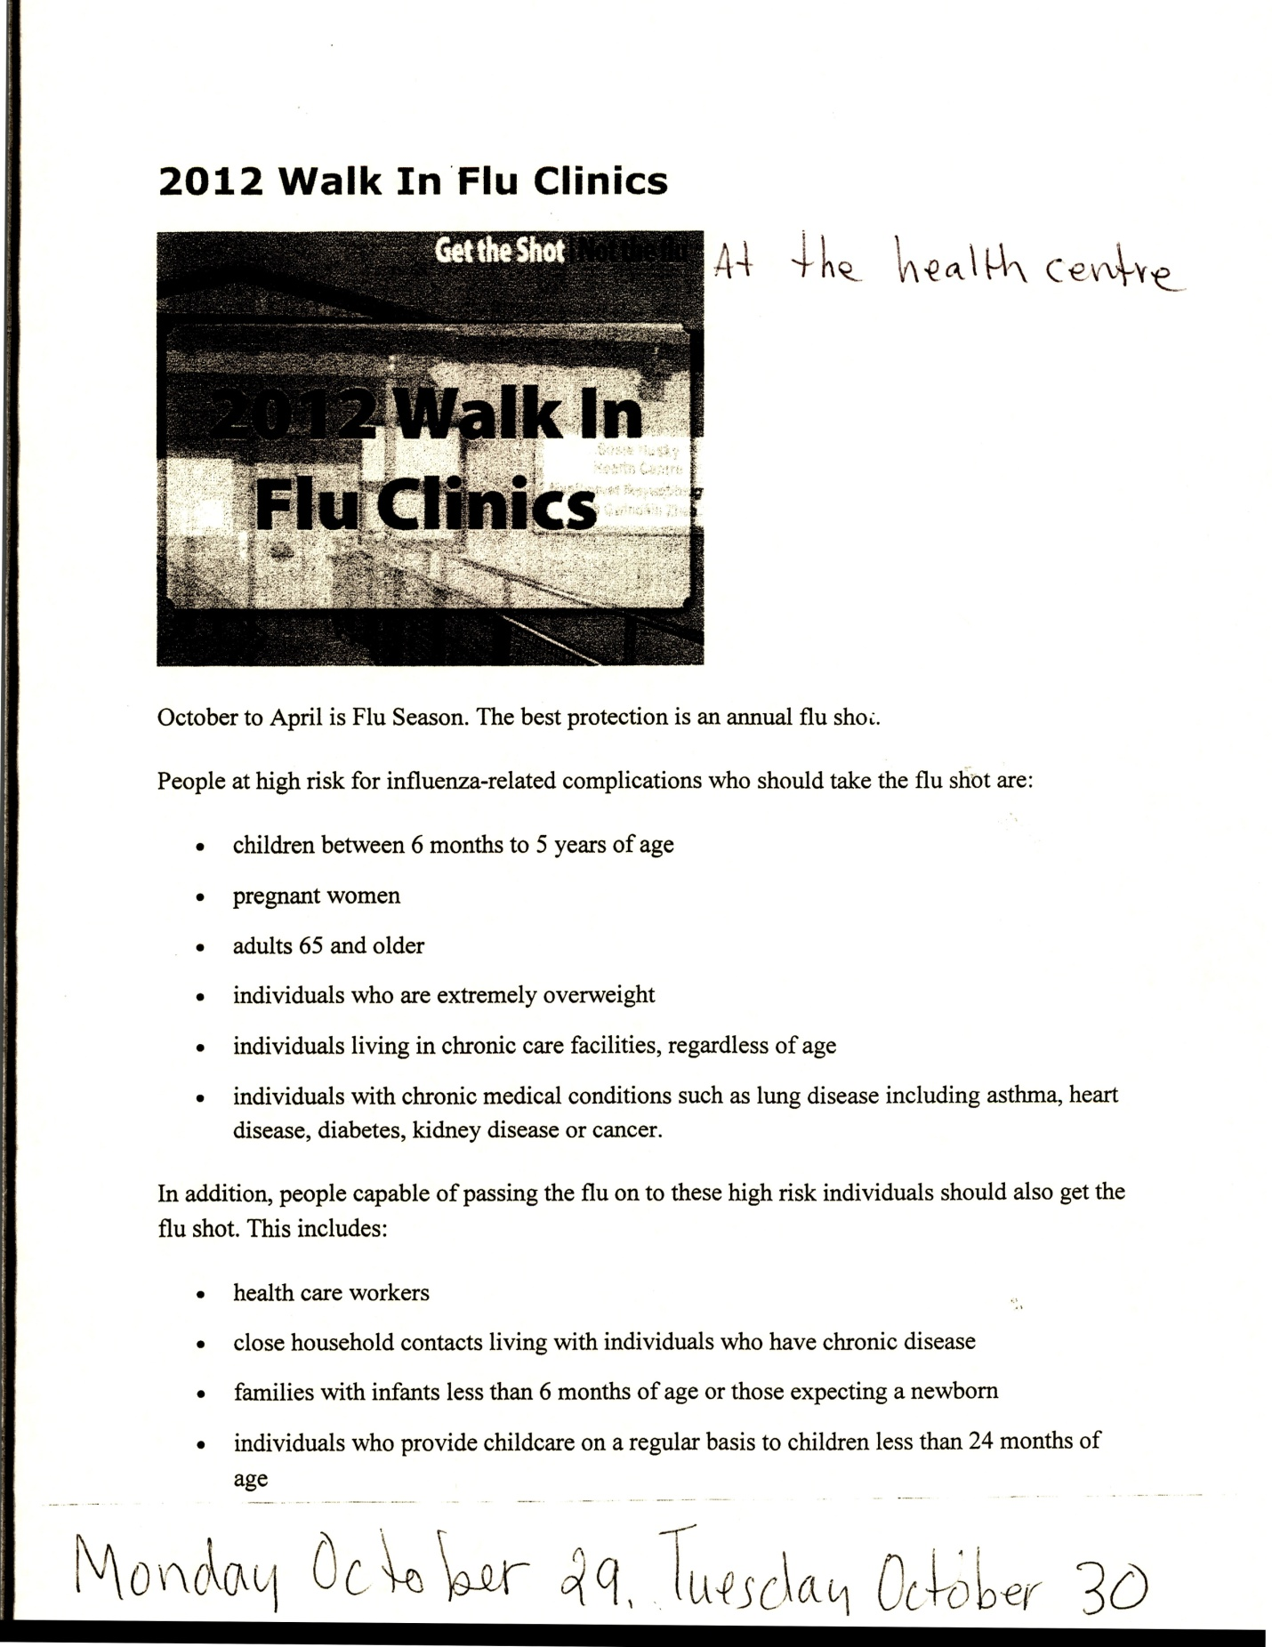

**THE FLU SHOT CONT’D…**

**HALLOWE’EN SAFETY TIPS**

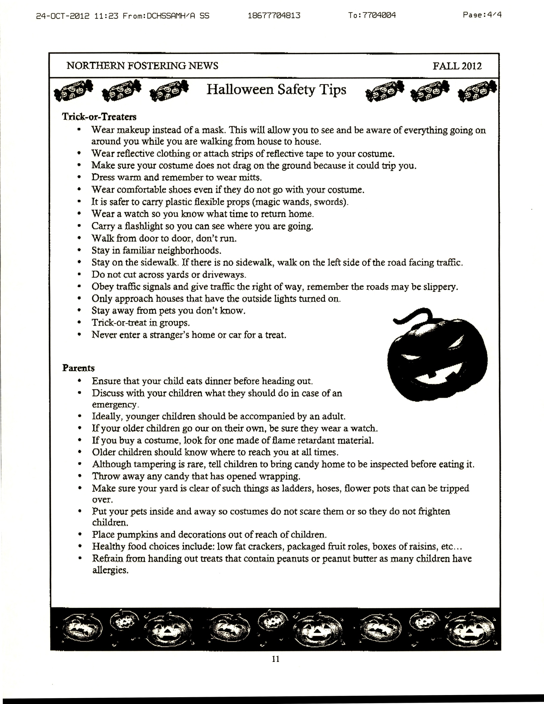

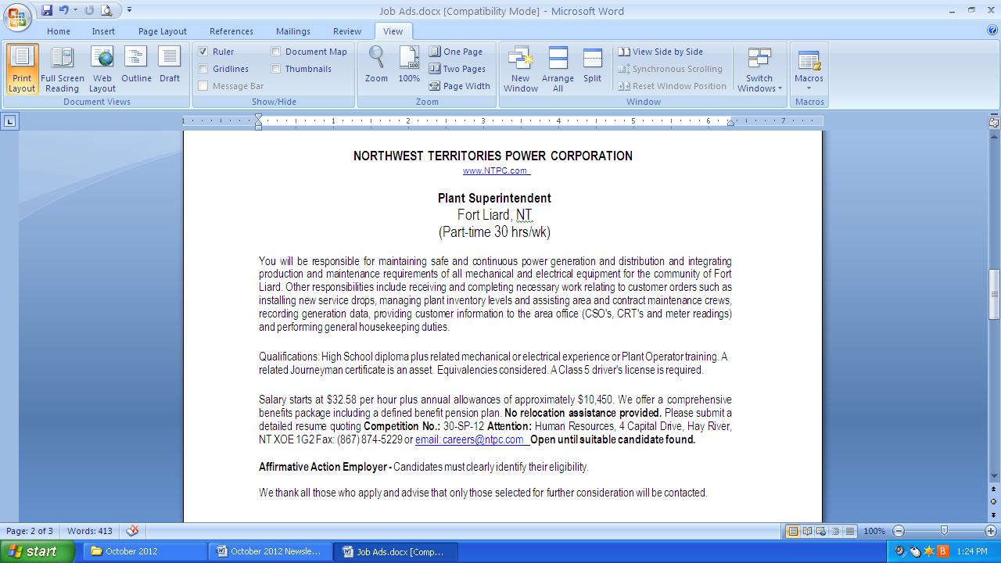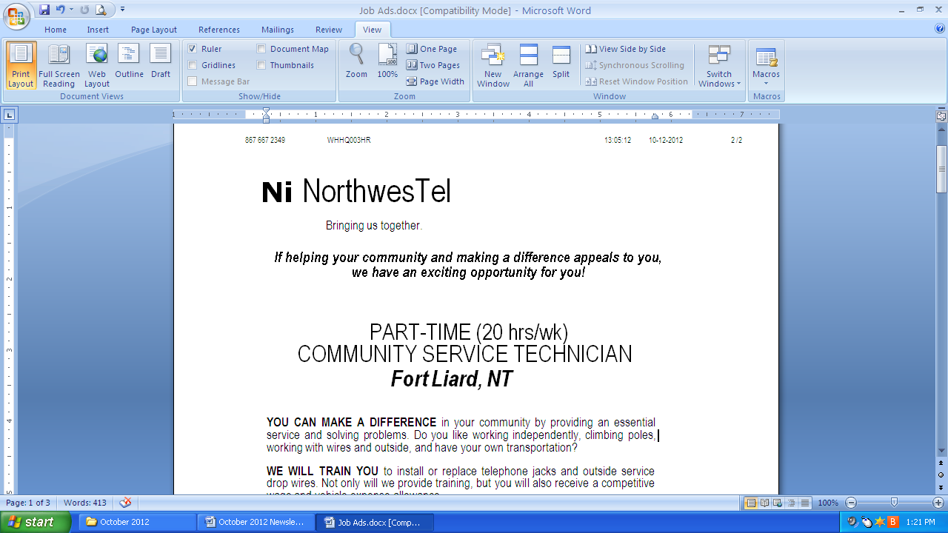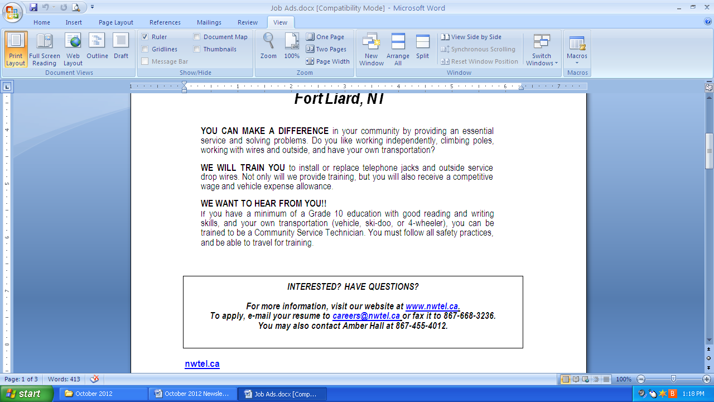

### COM_e+tag_cmyk-Color

### Part Time Casual Employment Opportunities

Guard positions with the Commissionaires at the RCMP Detachment in Fort Liard.

Guards are responsible for the monitoring and well-being of prisoners while in the care of the Police.

Applicants must pass a criminal record check, be capable of working independently and shift work.

First Aide and CPR is an asset.

To apply, contact the RCMP Fort Liard Detachment

**EMPLOYMENT OPPORTUNITIES**