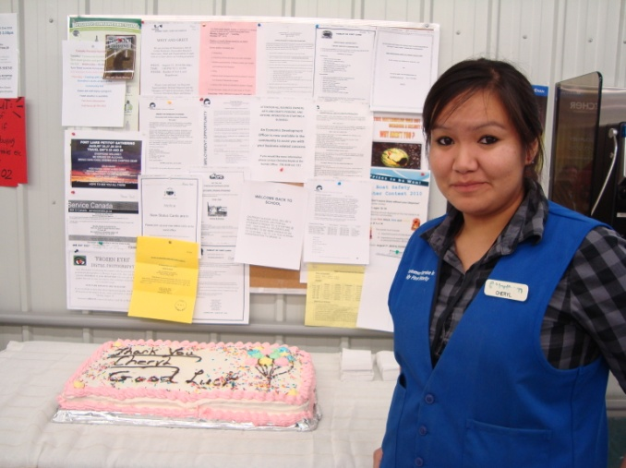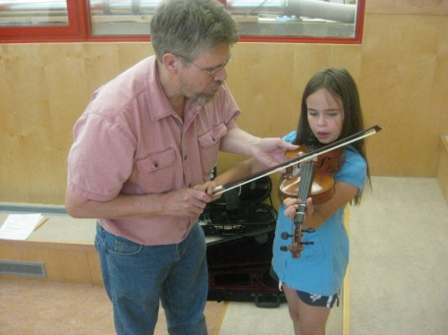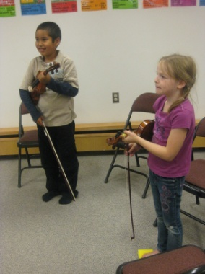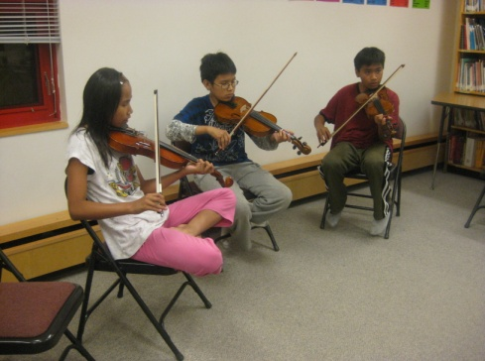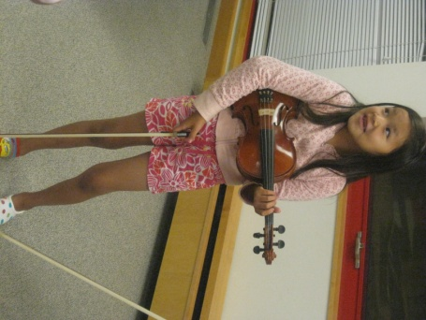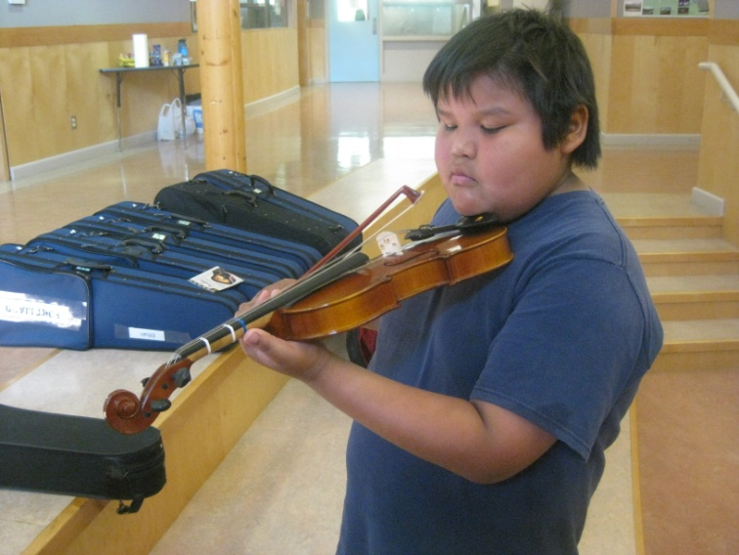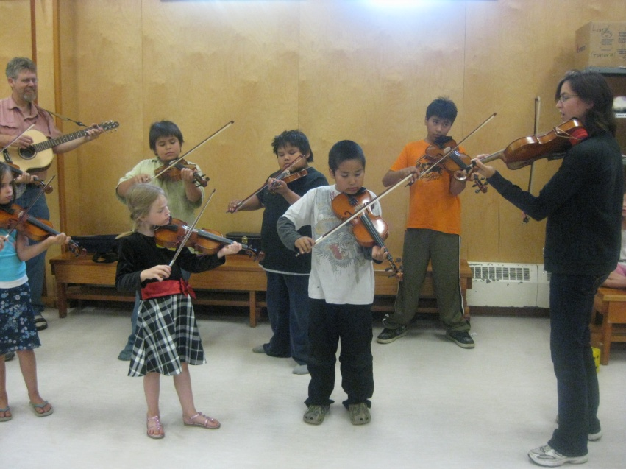

**‘FIDDLE CAMP’ A BIG SUCCESS!**

Cheryl Bertrand is celebrating her final day at the Northern Store in Fort Liard today before she leaves for Fort Smith next week.

Cheryl will be pursuing studies in Business Administration at Aurora

College’s Thebacha Campus.

She has been working at the Northern Store in Fort Liard for four years and will continue to work at Fort Smith’s store while she is in school. Cheryl says she is excited to begin her studies.

**Top:** Angus Capot-Blanc

**Middle Left:** Taeresha Berreault, Michael Sassie, Jamie Berreault

**Middle Right:** Logan Hardisty, Ava Yeo

**Left:** Rod Olstad, Meghan Yeo

**Above:** Hailey Sassie

**Below (clockwise from top left):** Rod Olstad, Dylan Steeves, Angus Capot-Blanc, Jamie Berreault, Trish Clair-Peck, Logan Hardisty, Ava Yeo, Meghan Yeo

The first Fort Liard Fiddle Camp was held from August 9th to 12th and 17 eager student fiddlers attended. Teachers Trish Clair-Peck and Rod Olstad travelled from Vancouver and Edmonton to give instruction. Students made two presentations of their fiddle playing at the community hall for their proud parents and family members.

**FORT LIARD SAYS GOODBYE TO CHERYL**

**NEW PLAYGROUND IN USE**

To the Mayor, Chief and Council, Community Members, and Parents of Fort Liard:

It is good to see parents taking their children and playing on the new playground equipment. There is still work to do, removing old broken timbers, raking, and mowing the grass.

The playground area is not a place for drinking, breaking bottles, throwing beer cans around or driving your quad near the equipment. There is video surveillance taken of the school yard 24 hours a day. If you abuse the equipment or break bottles in the playground, you will be caught on tape and will have to answer for it, charges may be applied. Please have some respect for the kids in the community.

There is garbage, bottles, beer cans, bags starting to gather around the playground equipment. Barrels with bags will be available soon to collect the garbage.

We would like to thank Encana for donating $5000 towards the purchase of the playground equipment. We mistakenly thanked Spectra Energy in the last newsletter.

Thank you to Craig King for donating the welding to finish the installation.

Our next goal is to work with the Acho Dene Koe Band, the Echo Dene Koe School, students, and parents to increase attendance at the Echo Dene Koe School. If kids aren’t at school they will not graduate, find meaningful employment or be able to effectively lead the community into the future. The children of today need to be given encouragement, know-how, support, and education to run our government and be the leaders of the future.

The DEA has regular meetings once a month, sometimes twice. Times are posted beforehand at the Hamlet Office and various places in the community. Everyone is welcome.

We welcome your feedback, complaints and support, and above all, your help. If you have a concern we need to hear from you directly. Change cannot happen because of stories or accusations. If you do not attend meetings you will not know what is happening from month to month and your view will be based on what someone else tells you.

Come out and help us support the children of Fort Liard.

Respectfully,

Melanie Louie – Chair, Robert Firth – Vice Chair, Karen McLeod – Trustee, Gilbert Capot-Blanc – Vice Trustee, Marilyn Marcellaise

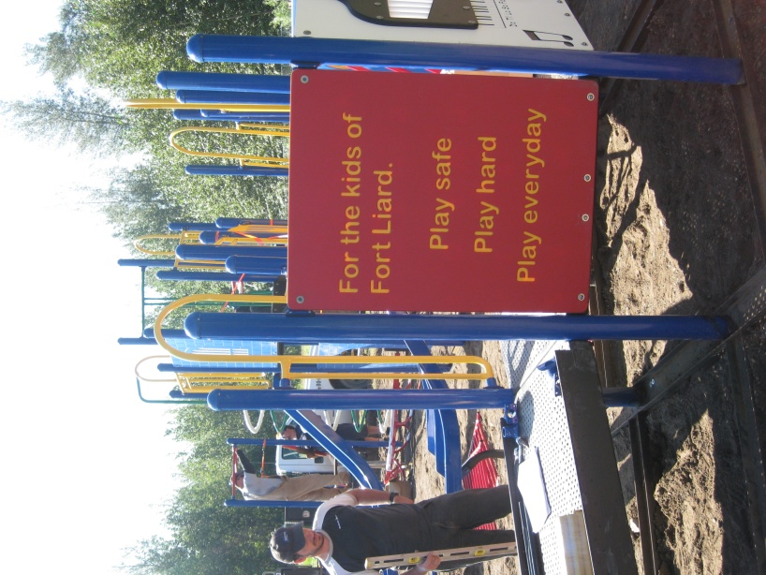

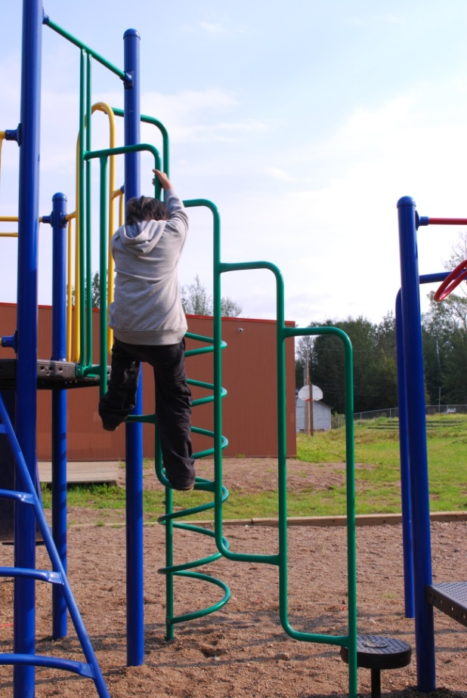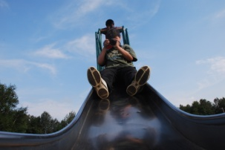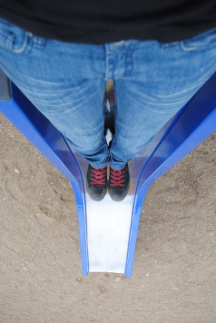

**Top:** Jonathan Yeo

**Above:** Tyler Bertrand, Tyrus Bertrand

**Below:** Tyler Bertrand



**If you have ever thought of joining the Fort Liard Fire Department, call Robert at 770-4104 for an application or information.**

**Mahsi**

**Petitot Gathering, August 26-28 2010**

The RCMP would like to remind motorists to drive safely while traveling to and from the gathering at the Petitot River.

Police will be patrolling on both sides of the border and can be reached by motorists using their cell phones.

The Fort Liard and Fort Nelson RCMP Detachments wishes everyone a safe weekend.

The Fort Liard RCMP Detachment will be hosting a Bicycle Rodeo Saturday September 11th, 2010 at the Community Arena. Lots of prizes will be distributed!! The day will include:

* A bicycle skills competition
* A bike decorating contest
* A BBQ lunch hosted by the Fire Department

The contests are open to ages 12 and under, parents are welcome to attend.

***Don’t forget your helmet!!***

**RCMP TO HOST BIKE RODEO**

**Keeping your community safe from animals**

There have been reported bear sightings in and around the community. I feel a lot of the sightings have to do with the carcasses and animal parts from hunting left in yards, and in the bush near homes. When you live in Bear Country a clean camp does not attract bears. The community is like your camp, just bigger.

**Don’t be a “Melon Head” Program**

Your Fire Department supports all efforts to prevent head injuries while bike and quad riding or skateboarding. I see very few kids wearing bike helmets while on their bicycles. I know the Health Centre and Karen McLeod have bike helmets for kids. **DON’T BE A MELON HEAD.**

The Fire Department will be supporting the RCMP’s Bike Rodeo in the first weeks of the new school year in September.

**S.A.F.E. Smoke Alarms for Everyone**

The Volunteer Fire Fighters are visiting all homes in the community and installing Smoke Detectors. Our goal is to make sure each home has a working Smoke Detector. We will look around to see if there are any hazards around your house that could result in a fire. If you have a wood stove we look at your chimney to make sure there isn’t a lot of creosote built up that could result in a chimney fire. Furnace rooms should not be used for storage especially in the winter.

**Drowning Prevention**

Thank you to everyone who came out for the Drowning Prevention Workshop and Barbecue August 5th and 6th. Winners of the Mustang Life Jackets were Raymond Kotchea and Arthur Loe.

The next workshop will be how to save yourself or someone else if you or they fall through the ice.

Remember:

“Wearing your life jacket won’t kill you!”

**THE WORD FROM THE FIRE HALL**

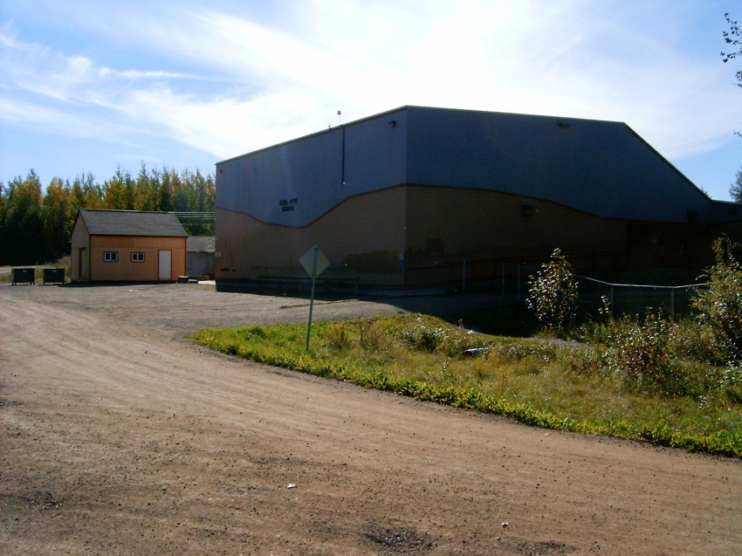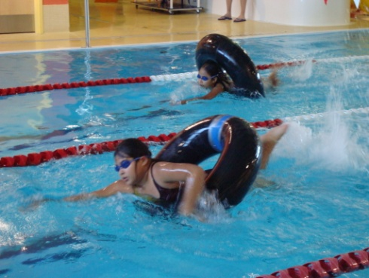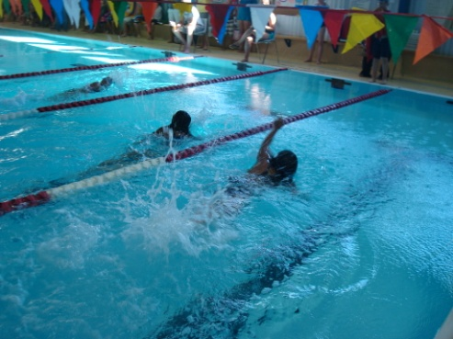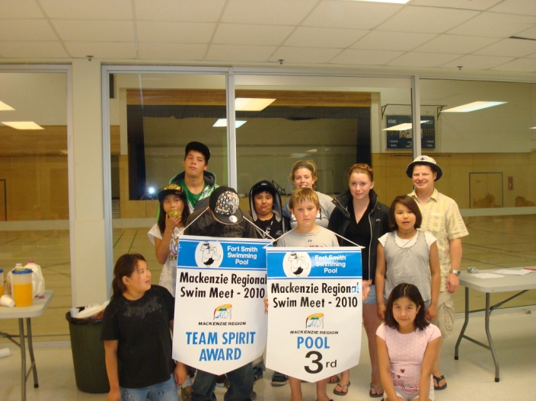

**Back to School:**

All students from Kindergarten to Grade 12 return to school today, August 20th 2010 for a regular school day. School hours this year are from 8:55 a.m. to 12:00 p.m. and from 1:00 p.m. to 3:30 p.m.

**Grief Workshop:**

The FVPP (Family Violence Prevention Program) has posted notices throughout the community (at stores, offices, etc.) to see how many people would be interested in a Grief Workshop. If you would be interested in attending a Grief Workshop, please sign one of the notices.

**Top:** Precious Hope, Kali Norn, Naomi Timbre, Taeresha Berreault and Brittany Newbury

**Bottom Left:** Naomi Timbre, Taeresha Berreault, Adrien Trembley, Jamie Berreault, Vaughn Nelson, William Newbury, Victoria Perron, Brittany Newbury, Precious Hope, Kali Norne and Tim VanDam

**Bottom Middle:** Naomi Timbre, Taeresha Berreault

**Bottom Right:** Kali Norn

All four recognized strokes (butterfly, backstroke, breaststroke and front crawl); some team building events like the lifejacket relay – everyone had to swim 25m with not one, but two lifejackets on; and events, the waterslide lunge, for example, which were purely for the fun of it.

The team came home tired and proud with the Spirit Award and a 3rd place finish. Congratulations to all participants, let’s go Dolphins!

The Fort Liard Dolphins, our local swim team, recently traveled to the Mackenzie Regional Swim Meet in Fort Smith. Competitor Adrien Trembley (Assistant Coach); Brittany and William Newbury; Taeresha, Alice and Jamie Berreault; Naomi Timbre; Vaughn Nelson; Kali Norn and Precious Hope all participated in an action-packed 2 days.

There were some serious events such as the 100m Individual Medley, a race that combines

**IN OTHER NEWS...**

**SWIM TEAM COMPETES IN FORT SIMPSON**

**IN OTHER NEWS CONT’D...**

**Health Centre:**

The Health Centre would like to remind community members of their schedule. Appointments are required for clinics; please call the Health Centre at 770-4301.

Also, the Health Centre would like to remind community members that an up-to-date NWT Health Care Plan Card is required for medical travel. Renewal forms are available at the Health Centre between Monday and Friday, 8:30 a.m. to 5:00 p.m.

**Community Garden:**

The Community Garden will be open on September 21, 2010. Come out and get a bag of potatoes.



From CPNP (Canadian Prenatal Nutrition Program), Karen McLeod

|  |  |  |  |
| --- | --- | --- | --- |
| Day | 8:30 – 11:30 | 12:00 – 1:00 | 1:00 – 5:00 |
| Monday | Clinic Appointments | Closed for Lunch | Chronic Clinic |
| Tuesday | As Above | Closed for Lunch | Well Woman Clinic |
| Wednesday | As Above | Closed for Lunch | Prenatal Clinic |
| Thursday | As Above | Closed for Lunch | Well Child Clinic |
| Friday | As Above | Closed for Lunch | Program Planning |

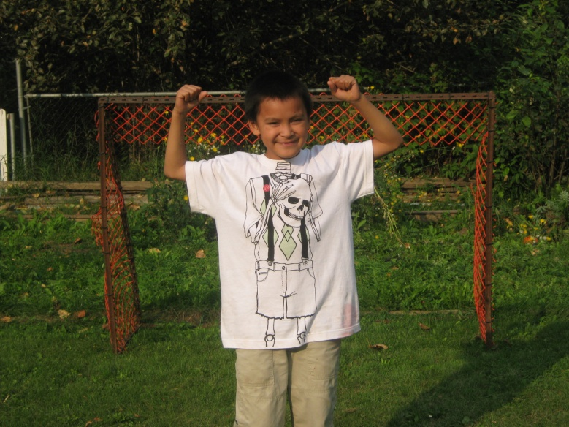

**Thank you note:**

Thank you to Randy Dobbs and the late Ina Thomas for donating $90.00 to the RC Church Building Fund.

From the St.Raphael RC Church – Parish Council

**BIRTHDAY WISHES**

**Petitot Gathering:**

The Petitot Gathering will take place from August 26-28th just south of the B.C. /NWT border. Participants are asked to bring their own food, dishes and camping gear. Details and a schedule will be posted when available.

**Volunteers are needed for this event; please call Jennifer at 770-4104.**

*Happy 13th Birthday to Terrance Kotchea*

*From Donna & Julianne*

*Hope your Birthday’s filled with surprises and lots of good things to do. ‘Cause Memo, in the whole wide world there’s no one as nice and special as you.*

*Have a great and happy 8th Birthday Memo.*

*Love your Mom & Sister*