**YOUNG ENTREPRENEURS OF FORT LIARD**

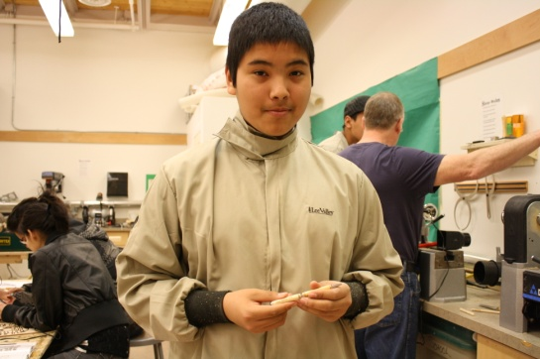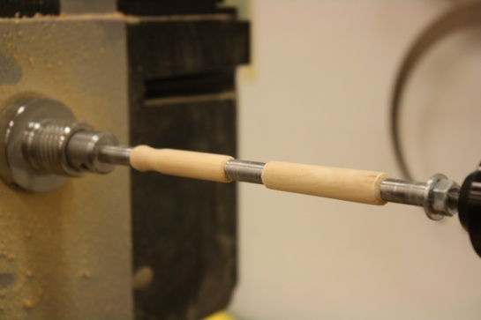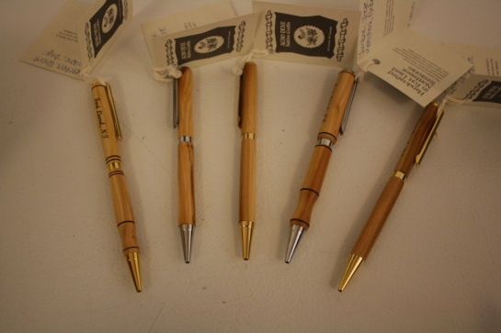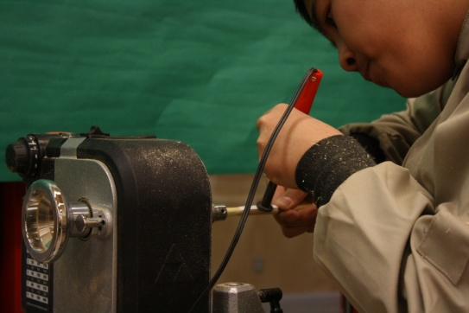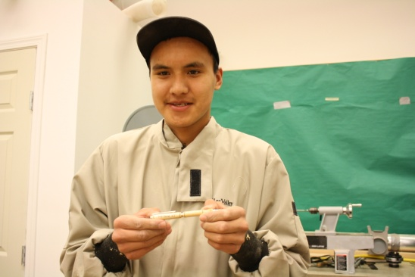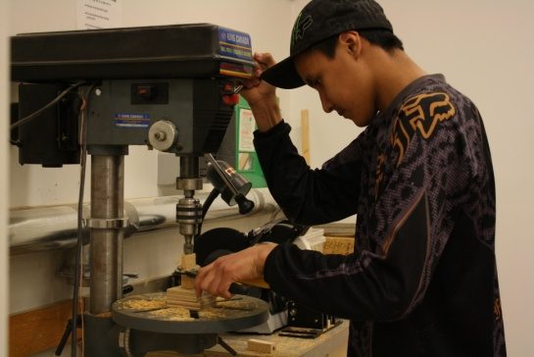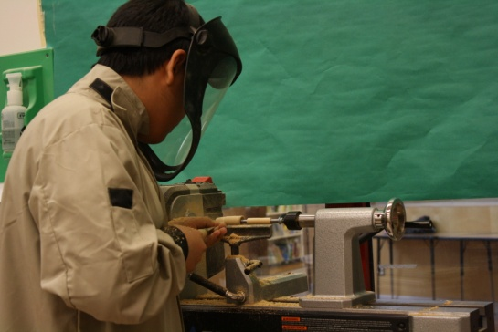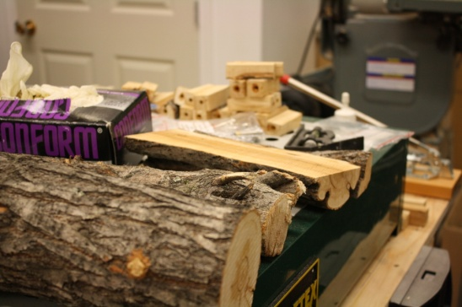

Trey Timbre uses a lathe to shape his blocks of wood to the shape of a pen

Above, from left: Trey Timbre transfers print to the pen using a wood-burning tool; Brent Kotchea tries a new design for his pen; Trey Timbre with his finished pen.

From far left: Brent Kotchea with his finished pen; pens for sale on display at Acho Dene Native Crafts.

Brent Kotchea prepares a block for the lathe using a drill press.

Diamond willow pieces are formed into blocks, then drilled through the middle for the ink

sell the pens? So they took their idea to Acho Dene Native Crafts and staff there agreed.

Each pen is made from scratch with diamond willow from the community and labeled however the buyer would like. Pens are for sale at the craft store and printed with Fort Liard, NT as a souvenir, however Trey and Brent are more than happy to take orders on their

pens and will personalize them however the buyer wishes.

It is nice to see local work by young artists on display. The pens are expected to be popular with tourists as a souvenir and these young men are more than happy to receive monetary recognition for their newly learned craft.

Echo Dene School students Trey Timbre and Brent Kotchea have been busy at school this year, especially when it comes to shop class.

With the help of their shop teacher, Phillip Meaney, Trey and Brent have learned to fashion souvenir pens. The young men were having such success with their newly learned craft that they had an idea: why not



**TAKE NOTE...**

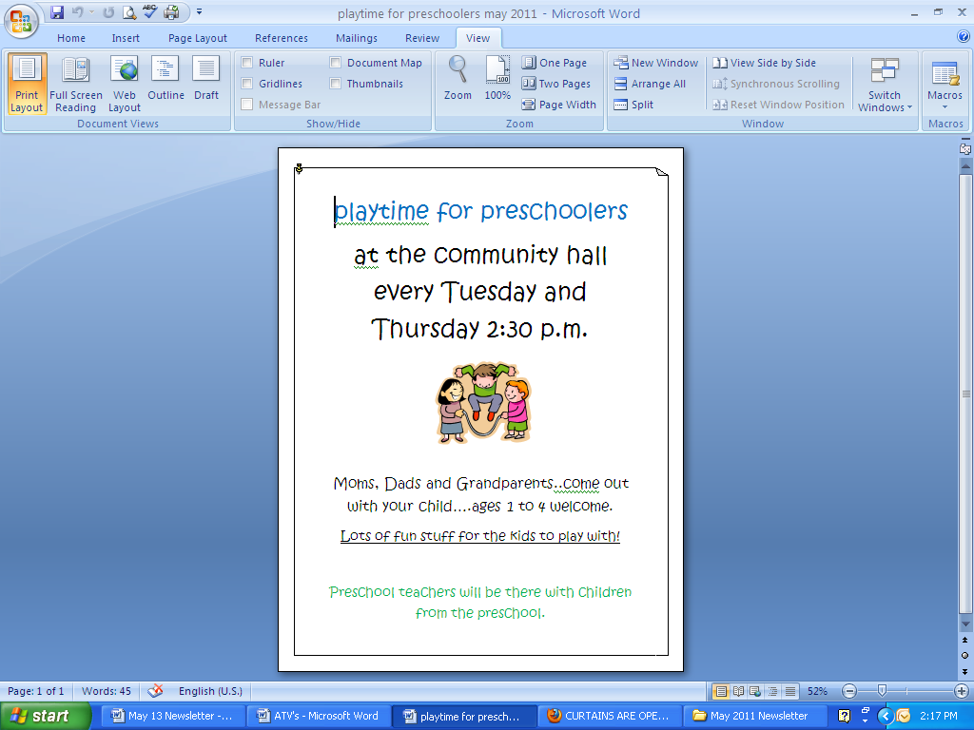

The Library is open at the Echo Dene School, five days a week: Monday, Tuesday, Thursday and Friday from 2:30 to 7:00 PM and on Saturday from 12:00 till 5:00 PM. Come in and see how easy it is to find that Book!

The Library’s Authors of the Month are Robert Munsch and Robert Muchamore. Jamie and Kathy have been busy shelving new books and there is quite an assortment: Plant Identification Books, Wild Meat cooking, Graphic Novels. We have books by Blondin, and Fumoleau so whether you are looking for a novel, mystery or ihhihh historical references, we will be happy to assist you. Free internet access is available. Come on in!

If you have an interest in the Library and would like to contribute to its growth or direction please come in. Your help and support is needed to make it Your Library.

*Birthday Greetings... May 19th*

*Happy Birthday to Donny Bertrand!*

*May you enjoy your special day. Wish you all the best.*

*With love always Loretta and Dawn*

**If you have ever thought of joining the Fort Liard Fire Department, Call Robert 770-4104 come down to the Fire Hall and have a coffee . All we ask is you to be a minimum of 18 years of age, male or female, and willing. We will take care of the rest.**

**Mahsi**

**Helmets**

Far too many kids don’t wear a helmet while bike riding. If you have a child with a bike he should be wearing a Bike Helmet that fits well. If you have a bike helmet that doesn’t fit your child give it to someone who it will fit. Watch for posters.

**S.A.F.E. Smoke Alarms for Everyone**

The Fire Department will be working hard to make sure you have a new working Smoke Detector in your house. If we missed you please call the Fire Department 770-4104 and let us know. You can also pick up a Smoke Detector at the Fire Hall.

**Remember Smoke Alarms are a sound you can live with!**

**Smoke Signals**

Upcoming training and workshops this summer:

**Fire Extinguisher Training and BBQ**

We will be conducting Fire Extinguisher training later this summer. We don’t often get an opportunity to use a Fire Extinguisher, would you know what to do if you had to? Call the Fire Hall for more information.

**Cold Water Boot Camp and BBQ Part 2 in June**

Last summer we had a workshop where you could learn how to save your own life if you fell in the water. We will be having this workshop again. You can win a Life Jacket, boating safety kits; learn to save your own life. Sounds like a great deal to me.

**THE WORD FROM THE FIRE HALL**

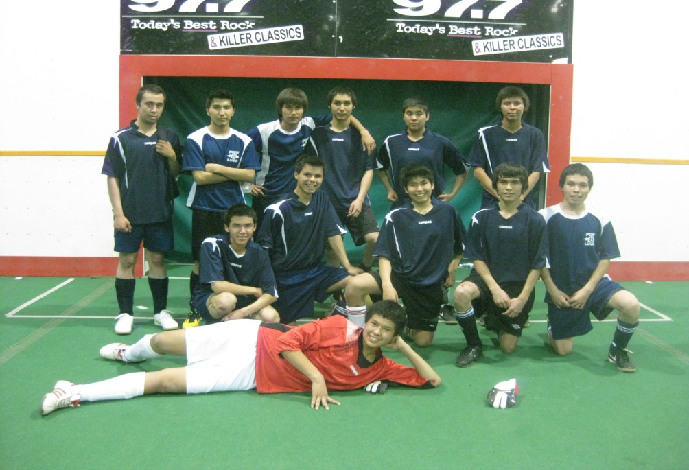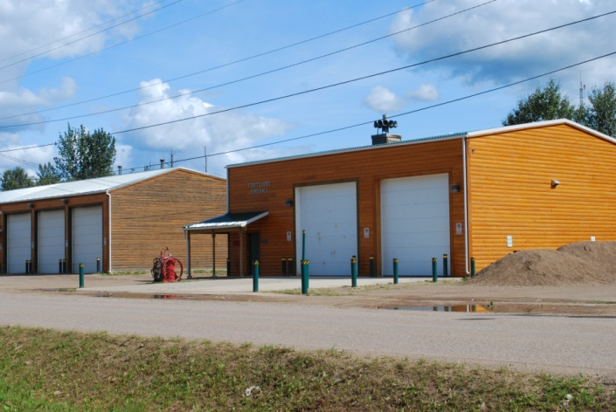

**Mahsi Cho to coaches Jamie and Dustin and to chaperones Collin and Christine.**

Fort Liard U19 Boys team (with players from Resolution and Providence) and coach Dustin Hope

‘**Rock Around the Clock’ Soccer Tournament in Grande Prairie**

From April 28th to May 2nd, 19 soccer players, 2 coaches and 3 chaperones travelled to Grand Prairie to play soccer at all hours of the day and night! Our boys and girls in the U12 and U14 categories played on the Fort Simpson teams and our U16 and U19 teams had players join their teams from Fort Simpson, Fort Resolution and Fort Providence. All Fort Liard players made us proud by putting in their best effort in every game and improving playing skills dramatically over the course of the tournament. The girls U12 team won the silver medal and U14 girls won the bronze medal! WELL DONE EVERYONE. You represented your community and school very well with your good sportsmanship and enthusiasm.

**SOCCER SUCCESS!!**

Fort Liard Fire Hall, photo by Dylan Steeves



**ROAD SAFETY WEEK**

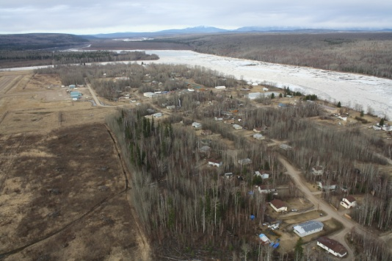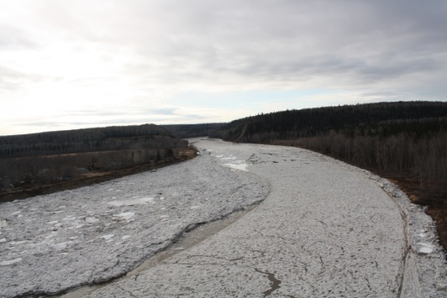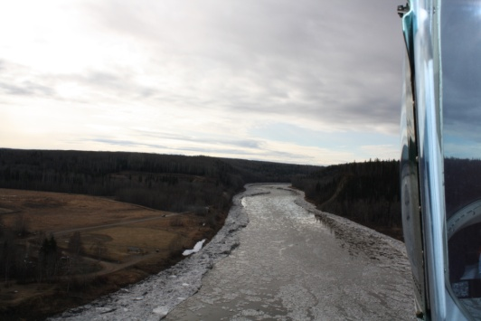

**SCENES OF BREAK-UP**

they know that the involvement of the driving public is essential to achieve safer streets and highways.

Canada Road Safety Week is sponsored by Transport Canada and endorsed by police and is part of “Road Safety Strategy 2015”, which has a goal of making Canada's roads the safest in the world and is the replacement strategy for the previous 10 year plan known as “Road Safety Vision 2010”.

**For further information or questions please contact: The Fort Liard RCMP Detachment 867-770-1111**

The focus during Canada Road Safety Week will be on behaviours that reduce risks for drivers, passengers and other road users: sober and alert driving, seat belt use, and refraining from all aspects of aggressive driving. All enforcement agencies across the country have been invited to participate.

Anyone can become a victim of unsafe driving ‑‑‑ whether by direct involvement or when a loved one is affected. Police agencies across the country are collaborating on this project because they have seen this kind of devastation, and because

**SAVING LIVES DURING CANADA ROAD SAFETY WEEK**

May 16 ‑ 23, 2011 will mark Canada Road Safety Week, a national campaign to make Canada's roads the safest in the world.

This week has been strategically chosen, as it is the first "summer" long weekend. More people are traveling and traffic collisions are more frequent. Police vehicles will be stationed at key locations in and around Fort Liard to remind people that safe driving habits save lives and reduce injuries on our roadways.

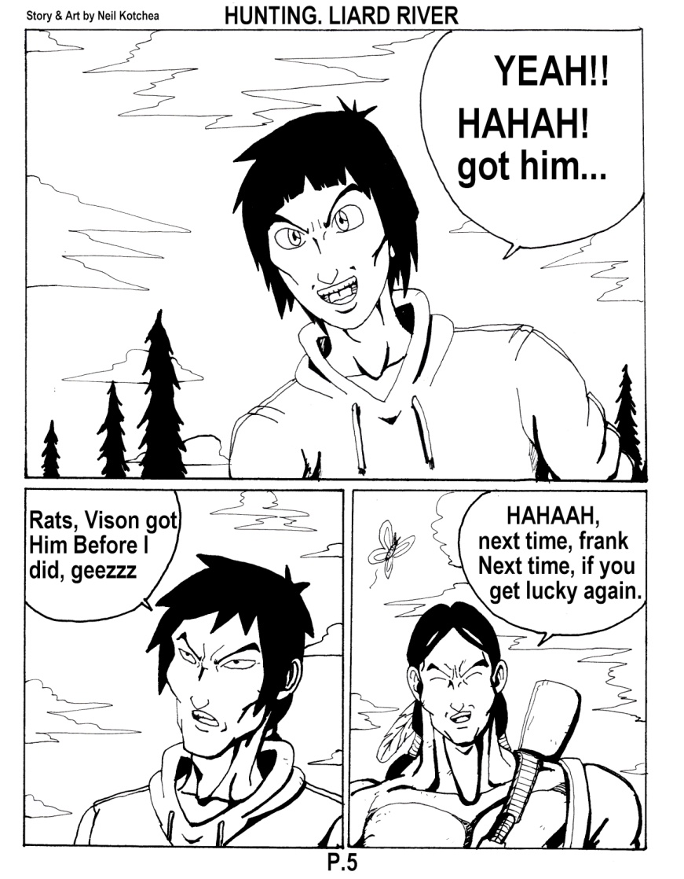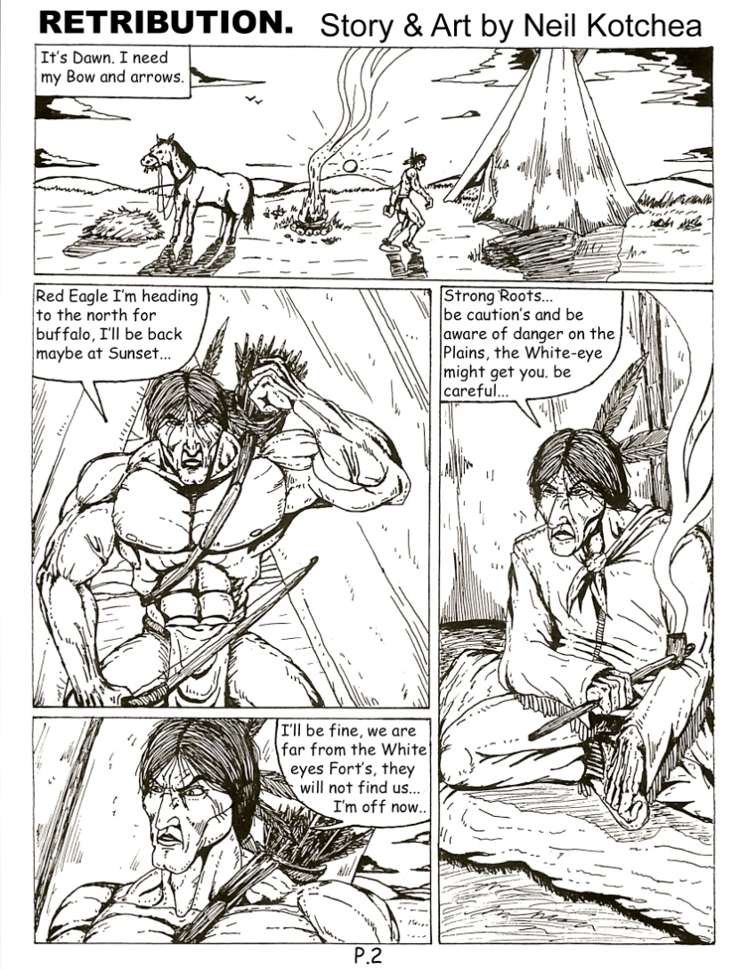

These verses are depicted on all the drawings by NEIL KOTCHEA and are seen at the Community Centre, Hamlet/ADK Offices. This is a part of NEIL we see and he is an inspiration for us all in his caring attitude for this community and being proud to live here. We finally have a Youth who takes the initiative to clean up voluntarily, the main street which is wonderful to see and makes us proud to have him in the community.

The people who throw garbage on the ground after Neil’s hard work should be ashamed of themselves.

We would like to take this opportunity to acknowledge him on his hard work and he should be PROUD of who he has become and don’t let anyone tell him otherwise. At least he is attempting to be part of the solution and not part of the problem.

**NEIL KOTCHEA**, THANK YOU FOR CARING AND BEING CONCERNED FOR OUR COMMUNITY AND DOING THE CLEAN-UP. YOU ARE AN EXCEPTIONAL INDIVIDUAL AND A GREAT ROLE MODEL TO ALL THE YOUTHS IN THE COMMUNITY.

***THANK YOU NEIL FOR A JOB WELL DONE...***

Community members;

ANGUS MCLEOD AND IRENE MCLEOD

*The Beauty of the trees, the softness of the air,*

*The fragrance of the grass, speaks to me.*

*The summit of the mountains, the thunder of the sky,*

*The rhythm of the river, speaks to me.*

*The faintness of the stars, the freshness of the morning,*

*The dewdrop on the flower, speaks to me.*

*The strength of the fire, the taste of fish, the trail of the sun,*

*And the life that never goes away, they speak to me and my heart soars.*

Poem by Chief DAN GEORGE

**SINCERE THANKS**

On August 29, 2010, RCMP in Fort Liard recovered an improvised explosive device that had been located in a playground.

Fort Liard RCMP are conducting an extensive investigation and are requesting the assistance from the public; should anyone have any information in regard to this matter, please contact Crime Stoppers or the Fort Liard RCMP.

**Crime Stoppers Contact Number: 1-800-333-000  
Fort Liard RCMP Contact Number: (867)-770-1111**

In the last 2 months 3 vehicles have been vandalized by scratching or sustaining broken windows. The RCMP are asking the public to bring forward any information in regards to these events.

The cost of insurance is high and the persons who own these vehicles will have to cover all the costs unless we can locate the subjects responsible.

Acho Dene Koe Vehicle – March 28th, 2011: broken window

Private Vehicle – April 20th, 2011: scratching of paint

Private Vehicle – April 23rd, 2011: scratching of paint

All tips are welcome.

Call the Fort Liard RCMP @ 770-1111

Sincerely,

Cpl Minty

**THE RCMP NEEDS YOUR ASSISTANCE!**



The Fort Liard RCMP Detachment would like to remind ATV operators that if you operate an ATV on the roadways in Fort Liard or on the Highway you must comply with the following regulations set out in the **ALL-TERRAIN VEHICLES ACT:**

• Your ATV must have a working white headlight and a working red brake light

• The operator has to be **14 Years old** or older

• The operator and the passenger must wear helmets and the chin straps must be securely fastened

• No more than **TWO** people can be on the ATV

• Your ATV has to be registered (license plate must be attached to the ATV)

• You must have valid insurance on your ATV

The RCMP will be doing traffic stops on ATVs throughout the summer. People found not following these regulations will be issued an offence ticket. If you have any questions or concerns, please call the Fort Liard RCMP Detachment 867-770-1111.

Thank you

**ATTENTION ATV OPERATORS**

*Keep an eye out for news on the upcoming Bike Rodeo!!*

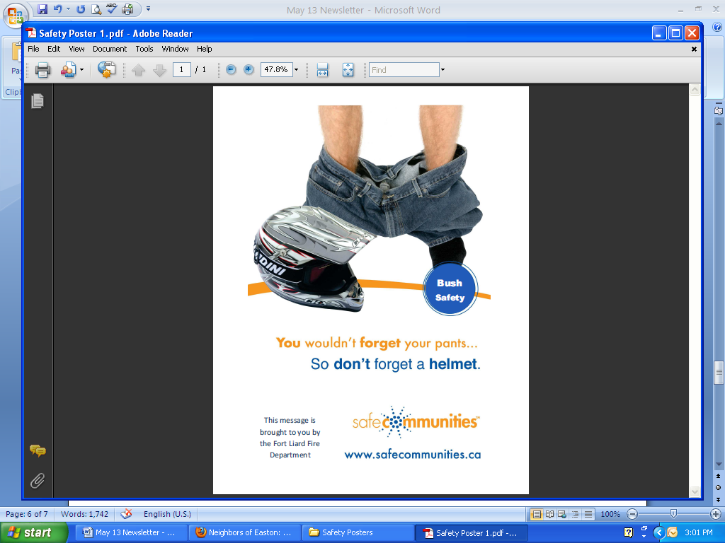Bush



**ATTENDANCE RECOGNITION for APRIL**

|  |  |  |  |  |  |
| --- | --- | --- | --- | --- | --- |
| **K/1 Class** |  | **Gr. 1/2** |  | **Gr. 3/4** |  |
| Elizabeth Nelson | 100% | Chantel McLeod | 100% | Leona Berreault | 100% |
|  |  | Keanna McLeod | 100% | Meghan Yeo | 100% |
|  |  | Ava Yeo | 100% | Charlene Bertrand | 100% |
|  |  | Briann Nelson | 100% | Mikala McLeod | 100% |
|  |  | Matthew Wezelman | 100% | Wyatt McLeod-Gargan | 100% |
|  |  | Nathaniel Yeo | 100% | Dallas Sassie | 100% |
|  |  | Logan Hardisty | 95% | Angus Capot-Blanc | 100% |
|  |  |  |  | Sherina Capot-Blanc | 100% |
|  |  |  |  | Jordan Hikmak-Nelson | 100% |
| **Gr. 5** |  | **Gr. 6/7** |  | Hailey Sassie | 100% |
| Brandon Hardisty | 100% | Keith Nelson | 97% | Megan Steeves | 100% |
| Dylan Steeves | 100% | Nathaniel Lomen | 95% |  |  |
|  |  | Selena Lomen | 95% | **Gr. 8** |  |
| **Gr. 9/10** |  | James Duntra | 95% | Briant Kotchea | 100% |
| Darla Sassie | 100% |  |  | Alinda Edda | 100% |
| Patricia Duntra | 100% |  |  |  |  |
| Emily Amprako | 95% | **TOTAL = 30 STUDENTS** |  |  |  |
|  |  |  |  |  |  |

**ATTENDANCE RECOGNITION for MARCH**

|  |  |  |  |  |  |
| --- | --- | --- | --- | --- | --- |
| **K/1 Class** |  | **Gr. 1/2** |  | **Gr. 3/4** |  |
|  |  | Chantel McLeod | 100% | Leona Berreault | 100% |
|  |  | Jackson Yeadon | 100% | Meghan Yeo | 100% |
|  |  | Ava Yeo | 100% | Charlene Bertrand | 100% |
|  |  | Briann Nelson | 97% | Mikala McLeod | 100% |
|  |  |  |  | Wyatt McLeod-Gargan | 100% |
|  |  |  |  | Dallas Sassie | 100% |
|  |  |  |  | Holly Fantasque | 97% |
|  |  |  |  |  |  |
|  |  |  |  |  |  |
| **Gr. 5** |  | **Gr. 6/7** |  | **Gr. 8** |  |
| Brandon Hardisty | 100% |  |  | Alinda Edda | 97% |
|  |  |  |  |  |  |
| **Gr. 9/10** |  | **Gr. 11/12** |  |  |  |
| Emily Amprako | 100% | Collin Needlay | 100% |  |  |
| Tina Klondike | 100% | Camilla Bertrand | 95% |  |  |
| Brent Kotchea | 97% |  |  | **TOTAL = 16 STUDENTS** |  |
|  |  |  |  |  |  |
|  |  |  |  |  |  |

*Students who maintain a high level of attendance at school are recognized every month at an assembly.*

*Next month’s assembly will be on the afternoon of* ***Wednesday,******June 1st*** *to recognize those students who had a high attendance for the month of May. Parents are encouraged to attend!!*

**SCHOOL ATTENDANCE**