**LIARD RIVER RESCUE**



*“It won’t work if you don’t wear it – Lifejackets save lives”*

downriver. Brent recalled the incident as being quite scary and he considers himself and his family to be very lucky. No one in the boat was wearing a lifejacket and Brent would like to pass on this message:

“If you’re going out on the water, please wear lifejackets and don’t let that boat ride be your last.”

Brent and Alma should be commended on their ability to think and act quickly under pressure and with limited resources. This was a scary situation with a happy ending.

supplies had been thrown overboard in the storage seat. Brent and his mother then quickly decided to attempt to start the motor; however this was made difficult by the fact that the fuel line had been ripped off when the gas tank fell overboard and the emergency key was with Brian in the river.

Quick thinking allowed Brent and his mother to start the motor together, as Brent held the emergency stop out and Alma was able to start the motor manually. They then had to avoid more driftwood in order to reach Brian, but they were successful in finding him, getting him out of the water, and getting to shore.

After a fire to warm up and dry out, Brent and his parents headed out to search for their missing supplies and managed to locate them approximately 3-4 kilometers

**Sunday, June 12th**

It was a regular Sunday on the river as Brent Kotchea headed out with his parents, Alma Jumbo and Brian Kotchea to search downriver on the Liard for William Betthale. As they were motoring through a channel, the boat hit a “deadhead,” a log floating just below the surface. Their boat took a sharp turn to the right and from that point on “everything happened so fast,” Brent recalls. Brian was tossed overboard along with a 14-gallon gas tank, a storage seat full of supplies, and the emergency key for the motor, which was around Brian’s wrist.

Brian immediately started trying to swim towards the gas tank as the river carried him quickly further downstream. Meanwhile, Brent was trying to find something that could be used as a flotation device to throw to his dad; however all of the

Brent Kotchea

**Fort Liard School & Community Library is Open**

Find us at the Echo Dene School. Please use the Aurora College entrance.

**CHECK IT OUT!**

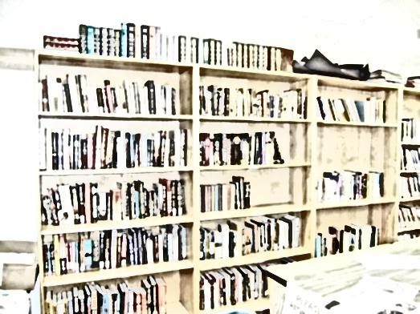

**Library Hours:**

Monday 1:30 to 6:00

Tuesday 1:30 to 6:00

Wednesday 1:30 to 6:00

Thursday 1:30 to 6:00

Friday 1:30 to 6:00

Closed Saturday, Sunday and Holidays

**Come Check Out:**

**Reading and Story Telling –**

Every Thursday beginning June 30 meet us at the Arbour at 3:00 until 5:00

for story- telling and readings. Come enjoy the campfire, some food and most of all the company.

**Internet Access –**

The Library has 3 computers for community use and a Wireless Network is available.



A **Big Thank you** to all of you to all who returned borrowed books. Some of you even donated ones you have read, thank you! New books are now on the shelves and more are coming. Come in and see!



**CONGRATULATIONS GRADUATES!**

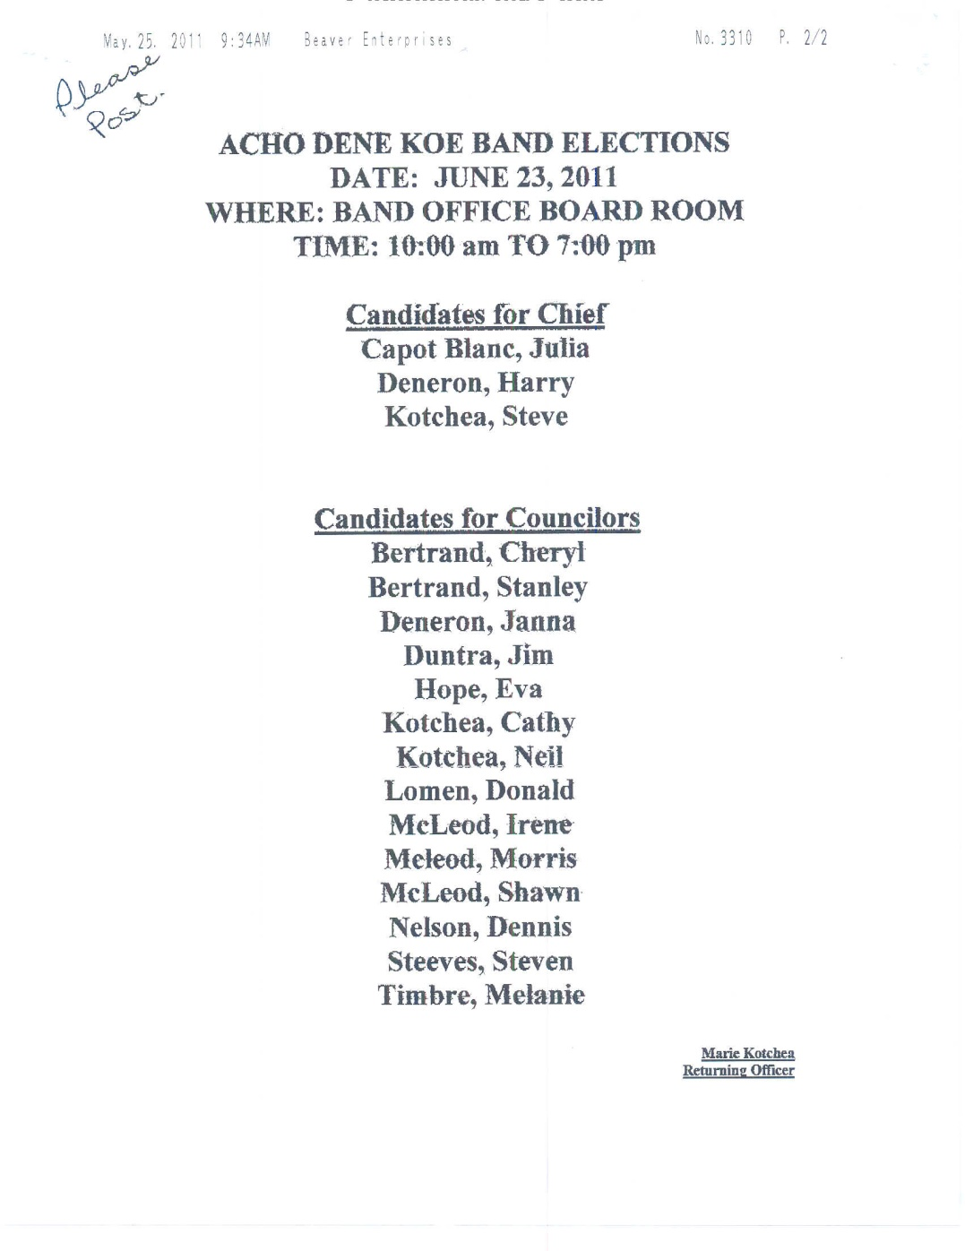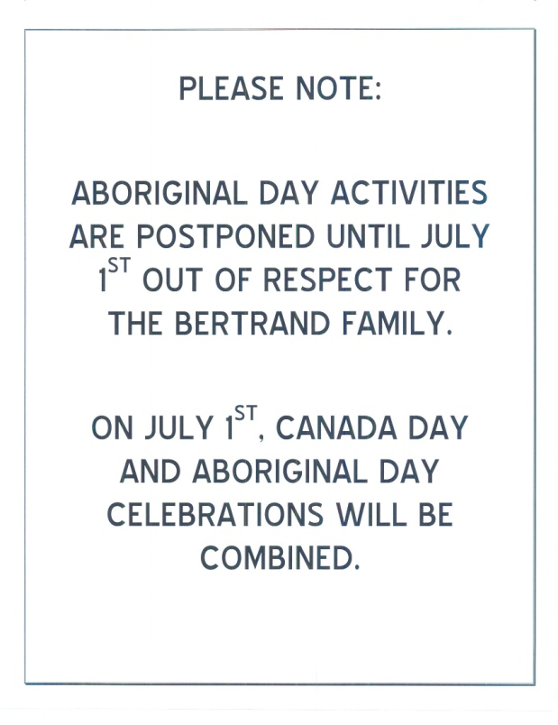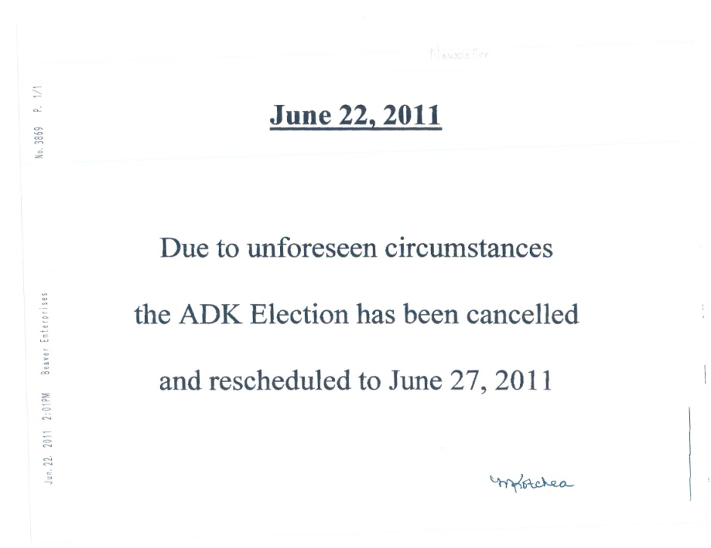

Aurora College is closed from June 17, 2011and will be open again Monday August 22, 2011. Thanks to all the students and community memebers that took part in Aurora College programs and services. I hope you have a great summer and look forward to starting a new school in September.

**COMMUNITY NEWS**

Collin Needlay and Briana Kotchea, left, celebrated their graduation from Echo Dene School on June 9th with a ceremony followed by a dinner which included friends, family and teachers. Presentations were made by Nahendeh MLA Kevin Menicoche and Terry Jaffray, Superintendent of the Deh Cho Divisional Education Council (pictured above with Collin and Briana). Congratulations Collin and Briana and best wishes for your future endeavours!



The Community pool opened June 15th to a crowd of youth eager to start their summer swimming activities. A family swim has been added to the pool schedule from 7-8 pm Mondays and Wednesdays, come and enjoy the pool with your family! Also

**COMMUNITY POOL OPENS!**

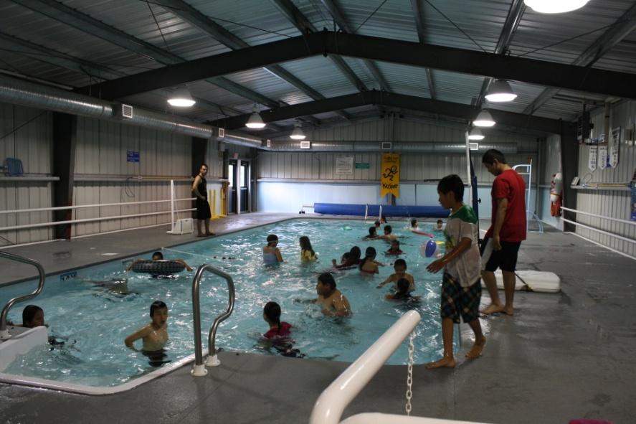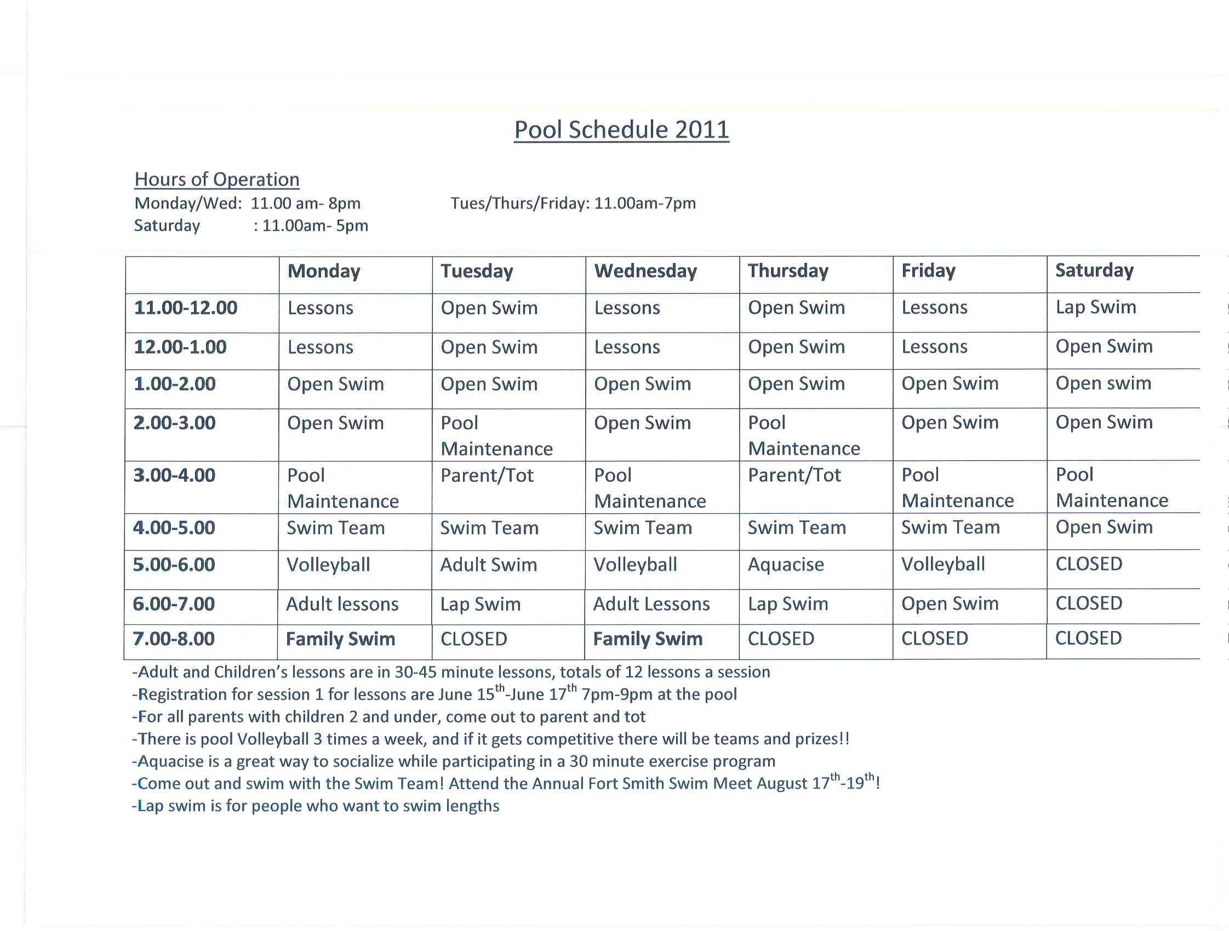

new this year is a parent and tot swim. Parents with children 5 and under beat the heat and come out with your tots Tuesdays and Thursdays from 3-4 pm. Passes are available for purchase at the front desk of the Hamlet Office.

Julianne Klondike lends a hand to Amy Duntra on their first day in the pool in 2011.

Lifeguard and swim instructor/coach Cameron MacKendrick looks on as excited pool-go-ers enjoy the break from a hot sunny day.



**IMPORTANT SAFETY INFORMATION**

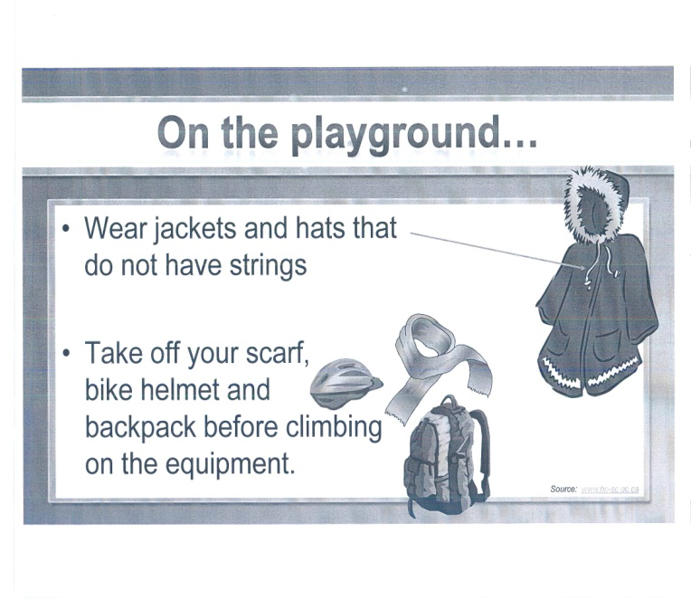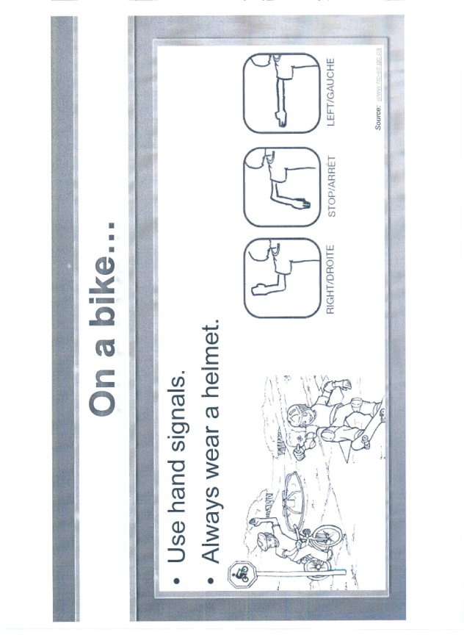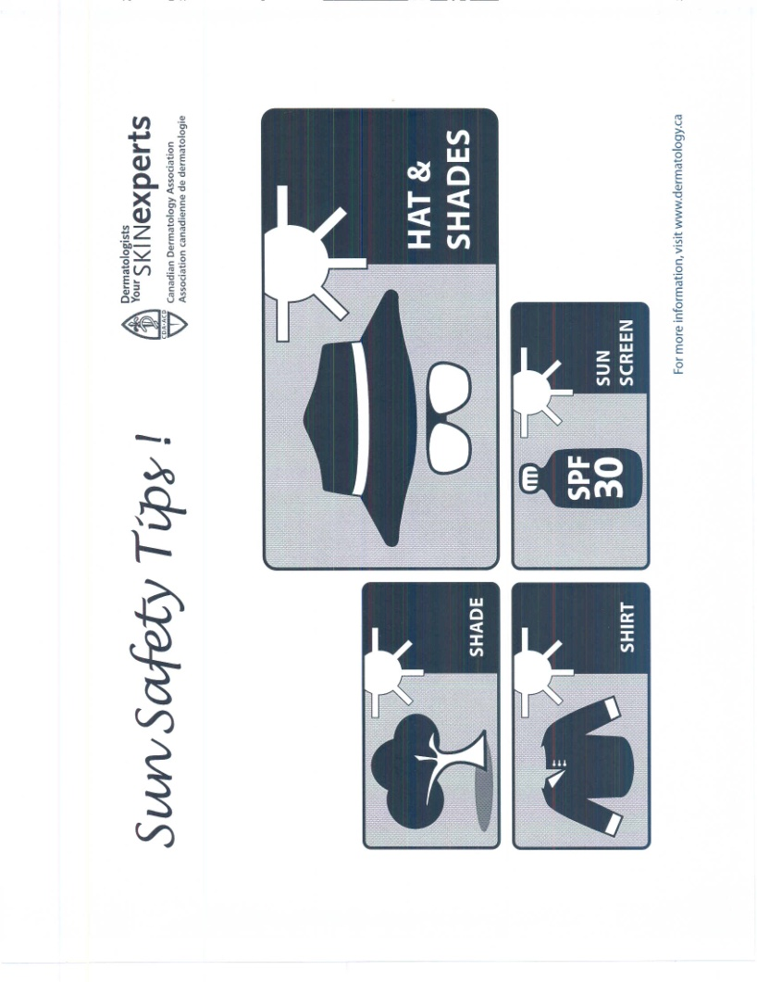rcmp.jpg

For more health and safety tips, or for any other questions or concerns, please contact your local Canadian Prenatal Nutrition Coordinator, Karen McLeod, at the Health Center 770-4301.

**RCMP CALL FOR INFORMATION**

Fort Liard RCMP are requesting assistance from the public to solve two Break and Enters wherein flat-screen televisions were stolen. If anyone has any information in regard to these occurrences, please contact the detachment at 770-1111.

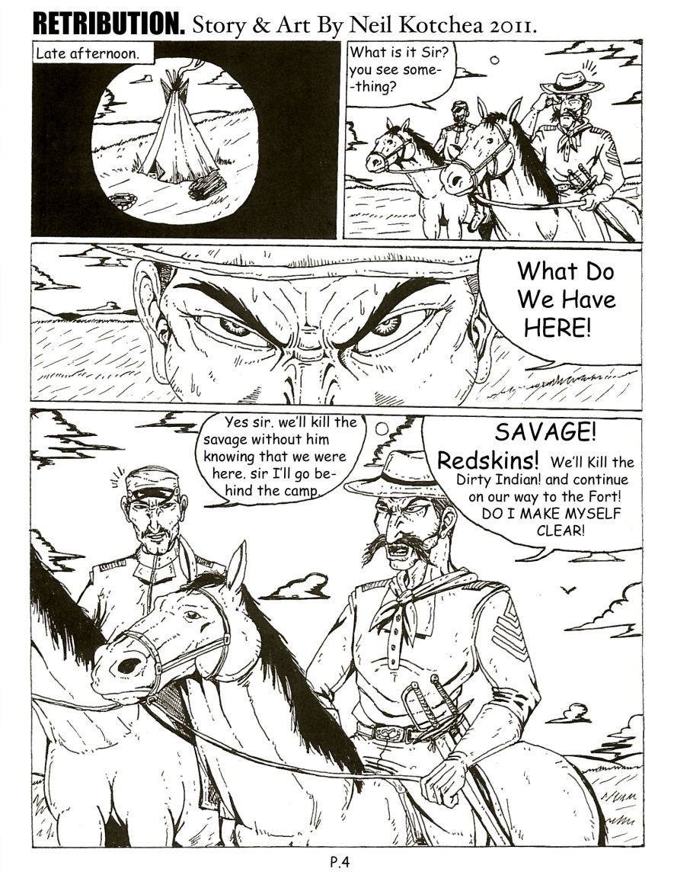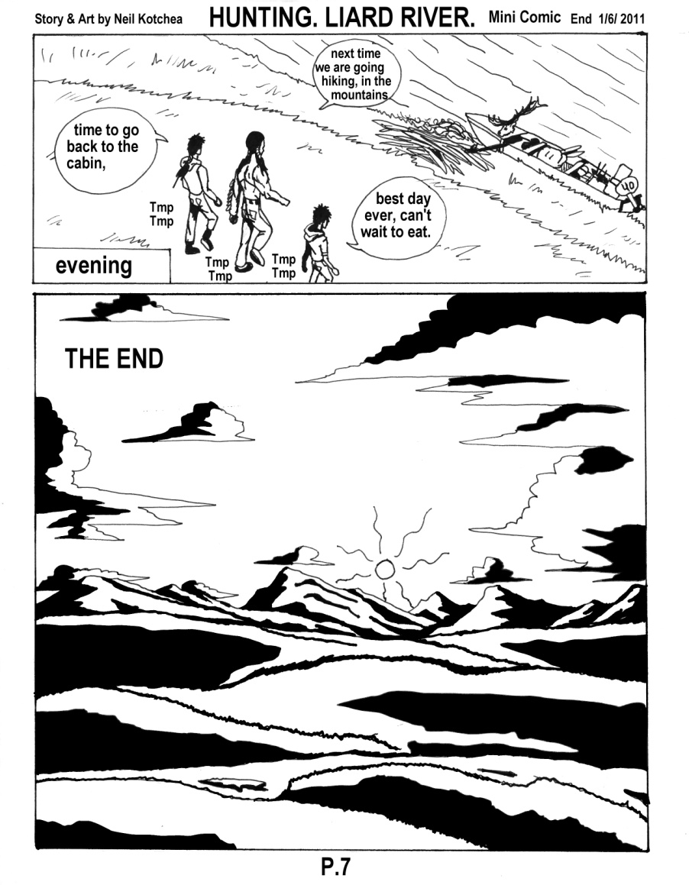

**SUPPORT YOUR LOCAL ARTISTS...**

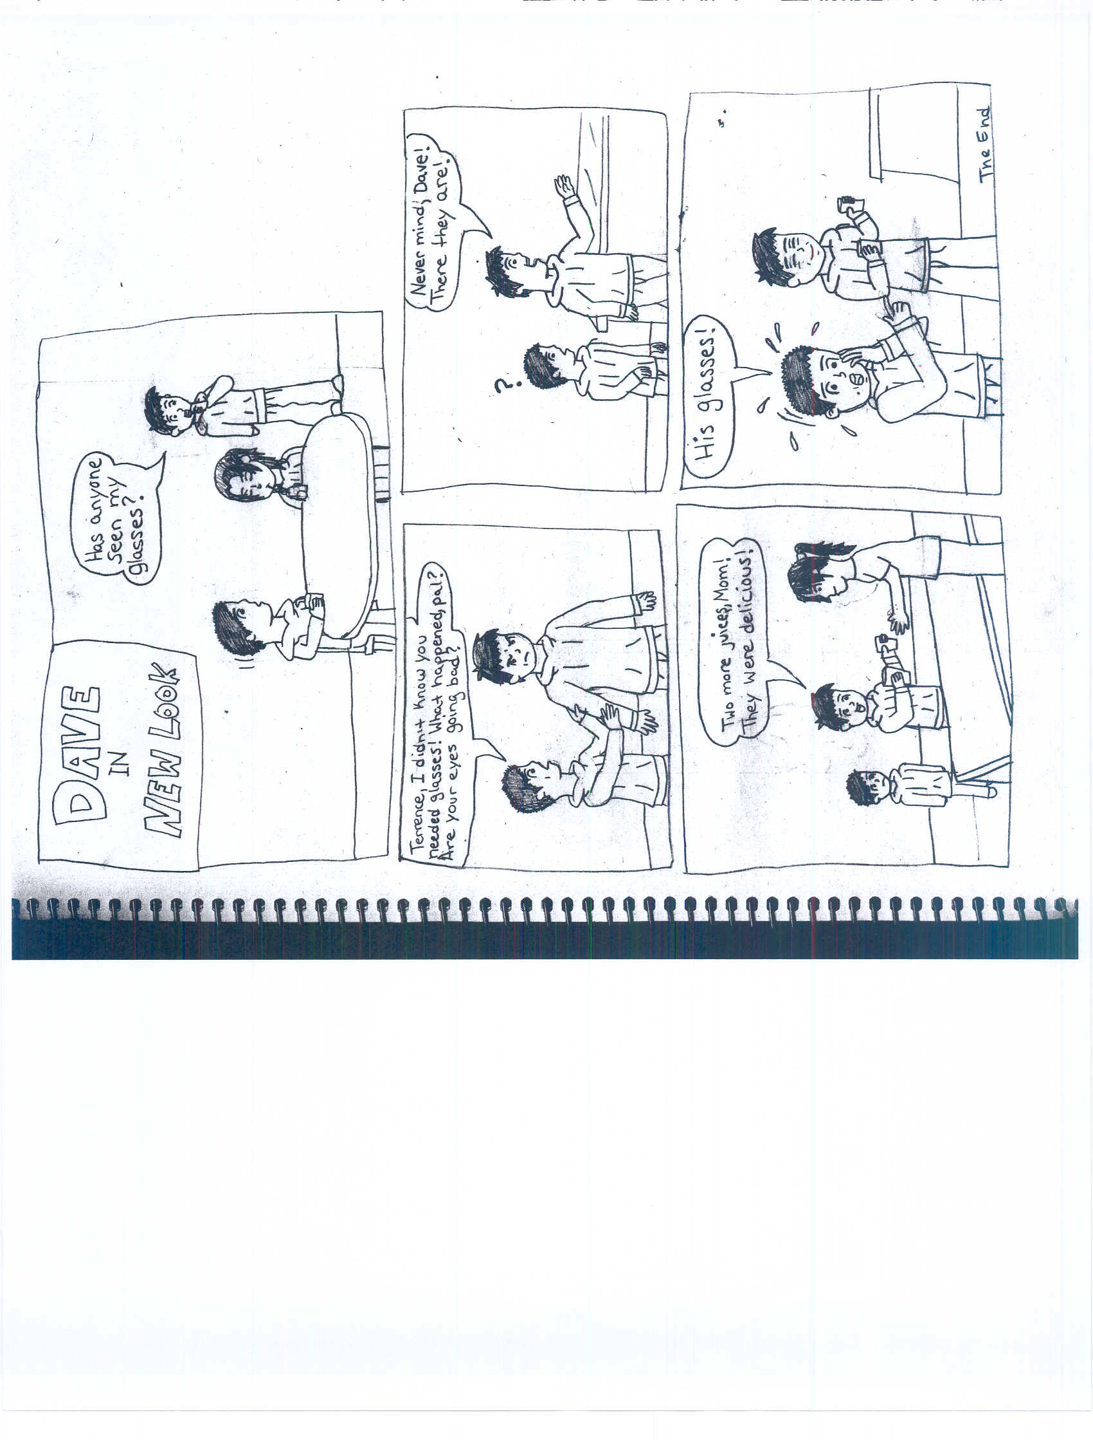

**Check out the Open Sky Festival July 1 – 3, 2011**

**Comic by Alinda Edda**

**\*NEW* ECONOMIC DEVELOPMENT OFFICER** ($36.20 HR. – 35 HR PER WEEK)

(MATERNITY FULL TIME)

The Economic Development Officer (EDO) is responsible for the effective delivery of business programs and services in all sectors including business, renewable resources, arts, crafts & tourism, energy, mining and petroleum with a mandate aimed at developing and sustaining a healthy business community of Fort Liard. The incumbent provides technical skills and access to financial resources in accordance with Federal and Territorial legislation and GNWT policies and procedures to achieve community and regional goals for the growth and development of the business community within Fort Liard. **PLEASE SUBMIT RESUMES BY JULY 13, 2011**

**EQUIPMENT OPERATOR MAINTAINER** ($32.65-$35.31 HR. – 40 HR PER WEEK)

(PERMANENT FULL TIME)

Reporting to the Manager, Municipal Works and Services, the Equipment Operator/Maintainer is responsible for road maintenance, preventative maintenance of mobile and stationary equipment and operation of heavy equipment including graders and loaders in order to ensure that residents receive effective and appropriate services. You must have a minimum of a Grade 12 education, good math and communication skills, knowledge of and ability to operate, repair and maintain municipal service equipment, a valid NWT Class 3 (with air endorsement) driver’s licence, heavy equipment operator certification, two year clear driving record (proof must be submitted with your application).

**MUNICIPAL SERVICE SUPERVISOR/WATER PLANT OPERATOR** ($35.70-$38.61 HR. – 40 HR PER WEEK)

*(PERMANENT FULL TIME)*

Reporting to the Manager, Municipal Works and Services, the Municipal Service Supervisor/Water Plant Operator will oversee all water and sanitation operations of the Hamlet and is responsible for the supervision, administration and delivery of all water and sanitation services including operation of the water plant in order to ensure that residents receive effective and appropriate services. He/She must supervise and lead municipal services staff in an effective and sensitive manner and ensure the level of morale is maintained. He/She must also respond to concerns and complaints of residents in a positive and courteous manner. You must have a minimum of a Grade 12 education, good math and communication skills, supervisory experience, knowledge of and ability to operate a water treatment plant, Class 1 NWT Plant Operation Certification and a valid NWT Class 3 (with air endorsement) driver’s licence.

**MAINTENANCE SERVICEMAN** ($25.40-$27.47 HR. – 40 HR PER WEEK)

*(PERMANENT FULL TIME)*

Reporting to the Building and Facility Maintenance Supervisor this position will provide maintenance services to all Hamlet buildings including social housing units. Duties include preventative and on-demand maintenance and repairs to existing buildings. You must have a minimum of a Grade 12 education, good math and communication skills, Maintainer Journeyman Certification, Class 5 driver’s licence.

**municipal services truck driver** ($28.55-$30.88 HR. + 1.10 WEEKEND SHIFT DIFF– 40 HR PER WEEK)

*(PERMANENT FULL TIME)*

Reporting to the Supervisor, Municipal Services, a Municipal Services Truck Driver is responsible for operating air-equipped single and dual axle water, sewer and garbage trucks providing municipal services to community residents. You must hold a valid NWT Class 3 (with air endorsement) driver’s licence and have a two year clear driving record. Proof must be submitted with your application

**THE HAMLET OFFERS AN EXCELLENT BENEFITS PACKAGE INCLUDING A FIXED BENEFIT PENSION, AND HEALTH/DENTAL COVERAGE. AN ANNUAL NORTHERN ALOWANCE OF $6,000 IS PAID IN ADDITION TO THE ANNUAL SALARY. HOUSING MAY BE AVAILABLE.**

PLEASE SUBMIT YOUR APPLICATION by email, fax or mail to:

**manager corporate affairs**

**hamlet of fort liard**

**general delivery**

**fort liard, nt x0g 0a0**

**telephone 867-770-4104 FAX 867-770-4004 E-MAIL** [**mca@fortliard.com**](mailto:mca@fortliard.com)

*WE THANK ALL APPLICANTS WHO APPLY AND ADVISE THAT ONLY THOSE SELECTED FOR FURTHER CONSIDERATION WILL BE CONTACTED.*

**HAMLET EMPLOYMENT OPPORTUNITIES**



**A MESSAGE FROM FORT LIARD PROTECTIVE SERVICES**